Learning Project Week 1 ‘Earth’.
Age Range Year EYFS
Weekly Maths Tasks – aim to do one per day | Weekly Reading Tasks – aim to do one per day
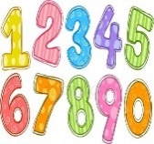  Try to do 10 minutes of arithmetic/ mental maths each day:  - Recap the days of the week song every day. Shout the day that you are on!  - https://www.bbc.co.uk/cbeebies/puzzles/school-counting-quiz complete the counting quiz.  - https://www.bbc.co.uk/cbeebies/puzzles/numberblocks-easy-patterns-quiz?collection=numbers-and-letters  - https://www.bbc.co.uk/cbeebies/puzzles/school-of-roars-monster-maths-quiz?collection=numbers-and-letters  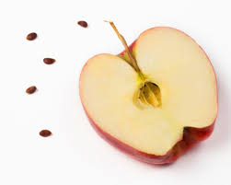  Pick one a day.  - Take a phone or tablet out with you or around the house. Go on a hunt for numbers and shapes. Take photographs. Did you see more of one number or shape than another? How many pictures did we get altogether? How many of each shape or number? Were there any shapes we didn’t get out of circle, triangle, square, rectangle.  - Go hunting for other seeds in the house. Look and talk about seeds inside tomatoes, apples, and other fruits. Can you count the seeds or see patterns inside when you cut them open? Print with the fruit and talk about the shapes.  - During your walk, collect objects that your child finds interesting. Reinforce NOT to pick wildflowers or remove insects from their habitats. Use any container to collect. When home, sort the objects into groups and make arrangements. E.g. are some made of plastic? Wood> Can we see any shapes? Group some objects and ask why they are a group? E.g. all made from metal. All are pointy, etc.  - Use an egg box or ice cube tray and put numbers underneath. Or use different containers with numbers underneath. Go around the house or garden and put the right number of objects into each section. Do we need smaller objects for bigger numbers in the egg box?  - Complete any maths work set by your school. | 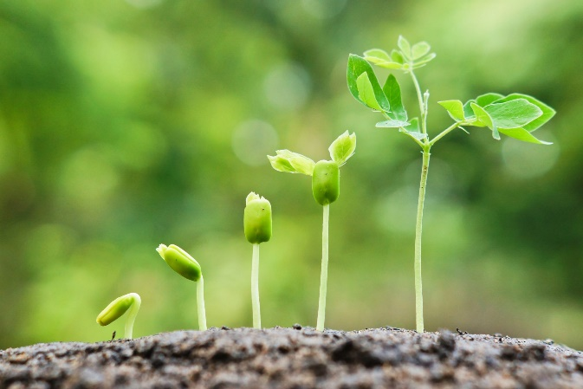  - Read ‘Plants in Spring’ https://readon.myon.co.uk/reader/index.html?a=aas_plants_f12 Do they recognise any words? Can they sound any out? What have we learnt about how plants grow from this book?  - Read ‘The Autumn leaf’ to your child. Do they recognise any words? Can they sound any out? How does the leaf feel before the fall? After the fall? Why?  https://readon.myon.co.uk/reader/index.html?a=cr_fall_f08  - Reception children: Children to read  to parents daily. https://www.oxfordowl.co.uk/for-home/find-a-book/library-page/?view=image&query=&type=book&age_group=Age+4-5&level=&level_select=&book_type=&series=#  Visit Oxford Owl for free eBooks that link to your child’s book band. You can create a free account.  Complete the linked Play activities for  each book.  - Read the Very Hungry Caterpillar and share with your child. If no access to the book click on the link below.  https://www.youtube.com/watch?v=75NQK-Sm1YY  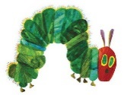  - https://www.youtube.com/watch?v=1NbgcXvdDUI at 1 min 12 sec. English level 2 read with the words. Talk about the vegetables and if the children have ever tried them.
Weekly Phonics Tasks – aim to do one per day | Weekly Writing tasks – aim to do one per day
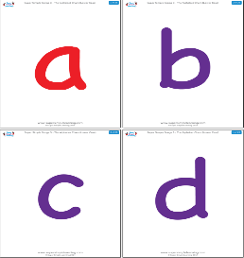  Daily phonics - your child to practise  their sounds and blend words.  Interactive games found on link below.  ● Phonics play  ● Top Marks  ● Spelling  https://www.bbc.co.uk/bitesize/topics/zvq9bdm Phase 3 phonics practise the sounds learning.  Read tricky words: no, go, I the to he she we, me, be. Practise writing and spelling the words.  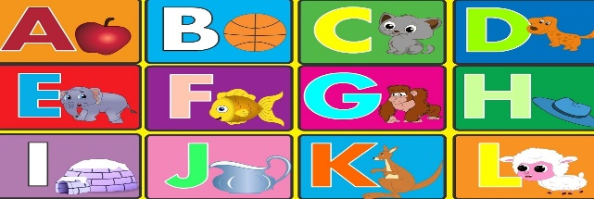 | Ask your child to  - Practise name writing. Write neatly first name, middle name and surname. Write it with water on pavement/ garden outside using a paintbrush.  - Practise handwriting forming letters a, c, o,  - Cut out the shape of a leaf. Find a leaf on a plant and describe it. Try and write some words in a leaf. Write a sentence My leaf is………….  - Start a plant diary and write day one of planting a seed. Draw and label picture of where and what seed planted.  - Write a list of what collected on the walk.  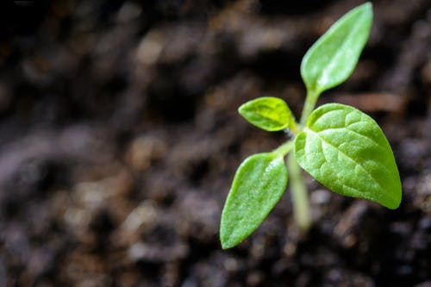
Learning Project to be done throughout the week
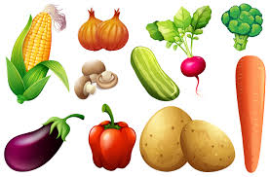
This project for the next two weeks aims to provide opportunities for your child to learn about earth. This week the focus is on plants and how they grow.

- Plant potatoes with your child. Use any small pot. Talk to your child about what you need to put in first and ask what they think will happen.
- Grow vegetable scraps https://www.bbc.co.uk/cbeebies/makes/dotf-vegetable-scraps
- Make plant labels to put in the garden for where your child will plant their seeds. Talk to your child about where a good spot for the plant would be and why and how long they think their seeds will take to grow.
- Make a fruit kebab. What fruit do they want to add to it? Which is their favourite fruit. Describe how the fruits look, taste and smell. Support the cutting of fruits and placing them onto a kebab stick.
- Make a compost heap. Explain to your child what you can and can’t put in there. Mad a mud kitchen and let your child add water and mix with old spoons, bowls, empty bottle, pans and cups.
- Go on a walk look at different plants. Talk about how some are tall and some are short. Talk about the colours, smells and where the plants have grown.
- Look at Van Gogh’s Sunflower picture https://www.nationalgallery.org.uk/server.iip?FIF=/fronts/N-3863-00-000095-WZ-PYR.tif&CNT=1&HEI=592&QLT=85&CVT=jpeg What type of flowers are in the painting? How many sunflowers are in the painting. How many different colours can you see? What are the flowers standing in? Can they see the stems, petals, leaves and seeds? Children to create their own picture of the sunflower using whatever tools they like e.g. crayon, felt pens or paint.
- Play a year on my farm – computer game. Practise key board control.
- Learn and sing the Yes, yes Vegetables Song - https://www.youtube.com/watch?v=DruYNHN4FYY

- Let’s move: Every day, Joe Wicks has a 30 minute workout at 9 am. Join in via YouTube.
Family learning
- Plan and hold a party for the people you live with: make invitations, menus and table decorations, prepare the food, prepare games to play. Enjoy yourselves.
- Talk together as a family about what you are thankful for and why.

