Learning Project Week 2 ‘Earth’
Age Range EYFS
Weekly Maths Tasks – aim to do one per day | Weekly Reading Tasks – aim to do one per day
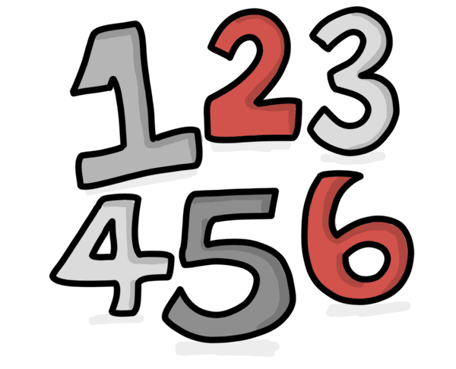  Try to do 10 minutes of arithmetic/ mental maths each day:  - Recap the days of the week song every day say loudly the day that you are on.  - Play ‘Kim’s game’. Put a number of objects (start with 5 and move up to 10) on a tray or flat surface. Cover with a cloth. Grown ups take one away. Children say which object has gone. Count how many are left. Repeat.  - https://www.bbc.co.uk/cbeebies/watch/numberblocks-days-of-spring-song learn the song and reinforce the numbers that come up on the screen.  - https://www.bbc.co.uk/cbeebies/puzzles/numberblocks-adding-up-quiz?collection=numbers-and-letters Do the number block  - Sing Panda song counting backwards. https://www.youtube.com/watch?v=_6fwkxtp4bw  Pick one a day.  - Make salt dough (see below for recipe)) and make circle shapes. (Use plain biscuits if you want the children to eat them after!) Talk about the shape and how there are no corners and one edge that goes around the circle. Either draw a line down the middle or use liquorice to cut the ladybird in 2. Set a challenge of each biscuit having 5 or 10 spots. You can add dots of dough or raisins, or chocolate drops. How many on one side? How many on the other? Talk about the calculation on both sides of the biscuit or dough to make the number. Can you write the number sentences you have made?  - Draw ladybirds (or use biscuits and dough as yesterday). This time each lady bird must have the same amount of spots on each side. How many different doubles have you got? Can you write them in a number sentence?  - Use a cup or mug and grown up hides 1-6 smarties, jelly beans, raisins (or anything else) under the cup. On pieces of paper have drawn dots similar to those on a dice. When the cup is lifted, children have to swat (with a fly swatter or a spoon) the correct number of dots as quickly as they can. Repeat with different amounts under the cup. This game is more about instantly recognising numbers than counting.  - Play a game using a dice for the children to begin quickly recognising a number. E.g. snakes and ladders. https://toytheater.com/snakes-and-ladders/  - Complete any maths work set by your school. | - Recap on the nursery rhyme – Incy Wincy Spider Say the rhyme and do the actions. https://www.youtube.com/watch?v=_6fwkxtp4bw  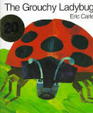  - Read a variety of books at home. Any favourites can be repeated. Include reading The Bad Tempered Ladybird. If no access to the book click on the link below.  https://www.youtube.com/watch?v=pmmdCoKZJaI  - Read ‘Weather in Spring’ to your child. Do they recognise any words? Can they sound any out? What is the book telling you?  https://readon.myon.co.uk/reader/index.html?a=aas_weath_f12  - Read The Busy Spring https://readon.myon.co.uk/reader/index.html?a=uk_cr_sprin_f08  - Look in the books to see if there are any tricky words they are currently learning.  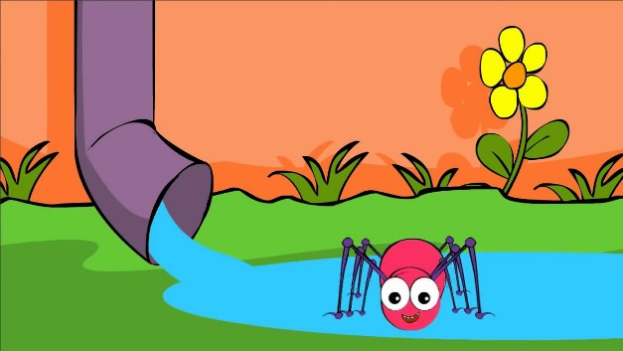  - Reception children: Children to read  to parents daily. https://www.oxfordowl.co.uk/for-home/find-a-book/library-page/?view=image&query=&type=book&age_group=Age+4-5&level=&level_select=&book_type=&series=#  Visit Oxford Owl for free eBooks that link to your child’s book band. You can create a free account.  Complete the linked Play activities for  each book.
Weekly Phonics Tasks – aim to do one per day | Weekly Writing tasks – aim to do one per day
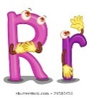  Daily phonics - your child to practise  their sounds and blend words.  Interactive games found on link below.  ● Phonics play  ● Top Marks  ● Spelling  https://www.bbc.co.uk/bitesize/topics/zvq9bdm Phase 3 phonics practise the sounds learning.  Read tricky words: was, my, you, they her, all are and recap last week’s words. | - Practise name writing. Write neatly first name, middle name and surname. Try to write it on a line getting the tall letters tall and any low letters coming under the line e.g. g.  - Practise handwriting forming letters d, g, q, Show the correct formation starting at the top.  - Write week 2 of simple plant diary. Draw a picture to show changes and what you have done e.g. added water put in the light etc.  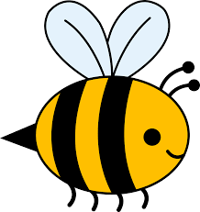  - Write a sentence about an insect. Eg An ant has 6 legs. I can see a bee. Etc.
Learning Project to be done throughout the week
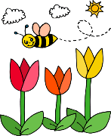
This is the second week of the project and aims to provide opportunities for your child to learn about earth. This week the focus is on minibeasts that are found in the garden and the different seasons of the year.

- Talk about the different seasons and the clothes you wear. Children to look at photos of themselves in the summer, and winter and discuss what was different and why. Use magazines to cut up pictures of sunny, rainy, windy and snowy days. If no magazines draw pictures of what you can wear on a sunny and rainy day.

- Watch https://www.bbc.co.uk/cbeebies/watch/mini-beast-adventure-with-jess-earwig-adventure and https://www.bbc.co.uk/cbeebies/watch/mini-beast-adventure-with-jess-snail-adventureGo on a minibeast hunt e.g. earwigs under a damp pot and snails Talk about where you found the different creatures and count how many you found in each place.

- Use 2 teddies/puppets children act out each toy taking turns in talking, being friendly and being kind to each other.
- Children to dig outside – fill buckets, old bowls containers and follow instructions. e.g. can you fill the big bucket? Can you nearly fill the saucepan? Which is the best tool to dig with spoon, spade, fork? Why?

- Listen to the song https://www.bbc.co.uk/cbeebies/watch/mini-beast-adventure-with-jess-theme-song. Children to learn the words and sing the song. Listen to the sounds that children can hear outside. Children to describe the sounds that they hear e.g. a siren, tweets of birds, talking, cars. Which sounds are loud? Which are quiet? Why?

- Use bricks, Lego or natural materials from outside to make a bug house for a creature. What would they need? How will it be safe and not fall over? How big would the entrance need to be? Ensure any creatures are returned to their natural habitats.

- Make salt doughhttps://www.youtube.com/watch?v=L7sH9bj-fl0. Children to make minibeasts out of the dough e.g. ladybirds, spiders earwigs etc When made bake in the oven until hard and then paint.
- Let’s move: Every day, Joe Wicks has a 30 minute workout at 9 am. Join in via YouTube
Family learning
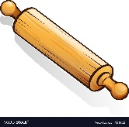
- Learn to use a new kitchen tool together e.g. whisk, rolling pin. Use to bake a cake or biscuits together and eat them!
- Talk together as a family about how you care for the world. What else could you do to help make the world a better place.

