Learning Project Week 3 ‘Water’.
Age Range Year EYFS
Weekly Maths Tasks – aim to do one per day | Weekly Reading Tasks – aim to do one per day
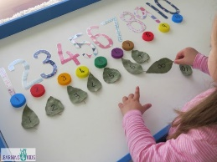  Try to do 10 minutes of arithmetic/ mental maths each day:  - Play a game of snap. Who will win the most cards?  - Count objects in the kitchen. How many cups in the cupboard? Repeat with plates, forks, bowls, pans. What do you have more of? What are there least of?  - Practise writing the numbers one to 10. Make sure the numbers are the right way around. Find objects from around the house to match to the numbers. Only rule – they must be the same thing e.g. 2 teddies, 5 toy cars etc.  - Use building bricks, Lego blocks, counters or anything available to count! Start with 4. Add one more. How many now? Can we write that as a number sentence? 4+1= 5. Repeat with other numbers. Always adding 1 more. Can we do it in our head?  - Use 4 objects. Split them into different sizes of groups e.g. 3 and 1. How many in each group? How many when they are put back together? Repeat by making different sized groups e.g. 2 and 2, 4 and 0 etc. See if you can write number sentences for each group.  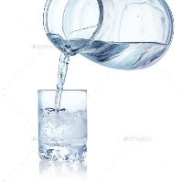  Pick one a day.  - Use bottles, cups, mugs, bowls, pans etc. Reinforce the language full, half-full and empty. Children to make bottles full, half full and empty and take a photo.  - Use bottles of different sizes in the water. Which one will hold the most? Look at the different bottles. How are they different? What happens if your pour one into another? How can we find out which holds the most?  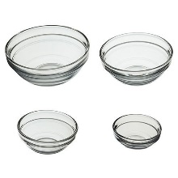  - Use a bowl. Use toy cups, bowls, pans. Or use ordinary cups, bowls pans (plastic preferably) Use objects and see how many cups it takes to fill a bowl, small pan and large pan. Which holds the most, which holds the least? Put them in order from most to least. Put a label on each object so know how many cups each object holds.  - Your teacher is really thirsty. Which cup should she use to have a drink and why? Use a range of cups, mugs of different sizes and children have to find out which one holds the most water.  - Complete any maths work set by your school. | 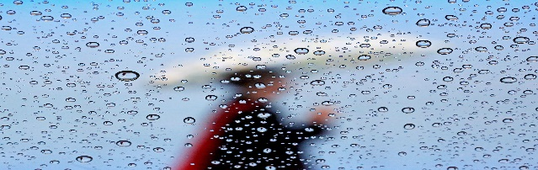  - Read ‘What is water’ https://readon.myon.co.uk/reader/index.html?a=wr_wwate_f11  Do they recognise any words? Can they sound any out? What have we learnt about water from this book?  - Read ‘Rain’ to your child. Do they recognise any words? Can they sound any out? What does rain do? What were the new words that you have learnt and what do they mean? Talk about them with a grown up.  https://readon.myon.co.uk/reader/index.html?a=ww_rain_f14  - Read ‘Raindrops fall all around.’ https://readon.myon.co.uk/reader/index.html?a=sww_rain_s15 Can you hear any rhyming words in the book. What are they?  - Reception children: Children to read  to parents daily. https://www.oxfordowl.co.uk/for-home/find-a-book/library-page/?view=image&query=&type=book&age_group=Age+4-5&level=&level_select=&book_type=&series=#  Visit Oxford Owl for free eBooks that link to your child’s book band. You can create a free account.  Complete the linked Play activities for each book.  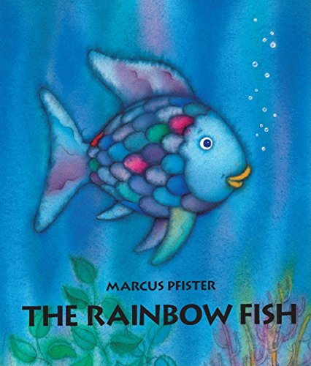  - Read a variety of books at home. Any favourites can be repeated. Include reading The Rainbow Fish’. If no access to the book click on the link below. https://www.youtube.com/watch?v=QFORvXhub28  - Read The Little Raindrop and share with your child. If no access to the book ,click on the link below.  https://www.youtube.com/watch?v=lcQm-supS5M Talk about the book. What was the favourite part of the story?  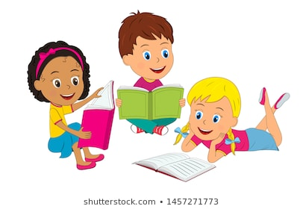
Weekly Phonics Tasks – aim to do one per day | Weekly Writing tasks – aim to do one per day
Daily phonics - your child to practise  their sounds and blend words.  Practise the alphabet song . Do you know all the letter names? https://www.youtube.com/watch?v=EF3_T0wMmXw  Interactive games found on link below.  ● Phonics play  ● Top Marks  ● Spelling  https://www.bbc.co.uk/bitesize/topics/zvq9bdm Phase 3 or 4 phonics practise the sounds learning.  Read tricky words: so, have, like, some, come. Recap last week’s words. Practise writing and spelling the words. | 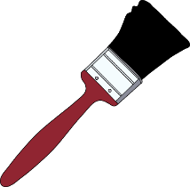  Ask your child to  - Practise writing tricky words in water on the pavement, in the garden. How many tricky words can you write?  - Practise handwriting forming letters l, I and t. At 1 minute. https://www.theschoolrun.com/helping-your-child-learn-write  - Write a ‘wash your hands’ poster and decorate for the bathroom.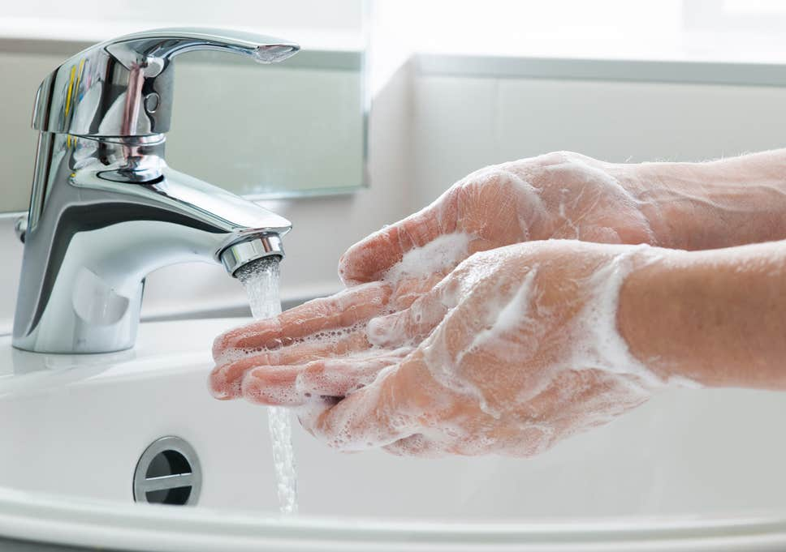  - Write week 3 of your plant diary, What are the changes?  - Write a list of words that rhyme with ‘wet’. Can you use your sounds to spell them?
Learning Project to be done throughout the week
This project for the next two weeks aims to provide opportunities for your child to learn about water.

- Go outside in the rain (If it doesn’t rain use a watering can) and listen to rain noises on an umbrella. What sounds can you hear. Is it loud or quiet? How does it make you feel?

- Are you scared of thunder and lightning? Watch Part 1 https://www.youtube.com/watch?v=QF4xWV7WEoc What is weather? Can you sign the words for rain, cloud, weather? Then watch Part 2 https://www.youtube.com/watch?v=GR9SKdRu70Q What is a cloud? Why does it rain? Can you sign lightning and thunder? What is thunder and lightning?

- Sing Rain. Rain go away, It’s raining it’s pouring. Do you know the songs? Are any songs new? Can you put actions to the songs? Do you know any more songs about rain? Sing them to your family.
- Put on your wellies! Find a puddle and jump in it! If there are no puddles make some outside. Stamp in the puddle and see what happens. What happens if you tiptoe through the puddle? What does the water do?

- Look at some soil. Make it wet. Is it easy to dig? Try and freeze some soil. When it is frozen, try and dig it. Is it harder to dig? Why? Try dry soil. Is this different? Use different tools to dig with. Which is the best tool to dig the soil with a spoon. a fork, a knife, chopsticks?
- Come to the rescue! Some toys are frozen in containers. You have to save them by getting them out from the ice. What can you use? Toy hammers and other tools that will help you come to the rescue. What works best?

- Listen to the song ‘Wash my Hands’ YouTube 28mins 11 secs https://www.youtube.com/watch?v=RkE6YNfl3do Why is it important to wash hands? Are there any other times that you need to wash your hands. How do we wash hands properly? Put water in a bowl with some pepper. Put a finger (or hand in) the pepper acts like germs. Put soap into the bowl. What happens to the germs? Wash hands properly to get rid of the germs (pepper) off hands.

- Look at the two pictures of babies at bath time.

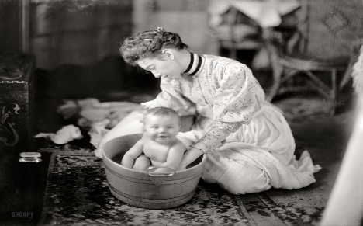

What are the same about the two pictures? What is different? Why is the baby being bathed in a tin bath in front of a fire? Why is the baby not being bathed in the bathroom?
Talk about bath time at home and what you like and don’t like about bath time.
- Use a bowl of water and a whisk. How fast can you make the water move? Add some washing up liquid and whisk. What happens to the water? Add some paint to the water and place a piece of paper over the top. What bubble prints can you make?
- Use a camera, tablet or a grown ups phone and take some rainy day pictures. See if you can take a picture of a raindrop. Take a picture of a person you know in the rain. See if you can catch an animal in the rain e.g. an insect, a bird or a pet.
- Time to wash your toys! It can be a car wash for washing toy vehicles, bath time for any dolls and teddies or laundry day for washing and pegging out clothes. Check the toys you can wash with a grown up first. Have warm water with soap for washing and some without for rinsing. Have sponges, cloths, brushes for washing and towels for drying or pegs to hang out with.

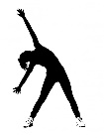
- Let’s move: Every day, Joe Wicks has a 30 minute workout at 9 am. Join in via YouTube.
Family learning
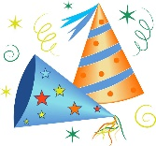
- Design and build a shelter out of just newspaper and sticky tape. Make sure it is big enough to fit in everyone who lives with you. Think about what shapes you will need to construct to make it strong. CHALLENGE: can you make it waterproof?
This Photo by Unknown Author is licensed under CC BY-NC
- Lie on the ground and look for shapes in the clouds. Talk about the shapes you see.

