Learning Project Week 4 ‘Water’
Age Range EYFS
Weekly Maths Tasks – aim to do one per day | Weekly Reading Tasks – aim to do one per day
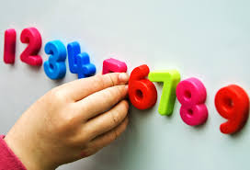  Try to do 10 minutes of arithmetic/ mental maths each day:  - Watch Reinforce the order of counting.  https://www.bbc.co.uk/cbeebies/watch/numberblocks-five-little-boats-song  - Sing 5 little Ducks went swimming one day, 5 little speckled frogs take away 1. What is happening to the numbers? Getting smaller. 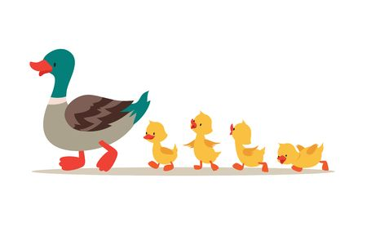  - Use building bricks, Lego blocks, counters or anything available to count! Start with 10. Take away one. How many now? Can we write that as a number sentence? 10-1 = 9. Repeat with other numbers. Always taking away 1. Can we do it in our head?  - https://www.bbc.co.uk/cbeebies/puzzles/numberblocks-adding-up-quiz?collection=numbers-and-letters Complete the task.  - Complete the Number blocks quiz. https://www.bbc.co.uk/cbeebies/puzzles/numberblocks-number-magic-quiz-level-1  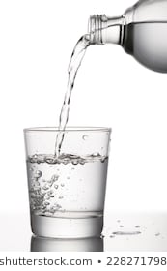  Pick one a day.  - Filling station: Use a range of pots and pans. Use a big ladle, spoon or small cup. Estimate first how many ladles, cups or spoons will fill each container and then measure. How far away from the right answer were you each time?  - Use a small bowl. Estimate how many of a small, large, wooden spoon and ladle it will take to fill a pan. Measure carefully. Which sized spoon is the best to fill the container. Why?  - Use tubed pasta or beads. Use wool or string. Thread pasta or beads to make necklaces. How many pieces are needed for different lengths of wool and pasta. Count.  - Play a game using a fishing game https://toytheater.com/fishing/ count how many coloured fish you caught.  - Complete any maths work set by your school.  - 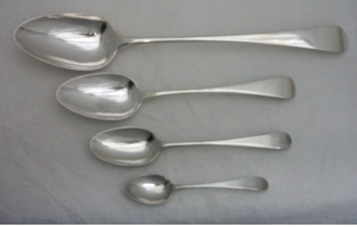 | 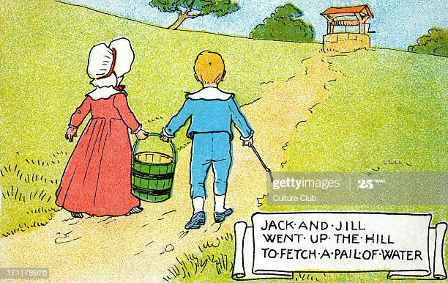  - Recap on the nursery rhyme –Jack and Jill went up the hill. Say the rhyme and do the actions. https://www.youtube.com/watch?v=RbNQ0SQT0Z4  - Read a variety of books at home. Any favourites can be repeated. Include reading The Bravest Fish’. If no access to the book click on the link below. https://www.youtube.com/watch?v=x9qCa0wntIY  - Listen to the story ‘The ugly duckling.’ How do you think the duckling feels? Why is it unkind to be called names? What should people have said instead of being so mean? What should his brothers and sisters have done? When was he happy? Why? https://www.youtube.com/watch?v=OSWLxj4kTKA  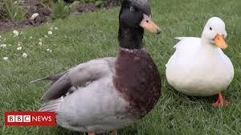  - Read ‘Ducks’ to your child. Do they recognise any words? Can they sound any out? What is the book telling you? What have you found out about ducks? What colours of ducks have you seen?  - https://readon.myon.co.uk/reader/index.html?a=fa_ducks_f16  - Read ‘Brilliant boats’ to your child. Do they recognise any words? Can they sound any out? What type of boats are there? Have you ever been on a boat? What are boats used for? Which is your favourite type of boat? https://www.youtube.com/watch?v=KK7Au1u-_xg  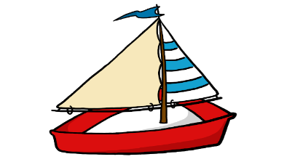  - Read ‘Who sank the boat?’  Look in the books to see if there are any tricky words they are currently learning. Can you find the rhyming words.  - Reception children: Children to read  to parents daily. https://www.oxfordowl.co.uk/for-home/find-a-book/library-page/?view=image&query=&type=book&age_group=Age+4-5&level=&level_select=&book_type=&series=#  Visit Oxford Owl for free eBooks that link to your child’s book band. You can create a free account.  Complete the linked Play activities for  each book.  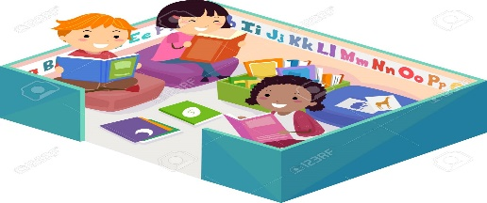
Weekly Phonics Tasks – aim to do one per day | Weekly Writing tasks – aim to do one per day
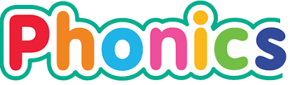  Daily phonics - your child to practise  their sounds and blend words.  Practise the alphabet song . Do you know all the letters? https://www.youtube.com/watch?v=75p-N9YKqNoWhich letter names have you got in your first name and surname?  Interactive games found on link below.  ● Phonics play  ● Top Marks  ● Spelling  https://www.bbc.co.uk/bitesize/topics/zvq9bdm Phase 3 or 4 phonics practise the sounds learning.  Read tricky words: were, little, one, all, do and recap last week’s words. Practise writing and spelling the words. | - Practise name writing. Write neatly first name, middle name and surname. Try to write it on a line getting the tall letters tall and any low letters coming under the line e.g. y.  - Practise handwriting forming letters u and y. At 1 minute in the video. https://www.theschoolrun.com/helping-your-child-learn-write  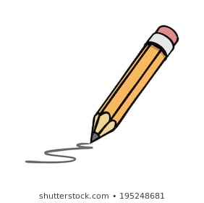  - Write week 4 of simple plant diary. Draw a picture to show changes and what you have done e.g. added water put in the light etc.  - Write a sentence about a duck. What they eat, their colour and what they do.  - Write a list of objects that float and a list of objects that sink.
Learning Project to be done throughout the week
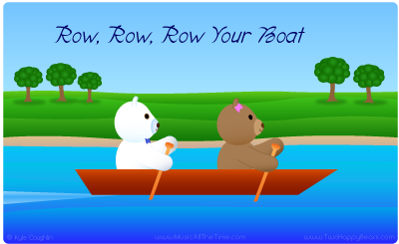
This is the second week of the project and aims to provide opportunities for your child to learn about water.

- Use a bowl of water. Try collecting water on different sized spoons. Is it easier or harder with a big or small spoon? How much water can you catch in a cup using 5 big spoons. Is the same amount with 5 small spoons? Why?

- Sing Row, row, row the boat and Jack and Jill went up the Hill. Can you do the actions to the songs? Can you change the names in the song? Can you change stream to lake? Can you think of rhyming words with the words that you have changes? What are they?

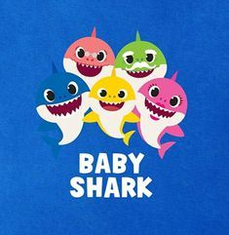
- Sing ‘Baby Shark’. Do the actions and sing the song. Show your family your dance and song and get them to join in.

- Sing Baby Shark wash your hands’ https://www.youtube.com/watch?v=L89nN03pBzI Reinforce the order of washing hands and how to stay healthy.

- Use bath toys and any animal toys that can go in the water. Do they float in the water or do they sink? Test them in the bath or in the sink. Try other objects from the kitchen (CHECK WITH PARENTS FIRST!) Sort the objects into objects that sink and objects that float. Watch : https://www.youtube.com/watch?v=eQuW8G2QV_Q
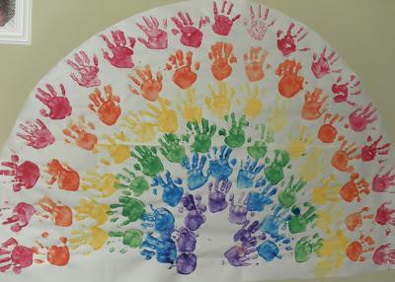
- Listen to the story of Noah’s Ark. https://www.youtube.com/watch?v=QAsfOcGjgoM What is the story about. Why did God send a rainbow?
- Look at pictures of Rainbows. When do rainbows appear in the sky? Do we see lots of rainbows? Have you ever seen a rainbow? Make handprint rainbow pictures using paint. If no paint, draw pictures of rainbows and put them in your windows.
- Make 2 boats using materials from home. What would be the best materials be? Put a sail on them using a triangular piece of paper. Use scissors to cut. Try using playdough or salt dough. Put them in the bath or sink and blow! Which one is first to the other side?
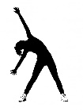
- If you have any kitchen funnels, tubes or pipes and plastic medicine syringes use them (outside with a bowl or inside with a floor covering!) Ask a grown up to cut plastic bottles in half to make some tubing and use any empty plastic bottles that you may have at home. What can you use to make the water travel faster? Can you make a waterfall?
- Let’s move: Every day, Joe Wicks has a 30 minute workout at 9 am. Join in via YouTube
Family learning
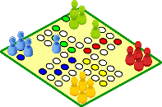
- Design, make and play a board game with the whole family. You could base it on a water adventure if you like or something completely different!
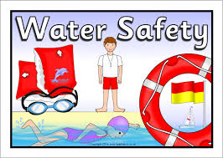
- Talk about water safety. What must you do near water? Talk about the four key water safety messages.

- Always swim in a safe place.
- Always swim with an adult.
- If you fall in, float, breathe, relax.
- If someone else in trouble, call 999

