Learning Project Week 5 ‘Air’
Age Range EYFS
Weekly Maths Tasks – aim to do one per day | Weekly Reading Tasks – aim to do one per day
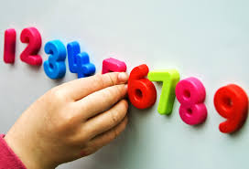  Try to do 10 minutes of arithmetic/ mental maths each day:  - Sing counting songs (counting on) 1,2,3,4, 5 once I caught a fish alive… and 1,2, buckle my shoe, 3,4, knock at the door.  - Sing counting songs (counting back) 5 little monkeys jumping on the bed and 10 green bottles standing on the wall.  - Watch Number blocks the whole of me https://www.youtube.com/watch?v=xifpq8nCEzk Talk about how the blocks are made up.  - Sing 5 little speckled frogs. If you can set up a log with frogs (pictures will be fine) and a pool (this can be a tray) and act out the song. Encourage the children to sing the song as they play. Count how many frogs are on the log and in the pool at the end of each verse.  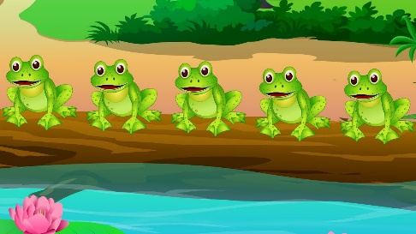  Pick one a day.  - Make 2 circles on the ground. Use string or plates or anything you can find! Use 5 (or 10)small toys. Can you split the toys up in different ways so there are different numbers in each group. Egg 3 toys in one and 2 toys in another? Repeat with different numbers in each group. 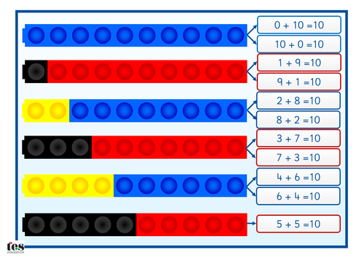  - Use building bricks, Lego blocks, sweets, counters or anything available to count! Make a tower or lines of 5 (or 10) using two different colours. Make another tower or line that is different again using the same two colours. What is the same? What is different? Can you make any more different towers of 5?  - 5 (or 10) balls and a bucket. If no balls, use something small that you can throw into a bucket. Throw the balls. How many land in the bucket? How many outside? How could you record the results? Ask the children to use their own ways of recording. Take it in turns.  - Play Bunny ears. Using 2 hands to be the ears, how many ways can you show 5 (or 10)? Show your child first. Can you make ears the same as mine? Use 3 fingers on one hand and 2 on the other. Can you make the same number in a different way?  - Use 2 bowls. Explain that there are 3 pebbles hidden inside the bowls. How many pebbles could be in each bowl? Could this bowl have 0 pebbles? Could this bowl have 4 pebbles? How do you know?  - Complete any maths work set by your school. | 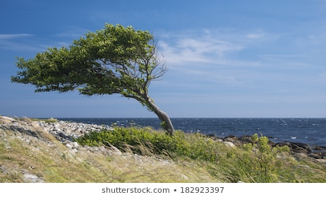  - Read the poem The Wind with your child.  The Wind  - The wind came out to play one day,  He swept the clouds out of his way,  He blew the leaves and away they flew,  The trees bent low and their branches did too,  The wind blew the great big ships at sea,  The wind blew my kite away from me.  Together put actions to the poem to understand what the poem is telling us. Can your child any words in the poem? Can we segment the word wind? W-i-nd. Wind.  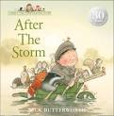  - Read a variety of books at home. Any favourites can be repeated. Include reading Percy the Park Keeper -After the Storm. If no access to the book click on the link below.  https://www.youtube.com/watch?v=fiYNdFuvAkU Talk about the things you like about the weather and things you don’t like. What is your favourite part of the story?  - Listen to the story ‘The Wind Blew. ’https  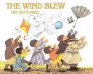  What do you notice about the book? Can you find the words that rhyme? How many things did the wind blow away? How many people were chasing after the things that the wind blew? What did the wind do when it got tired?  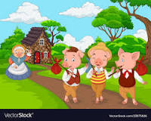  - Read ‘The Three Little Pigs’ to your child. Do they recognise any words? Can they sound any out? What is the book telling you? What have you found out about the three little pigs. Can you find some words to describe the pigs? What about words to describe the Big Bad Wolf? Join in with the story.” Little Pig, little Pig let me come in!” Join in with other parts to the storyhttps://www.youtube.com/watch?v=jpEBv1GFte4  - Read ‘Wind’ to your child. 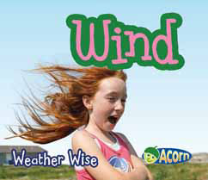https://readon.myon.co.uk/reader/index.html?a=ww_wind_f14Do they recognise any words? What is wind? What does wind do? What sort of wind is blowing today? Is it stormy or is a local wind blowing leaves? Is it a breeze? What is a breeze? What is a gale? Why do we need the wind?  - Reception children: Children to read  to parents daily. https://www.oxfordowl.co.uk/for-home/find-a-book/library-page/?view=image&query=&type=book&age_group=Age+4-5&level=&level_select=&book_type=&series=#  Visit Oxford Owl for free eBooks that link to your child’s book band. You can create a free account.  Complete the linked Play activities for  each book.  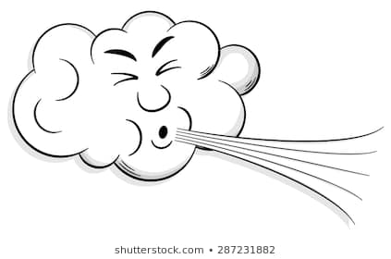
Weekly Phonics Tasks – aim to do one per day | Weekly Writing tasks – aim to do one per day
Daily phonics - your child to practice  their sounds and blend words.  Practise the nursery rhyme – ‘Blow wind Blow’ listen to the rhyme and join in.  https://www.youtube.com/watch?v=SsH7MYC7wto Can you work with your child to make different endings at the end of each line to make a nonsense poem? It can be as silly as you like! Can you make it rhyme?  Interactive games found on link below.  - Floppy’s Phonics Sounds and Letters  - Jolly Phonics  - Letterland Phonics  - Letters and Sounds (supplemented by closely matched and fully decodable books)  - Phonics Bug  - Read Write Inc.  - Sound Discovery  - Sounds-Write  https://www.bbc.co.uk/bitesize/topics/zvq9bdm Phase 3 or 4 phonics practise the sounds learning.  Read tricky words: ‘when, out, what, my, her’ and recap last week’s words. Practise writing and spelling the words. | - Practise name writing. Put some shaving foam into a tray. Practise writing your name in the mixture and then the alphabet.  - Practise handwriting forming letters r, n and m. At 1.58 minute in the video. https://www.theschoolrun.com/helping-your-child-learn-write  - Percy the Park Keeper doesn’t like the wind. Write a list of things that you don’t like.  - Write good things that the wind does and bad things that the wind causes like blowing the oak tree over in After the Storm.  - Write the words to describe you! Are you kind, clever and brave like the Little Pigs?  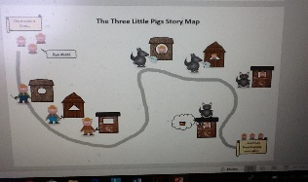  - Draw a story map of the story of the three little pigs showing the order of the story. Re-tell the story using your story map.
Learning Project to be done throughout the week
This project for the next two weeks aims to provide opportunities for your child to learn about wind and air.
- Take a walk outside. Let your child feel the power of the wind by running against it with a large piece of card, newspaper or umbrella. Try it with and without the card, newspaper or umbrella. Can you feel the difference? Can you spot the effects of the wind in the environment? Are there any fallen leaves, twigs, feathers or anything that has blown over? Can you collect any small objects that you have found that have been blown by the wind? You will need these later.

- Go outside and make some bubble mixture.
Instructions
- Get a large cup.
- Pour 1/2 cup of dish soap into the cup.
- Add 1 1/2 cups of water.
- Measure 2 teaspoons of sugar and add it to the water/soap mixture.
- Gently stir your mixture.
- Go outside and blow bubbles!
- Ask your child, can you see the wind? Can you feel it? What is the wind doing to the bubbles? What are the bubble full of? Is it possible for the wind to blow a bubble? Can you do this from just moving the wand?
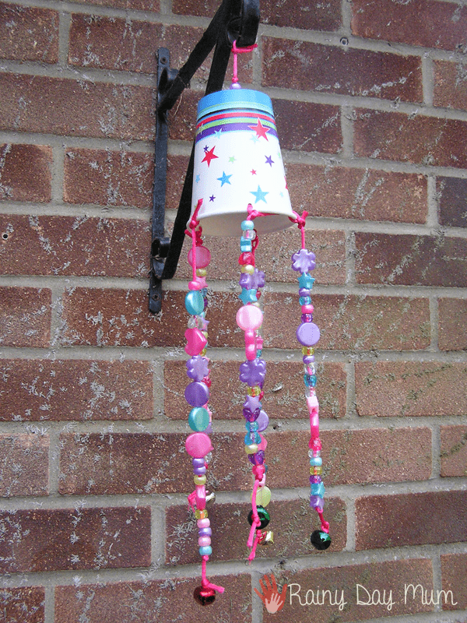
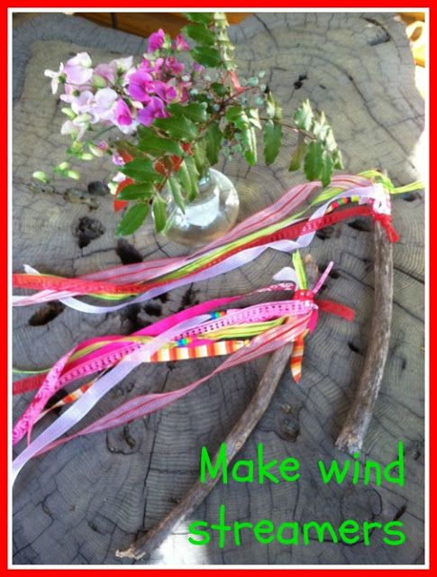
- Go outside, close your eyes and listen. What can you hear? Can you hear the birds? Can you hear the leaves rustling? Can you hear the traffic? Can you hear any animals? Describe the sounds you hear. Have you seen or heard a windchime? Listen to one and if you cannot listen to https://www.youtube.com/watch?v=uSqHrZgiwRM. Make a windchime of your own . You can use a paper cup and thread beads, pasta, shells on string. Or use empty tin cans of different sizes. Decorate and attach it outside, maybe in the garden. What sounds do they make?

- Make a rainbow wind streamer. Use a twig and material or paper of different colours. Find ways of attaching the material or paper to the stick. Which is the best way of attaching things. Take your streamer outside. Which way is the wind blowing? How can you tell? What is happening to your streamers?
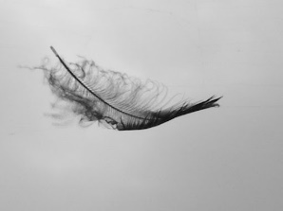
- Make a collage from the different things you have collected from your walk. Find different ways to stick them to the paper. You can add some paint or drawing if you want to.

- On a windy day find a straight line outside or draw one with a piece of chalk on some level ground. Find some different sized and types of balls e.g. a ping pong ball, football, small ball etc, Roll the ball along the line on a windy day. What happens? Try rolling it into the wind, away from the wind or when the wind hits it from the side. Does it make a difference? Do the same inside? Is it the same as outside? Why not?
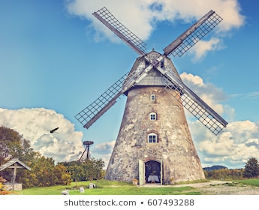
- Use your own voices encourage children to make wind sounds such as ‘whoooo’ and ‘shhhhhhhhh’. Record yourself on your tablet or phone making wind sounds. What different sounds can you think of? Can you make them loud, or quiet like a gentle breeze or like a storm?
- Look at the picture. What is this a picture of? Do you know what this building was used for? Work with a grown up to find out as much as you can about a building like this. Do we have any of these building close to where you live? Does it still work? What is it used for?

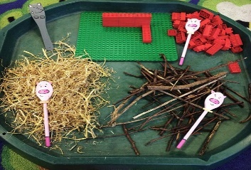
- Use different materials and create some puppets of the Three Little Pigs and the Big Bad Wolf. Act out the story. Can you build a house for the pigs using the materials?

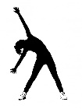
Let’s move: Every day, Joe Wicks has a 30 minute workout at 9 am. Join in via YouTube.

Family learning
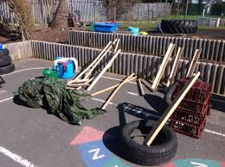
- Use different materials that you can find at home to create a structure that will keep a teddy bear safe in the wind. What are the best shapes? How tall is it going to be? What is the best material? Test your structure with a hairdryer! Can your structure stay up for longer than 2 minutes in the wind?

