Learning Project Week 6 ‘Air’.
Age Range Year EYFS
Weekly Maths Tasks – aim to do one per day | Weekly Reading Tasks – aim to do one per day
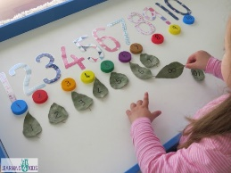  Try to do 10 minutes of arithmetic/ mental maths each day:  - Provide a starting line. Ask your child to take 9 giant steps, 9 tiny steps, 9 jumps, 9 tiptoes. How far do you travel each time? Join in? Who can travel the furthest in 9 giant steps? Who can travel the shortest distance with 9 tiny steps?  - Play skittles! Use 10 things that stand up e.g. water bottles and a ball. Child to record how many they knock down each time. Are there more skittles standing or more knocked over? Play with your child. After 5 turns who has knocked the most skittles over?  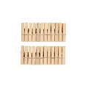  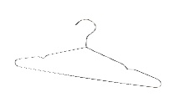  - Finger Gym. Put 10 pegs on a coat hanger (or 5). Ask your child to explore how their number can be partitioned (split up in different ways and recombined to see how many altogether. E.g. 4 and 6 makes 10.  - Learn the Number bonds rhyme.  Use your fingers to show the number bonds.  5 and 5 add up to 10  6 and 4 make it again  7 and 3 they also do  Guess what! So do 8 and 2  9 and 1, 10 and 0  Learn them all, you’re our number hero.  - Hide 10 items toys (or inside) and draw a large 10 frame on the ground. Ask your child to use the 10 frame to help them see how many toys they have found and how many are still hiding?  - 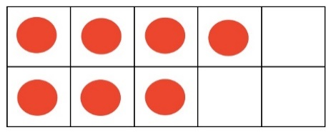  Pick one a day.  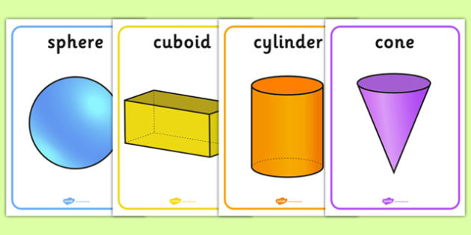  - Use shapes from the kitchen cupboards, boxes, tubes and toys. Can you build a model using all the different shapes? Take a photograph and send it to your teacher.  - Use a ball, tube of pringles (or any tube), box both cuboid and cube and a cone. Sort the shapes into those that will roll and those that will not. Why? What do you notice about the shapes that roll and the shapes that do not roll?  - Using dough (either playdough or salt dough make some 3-D shapes. Ask which shapes are the easiest to make and why? Do you need any equipment to make a flat side? What did you use? What worked the best?  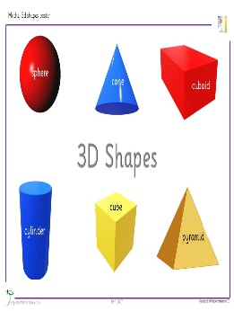  - Can you find some everyday 3D shapes and match them to their name? Cube, cuboid, cone, sphere and cylinder? What shape have you found the most of?  - Complete any maths work set by your school. | 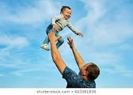  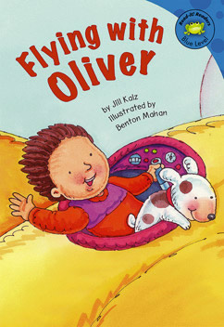  - Read ‘Flying with Oliver’ https://readon.myon.co.uk/reader/index.html?a=uk_rr_folive_s06 Can your child recognise any words and read some of the story by themselves? How is Oliver working the aeroplane? Have you got a remote-controlled toy that you can work? Discuss how it works.  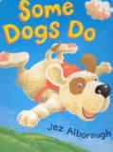  - Read ‘Some Dogs do’ . See if you can read some of the words. Can you add expression for the characters? Why are some words in capital letters? Can dogs fly? Is this a real story (fact) or fiction? Do you feel like you can fly when you are happy? https://www.youtube.com/watch?v=D4onEvfgAs4  - Reception children: Children to read  to parents daily. https://www.oxfordowl.co.uk/for-home/find-a-book/library-page/?view=image&query=&type=book&age_group=Age+4-5&level=&level_select=&book_type=&series=#  Visit Oxford Owl for free eBooks that link to your child’s book band. You can create a free account.  Complete the linked Play activities for each book.  - Read a variety of books at home. Any favourites can be repeated. Include reading Percy the Park Keeper stories. Watch the story about the book Percy the Park Keeper - The Hedgehog’s balloon. If no access to the book click on the link below. https://www.youtube.com/watch?v=diTpTIyX6AI  Talk about how Percy solved Hedgehog’s problem. Can you think of another way to let the hedgehog play with a balloon?  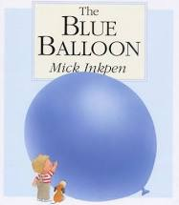  - Read The Blue Balloon and share with your child. If no access to the book ,click on the link below.  https://www.youtube.com/watch?v=dsqHgGeBkVkTalk about the book. What was the favourite part of the story?
Weekly Phonics Tasks – aim to do one per day | Weekly Writing tasks – aim to do one per day
Daily phonics - your child to practise  their sounds and blend words.  Focus on the phoneme ‘air’ decide which words are real or nonsense.  - Hur, hair, hure  - Fairy, fary, fowry  - Chor, chigh, chair  Can you think of anymore air words?  Interactive games found on links below.  - Floppy’s Phonics Sounds and Letters  - Jolly Phonics  - Letterland Phonics  - Letters and Sounds (supplemented by closely matched and fully decodable books)  - Phonics Bug  - Read Write Inc.  - Sound Discovery  - Sounds-Write  https://www.bbc.co.uk/bitesize/topics/zvq9bdm Phase 3 or 4 phonics practise the sounds learning.  Recap on the reception key words. Start with ‘I, in, and big, went, it for.’ Practise reading them and writing them by yourself, spelling the words accurately. | Ask your child to  - Practise name writing. Put some dry rice into a tray. Practise writing your name in the mixture and then air words.  - Practise handwriting forming letters h and b. At 1 minute 58 seconds in the video.. https://www.theschoolrun.com/helping-your-child-learn-write  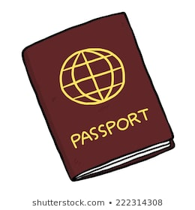  - Write a sentence (or more if you can) saying where Oliver and his aeroplane will go. Make it exciting!  - Make a passport for your aeroplane adventures. Write a list of countries that you have been to or want to visit in your passport. Write your name and address too!  - If you could fly up in the sky like Sid, what would you see and do? Write sentences ‘If I could fly I would……’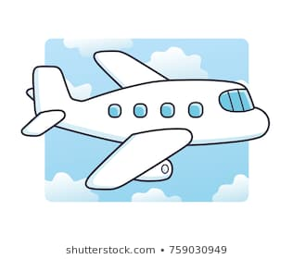
Learning Project to be done throughout the week
This project for the next two weeks aims to provide opportunities for your child to learn about wind and air. This week the focus is air.
- Find a balloon. Blow it up. What is it now filled with? Let it go! What is happening to the balloon? Why did that happen. Blow it up again. How far can the balloon travel?

- Listen to the song ‘Hands in the Air’. Clap the beat of the music by clapping or playing an instrument (if you have one’. Follow the beat of the heart on the screen. https://www.bbc.co.uk/games/embed/bring-the-noise?exitGameUrl=http%3A%2F%2Fbbc.co.uk%2Fteach%2Fbring-the-noise%2Feyfs-ks1-music-play-it-bring-the-noise%2Fz4sq92p

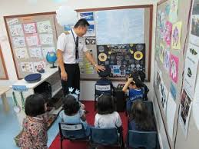
- Make an aeroplane for the family to sit in. Make sure there is an aisle for the air stewards to walk down to serve drinks and food. Don’t forget to bring your luggage on the plane and check your tickets and passports. Watch Inside an airplane ‘Suzie goes on an aeroplane.’ https://www.youtube.com/watch?v=ZiMG7PR0BCw. What do you notice? Decide where you are going on your airplane. I hope it is not a bumpy landing!

- Listen to the song Airplanes https://www.yo utube.com/watch?v=C9Z_YgbOLnY what have you learnt about the different aeroplanes in the song? Tell a grown up.

- Look at the pictures of the two planes.

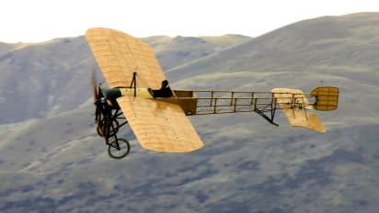
What is the same and different about them? Can you tell which one is old and which one is newer? Which plane would you prefer to travel in and why? Which one would you feel safer in?

- Blow painting – Dab a puddle of watery paint onto thick paper or card and use a straw to blow it in different directions. What patterns and pictures can you make?
- Use recycled materials to design and make your own aeroplane. It can be any shape and size that you want but it must have wings to fly and wheels to land. Find different utensils e.g. knife, scissors, glue to use to cut and stick the materials.
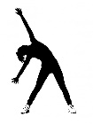
- Share a happy memory with the people you live with. Talk about who is in the memory and why you remember it. What was it that made you happy? Talk about a memory from today. Capture it and blow it up into the air.
Let’s move: Every day, Joe Wicks has a 30 minute workout at 9 am. Join in via YouTube.
Family learning
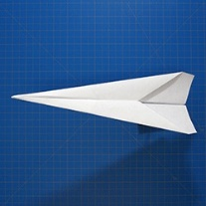
- Design and make a paper aeroplane. Decorate it and test it. Which member of the family has made the best paper aeroplane that travels the furthest?

