Learning Project Week 7 ‘Fire’
Age Range EYFS
Weekly Maths Tasks – aim to do one per day | Weekly Reading Tasks – aim to do one per day
Try to do 10 minutes of arithmetic/ mental maths each day:  - Use fruit, raisins or. sweets! Work with a grown up. Grown up is going to share them so that there is going to be half for you and half for them. Grown up puts a handful into each bowl without counting (make sure there is more in one than the other). Is that fair? Child to show how to make it fair. Repeat with other numbers.  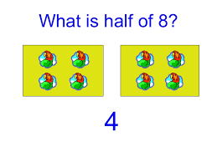  - Use a given number of objects and share them equally between toys e.g. 6 cars between 2 teddies. Repeat with different numbers.  - Use 2 teddy bears, 2 plates and loose parts of food e.g. raisins, fruit, carrots. Use 6 carrot sticks. Share them equally for the picnic. Use 10 grapes. Share them equally. 12 raisins. Share them equally. How many does each teddy have each time? Can we share 5 tomatoes equally? Why not?  - Use 10 pennies in a purse. Can you share them equally between two people? What about 8 pennies? Are there any pennies that we cannot halve equally?  - Use paper. Fold it in half. What do you notice? It is the same on both sides. What would happen if it wasn’t the same on both sides? Is that in half? Use different materials e.g. dough, ribbon string, paper. Cut in half and stick onto paper to show what 2 halves look like.  Pick one a day.  - Compare height within people who live in the house. Find someone who is taller than you. Find someone who is shorter than you. Is it a pet? Is there no-one shorter than you? Can you draw a picture of people in your house in order of height, starting from the shortest? Draw a line on the paper for everyone to stand on. Make sure you get everyone in the right order!  Shorter than a pencil The same length as a pencil Longer than a pencil  - Use dough or plasticine. Can you make a long snake? A short snake? Can you make a thick snake? A thin snake? Make the longest snake that you can. How many Lego blocks long is it? (If no Lego use any bricks or objects of the same size. Can you make a snake as long as a pencil? Then longer and shorter than a pencil?  - Use string, wool, ribbon, lace or material cut into strips. Can you cut a piece as long as a pencil? Longer than a pencil, shorter than a pencil? Stick them on a piece of paper.  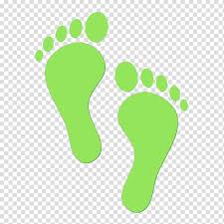  - Footprints. Draw around or print a foot of everyone in the family. Cut them out. Put them in order from longest to shortest. Measure using blocks or pennies how long each foot is.  - Using any small toy or cup, build a tower taller, shorter than the toy. Use any building blocks of the same height. If no blocks find something of the same height to build with. | - Read the book ‘The Birthday Cake Mistake.’ Read as much of the book as you can by yourself.  https://leics-fire.gov.uk/wp-content/uploads/2016/12/frf_bbs_lesson_story.pdf How did Ben and Katy Feel when they came home from the birthday party? Why do you think Katy took the matches upstairs? What happened when the children played with the matches? How do you think Kay and Ben felt at the end?  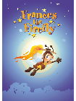  - Read ‘Frances the Firefly’ . What do you learn from the story? Why should you never play with matches, even if someone tries to convince you to? Was Charlie the Cockroach a good friend? Why was he punished? https://assets.publishing.service.gov.uk/government/uploads/system/uploads/attachment_data/file/532662/Frances_the_Firefly_Book.pdf  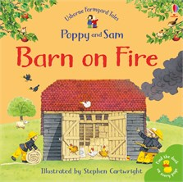  - Listen to the story ‘Barn on Fire’ https://www.youtube.com/watch?v=fsQia6QjbS8 Read the words at the top of the book by yourself. A grown up can read the other text. What sense did Sam use to know the barn was on fire? Why did Poppy and Sam have to stay indoors? Where did the firemen get the water from? Should the campers have been cooking near a barn?  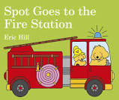  - Read the story ‘Spot goes to the Fire Station.’ https://www.youtube.com/watch?v=HX1VfxQsYj8 How many helmets are there in the story. What was Spot sliding down. What is the pole used for? What did Spot do to Grandpa? What did Spot touch that he shouldn’t have?  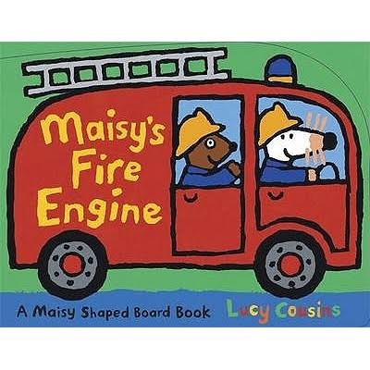  - Read the story Maisy’s Fire Engine’ https://www.youtube.com/watch?v=CXCBuGiJgzAWhy has the water got to be checked? Why was the cat scared? What was firefighter Maisy’s job? Have you seen a fire engine? What do car’s have to do when a fire engine comes by? Why?  - Reception children: Children to read  to parents daily. https://www.oxfordowl.co.uk/for-home/find-a-book/library-page/?view=image&query=&type=book&age_group=Age+4-5&level=&level_select=&book_type=&series=#  Visit Oxford Owl for free eBooks that link to your child’s book band. You can create a free account.  Complete the linked Play activities for  each book.
Weekly Phonics Tasks – aim to do one per day | Weekly Writing tasks – aim to do one per day
Daily phonics - your child to practise  their sounds and blend words.  Sing the rhyme  To the tune of Row, Row, Row Your Boat If your clothes catch fire,  This is what to do,  Fall on the ground, and roll around  That’s the best for you  Can you find the words that rhyme? Can you find other words to rhyme with ‘do’?  Interactive games found on link below.  - Floppy’s Phonics Sounds and Letters  - Jolly Phonics  - Letterland Phonics  - Letters and Sounds (supplemented by closely matched and fully decodable books)  - Phonics Bug  - Read Write Inc.  - Sound Discovery  - Sounds-Write  https://www.bbc.co.uk/bitesize/topics/zvq9bdm Phase 3 or 4 phonics practise the sounds learning.  - Recap on the reception key words. Start with ‘go, the, of, we, me, no, come.’ Practise reading them and writing them by yourself, spelling the words accurately.  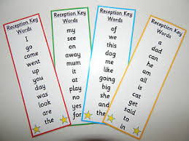 | - Practise name writing. Use the cornflour gloop! Write your name and the numbers 999.  - Practise handwriting forming letters k and p At 1.58 minute in the video. Practice writing all of the robot arm letters. https://www.theschoolrun.com/helping-your-child-learn-write  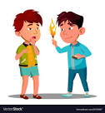  - Make a poster about never playing with matches or a lighter.  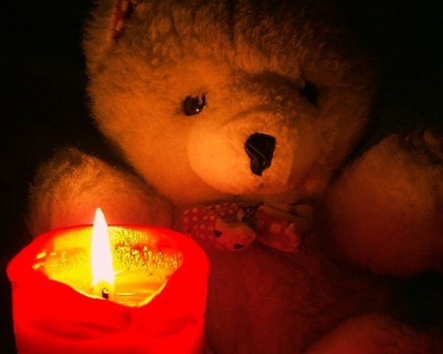  - Look at the picture. Say a sentence to a grown up about the picture. Now write the sentence about the picture.  - Write a rule about not touching hot things. E.g. Do not touch hot things or keep away from the cooker.  - Make a birthday card for someone’s birthday linked to the story The Birthday mistake. Put a number on the card for how old the person is.
Learning Project to be done throughout the week
This project for the next two weeks aims to provide opportunities for your child to learn about fire. The focus for this week is the danger of fire.
- Take a walk inside with a grown up. Find things that are hot and things that are cold. Hot things give out heat but it can be dangerous. Draw two circles and sort objects into hot and cold things.

- Look in the kitchen with a grown up. Find hot things that can be dangerous. DO NOT TOUCH! Can you find a cooker, lights, radiator, hot foods, an iron? Look elsewhere in your house. Can you see hairdryers, straightening irons, a barbecue, lighters or matches, plug in heaters, candles, cigarettes a lamp? All of these objects get hot and can burn you. Talk to a grown up about why you should not touch them and why you have to wait until some things cool down.
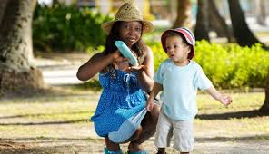
- Go outside and talk about the sun. Grown up to reinforce that you must never look directly at the sun as it can blind you. Reinforce why you must wear sun cream, drink water, wear a hat and stay in the shade. Watch https://www.bbc.co.uk/cbeebies/watch/sun-safety-for-kids. Use a magazine and cut out pictures of things you must pack to stay safe in the sun to help you not be poorly.

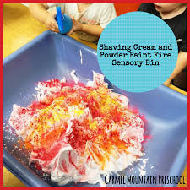
- Make a ‘pretend fire’ using shaving cream and powder paint on a tray or in a bowl . Children use small water guns or empty spray bottles, or syringes to spray onto the ‘fire’ to put it out.

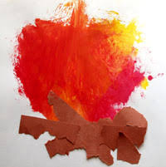
- Make a fire picture using paint or crayons. Reinforce the primary colours red and yellow. When they are mixed together they make orange. Use these colours to create a flame picture. Fetch some twigs from outside to stick on the bottom of your fire.

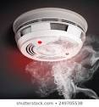
- Look at a real smoke alarm. What does it do? It smells the smoke in a house or building and keeps people safe. Show the children the sound that the smoke alarm makes and what to do when you hear it. If no smoke alarm watch https://www.youtube.com/watch?v=3y456Ysh2XQ Children to make their own smoke alarm using cardboard circles (paper plates) bottle tops or red dots, batteries (cut out shapes). Be as creative as you want. Once it is made you can use it when you sing the Smoke alarm song.

Smoke alarm (To the tune of I’m a little teapot)
I’m a little smoke alarm, beep, beep, beep(Squat down and point to self)
I will sniff for smoke when you are asleep (Wrinkle nose and sniff)
Push my little button and then you will hear (Touch nose with finger)
A sound that says I’m working all through the year (Jump up)

- Learn the Song ‘Fire’ to the tune of (pop goes the Weasel)
Fire is used by grown – ups,
It’s used to cook our food,
When it’s cold it makes us warm,
Fire is used by grown ups

But fire can mean there’s danger too,
It burns things up and might burn you
So listen carefully boys and girls,
Fire can hurt, it’s not a toy!

Can you sing the song and put actions to the words? Now teach it to your brother, sister or someone in your house.

- Watch the Moonlighters Film What can matches and lighters do? Remember not to touch matches and lighters. Why was Hoblock silly? Why was everyone cross with Hoblock? Would you be cross with Hoblock? What had Hoblock learned? Use toys to act out the story.
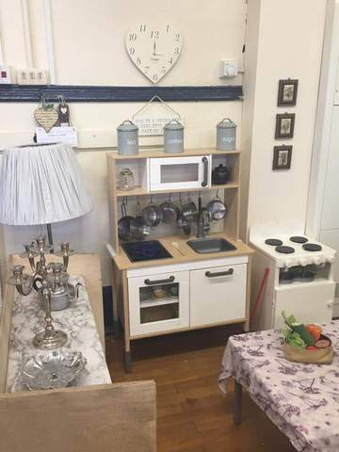
- Create a home corner to play in with a phone, kitchen, cooker, pots and pans. Play at being safe at home. Remember to walk through the kitchen and not run, to reduce accidents. Pretend there is a kitchen fire and the smoke alarm goes off. Practise pretending to ring 999 and learn your address! If you haven’t got a kitchen set, it doesn’t matter, just borrow some real pans and plates, but ask a grown up first!

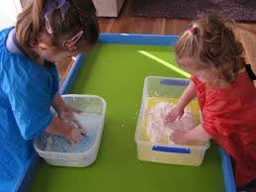
- Make cornflour and water gloop! Pour a cup or two of cornflour into a bowl, and gradually add water until you have a gloopy mixture. Let your child hold one of the spoons and help you "stir" as you go. Add a few drops of food colouring, if you're using it, and stir again. Create flames! Using cutlery draw flames in the gloop. Or add some cars, fire engines (if you have them and make them travel through the ‘gloop’ Can you see any patterns. Put an apron on if you have one or old clothes as this can get messy!

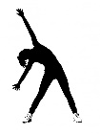
Let’s move: Every day, Joe Wicks has a 30 minute workout at 9 am. Join in via YouTube.

Family learning
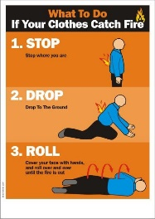
Reinforce fire safety as a family. Practise the ‘Stop, drop and roll’ techniques so that everyone knows what to do if your clothes ever caught fire. DO NOT run around. Cover your face with your hands, lie down and roll around until the fire is out.
- To the tune of Three Blind Mice Learn the song.
Stop, Drop, Roll,
Stop Drop, Roll,
Here’s what to do,
If this should happen to you,
If ever your clothes should catch alight,
Don’t you panic and run in fright,
Because you know that it wouldn’t be right,
You stop, Drop, Roll

