Learning Project Week 8 ‘Fire’.
Age Range Year EYFS
Weekly Maths Tasks – aim to do one per day | Weekly Reading Tasks – aim to do one per day
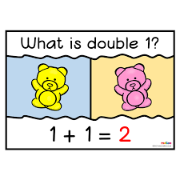  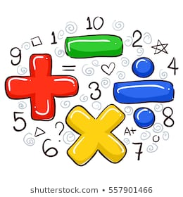  Try to do 10 minutes of arithmetic/ mental maths each day:  - Use sweets! You have 1. Double 1. What does that mean? It means twice as many. So if you double it you will have 2! Repeat with different numbers. Use 4 sweets. Put them in a line. Double the number by putting the same number alongside. How many have you got now? Play with different numbers of sweets, doubling them all the time.  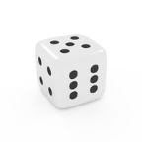  - Use a dice (if no dice use https://eslkidsgames.com/classroom-dice. Roll the dice. What is the number? Can you make the double of the number?  - Ask a grown up to hide some objects under a tea towel up to 5. Reveal the objects. Quickly count the number of objects and find the double of the numbers.  - Learn the doubles song. https://www.youtube.com/watch?v=Ik_-OAgzD-8  - Use empty plastic pots, bowls or pans. Put a number of pebbles, stones, pieces of pasta (etc) into one. Now put the double of the number into the other pot. E.g. 4 in one pot and 8 into another.  Pick one a day.  - Today you are going to be a human balance scale! Put an apple and a grape in each hand. Which is heavier and which is lighter? How do you know? Check using any scales if you have them. What does heavier mean? Repeat with different objects, using the words heavier and lighter. If you do not have an apple or a grape, anything will do!  - Use 2 buckets or carrier bags. Put objects into each one. Which is heavier and which is lighter? Can you feel the downward pull? Make a bucket or a bag heavy for the fireman to lift and one that is light for the fireman to lift. Grown-ups! Try and prove that big things are not always the heaviest!  - Use buckets or carrier bags again and a strong elastic band attached to the handles. Hold the elastic band and watch how far the elastic band stretches when a heavy object is put in and when a light object is put in. What do you notice? 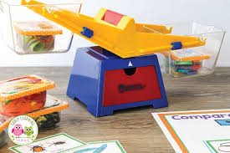  - Use different buckets, bags or boxes of different sizes with different weights inside them. Maximum 5. Can you put them in order from heaviest to lightest? Again, prove that the biggest one is not always the heaviest. Can you find the heaviest? The lightest? Which one is lighter than this one?  Lighter than The same weight as Heavier than  - Pick any object around the house. Children are to hunt around to find objects lighter, heavier and the same weight as the object. Record it in a table. Happy hunting! | 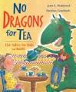  - Read ‘No dragons for tea’ Would your mum let a dragon come for tea? What happened when the dragon sneezed? What do you think you know what happened after the dragon sneezed? Can you hear the rhyming words? Why did they crawl out? Why can you not go back into a house in a fire? Can you spot the rhyming words? https://www.youtube.com/watch?v=ycBUMCIPYQE  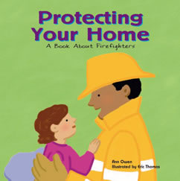  - Read ‘Protecting your home’ Can you list some of the jobs that firefighters do? What do they protect? Have you ever met a firefighter?https://readon.myon.co.uk/reader/index.html?a=uk_cw_phome_f03  - Reception children: Children to read  to parents daily. https://www.oxfordowl.co.uk/for-home/find-a-book/library-page/?view=image&query=&type=book&age_group=Age+4-5&level=&level_select=&book_type=&series=#  Visit Oxford Owl for free eBooks that link to your child’s book band. You can create a free account.  Complete the linked Play activities for each book.  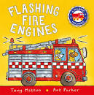  - Read a variety of books at home. Any favourites can be repeated. Include reading Flashing Fire Engines. What do firefighters wear? Why do firefighters wear masks? Are there any words you don’t know? What is a nozzle? What does sizzle mean? https://www.youtube.com/watch?v=4aO-QdtdlAE  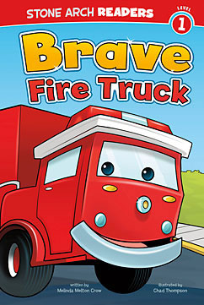  - Read the Brave Fire Truck’ Can you read lots of the words by yourself? Who is your favourite character in the story? Why? Look at the story words, friends, raced, fire, brave, job. Try and read them by yourself. Talk about a time when you have been brave.  https://readon.myon.co.uk/reader/index.html?a=sar_brfitr_f11  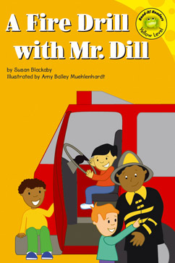  Read A Fire Drill with Mr Dill Try and read words in the text by yourself. Is it a fact or fiction book? Have you had a fire drill at school? What do you have to do? Where do you line up? https://readon.myon.co.uk/reader/index.html?a=uk_rr_fdril_f04  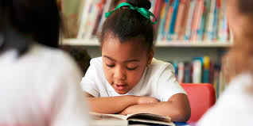
Weekly Phonics Tasks – aim to do one per day | Weekly Writing tasks – aim to do one per day
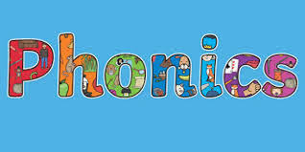  Daily phonics - your child to practise  their sounds and blend words.  Focus on the phoneme ‘era’ decide where does the phoneme come in a word? Find words with ‘er’ in and make a list.  Interactive games found on links below.  - Floppy’s Phonics Sounds and Letters  - Jolly Phonics  - Letterland Phonics  - Letters and Sounds (supplemented by closely matched and fully decodable books)  - Phonics Bug  - Read Write Inc.  - Sound Discovery  - Sounds-Write  https://www.bbc.co.uk/bitesize/topics/zvq9bdm Phase 3 or 4 phonics practise the sounds learning.  Recap on the reception key words. Start with ‘to, up, you, was, look, he, said.’ Practise reading them and writing them by yourself, spelling the words accurately. | Ask your child to  - Practise name writing. Put some writing of names and words using chalk.  - Practise handwriting forming letters in the zig zag family. Look at video at 4 minutes and 42 seconds. Write letters, v, w, x and z. https://www.theschoolrun.com/helping-your-child-learn-write  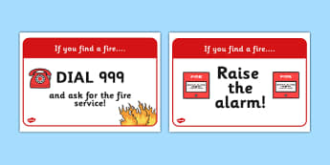  - Make a poster saying Dial 999 and ask for the fire station  - Make 2 lists of reasons why you would invite a dragon for tea and why you wouldn’t invite a dragon for tea.  - Write about a time when you were brave like in the story ‘Brave Fire Truck.’  - Fill in a Fire safety Incident form for when you have attended a call out (link to the role play or for the ‘No dragons for tea story.’ Include the Date, time, type of incident E.G. kitchen fire, location, how many firefighters attended, other emergency services required and sign the form. 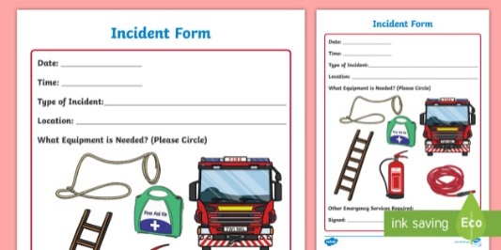
Learning Project to be done throughout the week
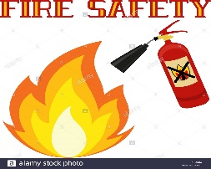
This is the second week of the project and aims to provide opportunities for your child to learn about fire safety.
- Play outside on a bike, toy car, scooter. Pretend it is a fire engine. Climb up steps. Jump through gaps in paving stones, pretending that you are getting to the fire. Crawl on your hands and knees, low to the ground, to try and not breathe in dangerous smoke. Chant the rhyme: Get down low and Go, Go, Go!

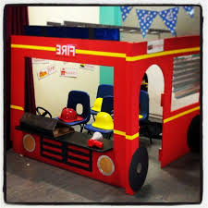
- Draw Chalk flames outside. Pretend you are a firefighter. Use spray bottles or a garden hose and wash the flames away!
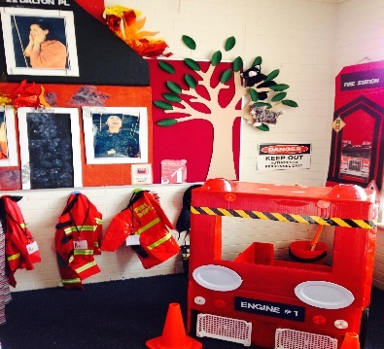
- Set up a fire station home corner. Make a large fire engine out of a large box or cardboard. Put in chairs and pretend hats, hoses ready to be a firefighter! Or create the station with a bed, phone and uniforms. Play at being firefighters. Grown ups can join in too! Have a notepad so that you can write the address of where you are going!

- Make your own Firefighter hat using a paper plate.
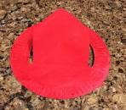
How to make your Firefighter Hat Craft:
- Paint the paper plate yellow.
- Cut the paper plate in a U shape
- Trim the edges so the cut part resembles a firefighter hat.
- Cut a small shield from red paper.
- Write a number on the shield with the black marker. You might want to put your name on too.
- Stick the shield on the hat

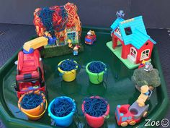
- Using toys you have at home create a town scene with cars, any houses (or make small boxes into houses- pretending is fun!) Have a fire engine and act out a fire scene. Use little people and wool (or any blue material) to put the fire out. Make up your own stories.

- Learn the song London’s Burning (or anywhere else e.g. Derby!)

London’s burning, London’s burning,
Call for engines, call for engines,
Fire, fire! Fire, fire!
Spray on water, spray on water,

Also learn:

Hurry, Hurry Drive the Fire Truck https://www.kididdles.com/lyrics/h027.html

Act out the songs and make up your own actions.

- Look at the two pictures of fire engines.
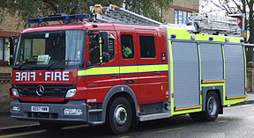
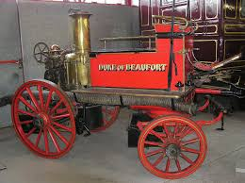
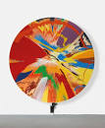
What is the same and different about them? Can you tell which one is old and which one is newer? Which fire engine do you think would be safer? Faster? Which would help people more? Why?
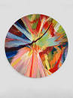
- Spin painting – Look at Damien Hirst Spin Art. Using red, yellow and orange paint create your own spin painting. Put blobs of paint onto a paper plate (or cardboard. Put it onto the paper and spin. Can you make a picture that reminds you of fire?

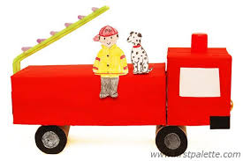
- Use recycled materials to design and make your own fire engine. Think about the wheels. What can you use to make them turn? Remember to put in doors and a window. Use pictures to help you and cut and stick carefully. Decorate your fire engine when it is finished.
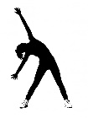
- Sit with a grown up and ask them to light a candle. Think about a happy time you had when there was a flame. It could be a birthday cake or a bonfire. What made you happy? What made you feel special and why. Ask a grown up about their happy thought. Blow out the candle.
Let’s move: Every day, Joe Wicks has a 30 minute workout at 9 am. Join in via YouTube.
Family learning
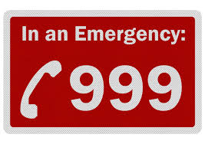
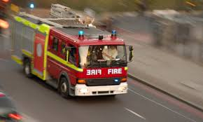
- Practise phoning the fire brigade if there was a fire. Prepare a script that would be used in an emergency and act it out with each other with one person being the operator and the other person reporting the fire. Remember your address!
Talk as a family about the different escape routes out of your home if there was a fire. What would you do? How would you exit if it was smoky?

