Learning Project Week 1 ‘Earth’
Age Range Year 1
Weekly Maths Tasks – aim to do one per day | Weekly Reading Tasks – aim to do one per day
- Complete any maths work set by your school.  Try to do 10 minutes of arithmetic/ mental maths each day:  - If you have 10 counters numbered 1-10, how many can you put into pairs that add to 10? Which ones do you have to leave out and why? Extend up to 20. Write numbers on pieces of paper.  - Put cubes or objects under a cloth up to 20. Start with a number. Remove some objects. Take some out. How many are left under the cloth?  https://nrich.maths.org/6927  - Play I’m 6. Find as many ways as possible to make the number 6 e.g. 10-4, 2+4, 2+2+2 etc. Children to think of as many ways as they can and write the ways down.  - White Rose Maths has daily maths lessons for you to work through:  https://whiterosemaths.com/homelearning/year-1/  Watch the video, pausing to do the activities when you are told. The BBC are providing free worksheets to support the White Rose Maths lessons. Access these here.  From May 4th, White Rose Maths are charging for their worksheets – your school may provide you with a code to access these – the BBC sheets are completely compatible with White Rose. | - Read ‘Growing a garden’. Are there any words that you can read and sound out. What sort of book is it? Fiction or non-fiction? What have you learnt from the book? What do plants need when they are growing?  https://readon.myon.co.uk/reader/index.html?a=gar_growg_s10  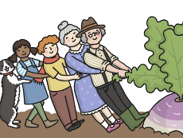  - Read the ‘Sunflower Garden’ to your child. Discuss hail and the damage that it can cause to plants. Why was Grandpa so upset? Talk about why the sunflower heads turn to face the sun. What does water do to the shell of the sunflower seed? What is a ‘bud’ of a sunflower? How tall can sunflowers grow? What damage did the hail do to Troy’s sunflowers? How many small flowers are there in a sunflower head? Read the glossary to understand the text. https://readon.myon.co.uk/reader/index.html?a=kr_ssunf_f07  - Listen to the story of the Enormous turnip  https://www.youtube.com/watch?v=mGw5yTOPTSQ. Can you hear any words that rhyme?  Act out the story of the enormous turnip with the family.  - Year 1 children: Children to read  to parents daily. https://home.oxfordowl.co.uk/reading/reading-age-5-6-year-1/  - Visit Oxford Owl for free eBooks that link to your child’s book band. You can create a free account.  Complete the linked Play activities for  each book.
Weekly Phonics Tasks – aim to do one per day | Weekly Writing tasks – aim to do one per day
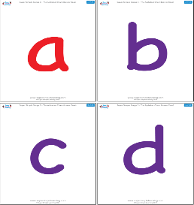  Daily phonics - your child to practise  their sounds and blend words set by the school.  Interactive games found on link below.  ● Phonics play  ● Top Marks  ● Spelling  https://www.phonicsbloom.com/uk/game/list/phonics-games-phase-5  - Phase 5 phonics practise the sounds learning.  - Read tricky words: oh, their, people, Mr, Mrs. Practise writing and spelling the words. | 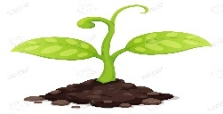  - Write a list of instructions of how you planted tomato seeds. e.g. First I cut open a tomato. Next I …. Use the Growing sunflowers activity on p31 of ‘Sunflower Garden’ to help you.  - Make a simple glossary for the tomato seed (use the glossary on p31 of ‘Sunflower garden’ to help you. Put the words in alphabetical order.  - Make a list of words that mean big e.g. huge, vast, enormous etc. Use a dictionary and thesaurus to help you.  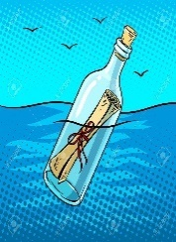  - Write a message in a bottle from Christopher Columbus stating where you are in the world and a postcard from space from Neil Armstrong.
Learning Project to be done throughout the week
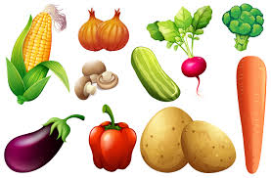
This project for the next two weeks aims to provide opportunities for your child to learn about earth. This week the focus is on plants and how they grow.

- Science: Look at the fruits and vegetables you have at home. Where are the seeds? Compare the size of the seeds. Grow a tomato plant. If you have a tomato at home, you can cut it open to find seeds. Plant the seeds in pots with some soil or compost. Cover with a polythene bag and place on a warm sunny windowsill. Keep them damp and warm (indoors). Track their progress as they grow. Once they are established (this will take a few weeks!) try putting one outside. Which plant grows quickest? Which looks strongest? Which one will produce fruit first? Which one will produce the largest tomato?

- Art & Design: Make salt dough and design and create a flower. E.g. a sunflower. Follow the link. https://www.google.com/search?rlz=1C1CHBF_en-GBGB842GB842&sxsrf=ALeKk027ilvCFPuO160BoDmMpcFloodVAA%3A1585570617402&ei=OeOBXouRGLyj1fAP1rOy4Ac&q=salt+dou Then paint the flower.
- History: compare two great explorers Christopher Columbus and Neil Armstrong. Discuss who the men were and what they discovered. https://www.youtube.com/watch?v=Kmwriy3a6sc

https://www.youtube.com/watch?v=kbHD1rVCORE&list=PL5EA9543C6D382958&index=26&t=0s. What country did they come from? What was the famous thing that Neil Armstrong said? How old was he when he died?

- Design and Technology: make a fruit salad. Adult supervision required. Practise using a knife to cut bite-sized pieces of fruit. Choose a variety of fruits and colours. Discuss seasonality of fruit choice: where does each fruit come from? What climate does it require?

- RE: It can be easy to be negative with the current situation Discuss finding things to be grateful for. Write a thank you prayer,

- PE: Every day, Joe Wicks has a 30 minute workout at 9 am. Join in via YouTube.
Family learning
- Plan and hold a party for the people you live with: make invitations, menus and table decorations, prepare the food, prepare games to play. Enjoy yourselves!
- PSHCE: Your child may have concerns about the current situation. Childline has lots of advice about how to discuss it with your child. https://www.childline.org.uk/info-advice/your-feelings/anxiety-stress-panic/worries-about-the-world/coronavirus/

