Learning Project Week 2 ‘Earth’
Age Range Year 1
Weekly Maths Tasks – aim to do one per day | Weekly Reading Tasks – aim to do one per day
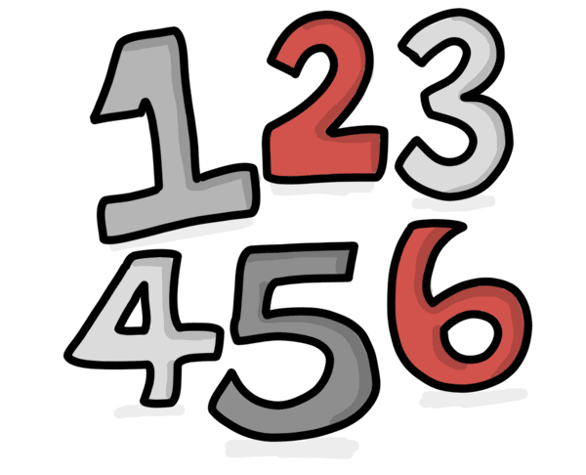  - Complete any maths work set by your school.  Try to do 10 minutes of arithmetic/ mental maths each day:  - A gardener saw 12 legs walk past his shed. How many creatures could he have seen? There were two spiders, two ants, a worm, two blackbirds, three ladybirds and a hedgehog in the garden. How many different answers can you find?  - Recap doubles using the doubles song. https://www.youtube.com/watch?v=8jOzhiACB68. Recap every day.  On Friday at 9 am, the magic plant was 2 cm tall. Every 24 hours it doubled it’s height. How tall was the plant on Monday at 9am?  - White Rose Maths has daily maths lessons for you to work through:  https://whiterosemaths.com/homelearning/year-1/  Watch the video, pausing to do the activities when you are told. The BBC are providing free worksheets to support the White Rose Maths lessons. Access these here.  From May 4th, White Rose Maths are charging for their worksheets – your school may provide you with a code to access these – the BBC sheets are completely compatible with White Rose. | 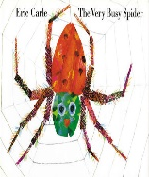  - Read the Very Busy Spider and share with your child. If no access to the book click on the link below.  https://www.youtube.com/watch?v=YnOIggDEW6k  - Year 1 children: Children to read  to parents daily. https://home.oxfordowl.co.uk/reading/reading-age-5-6-year-1/  - Visit Oxford Owl for free eBooks that link to your child’s book band. You can create a free account.  Complete the linked Play activities for  each book.  - Read ‘Animals in the garden’. https://readon.myon.co.uk/reader/index.html?a=gar_angar_s10  How many words can you read on your own using sounds to help ? Which animals are helpful in the garden and which are not? Why? Which animals named can fly? Which live below the ground?  - Read Garden Wigglers https://readon.myon.co.uk/reader/index.html?a=bb_earth_f05  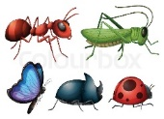  How do earthworms breathe? Do earthworms have eyes and a nose? How do they see and hear? What do earthworms eat? Why are earthworms helpful in the garden? How do they move? What animals eat worms?
Weekly Phonics Tasks – aim to do one per day | Weekly Writing tasks – aim to do one per day
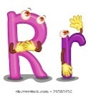  Daily phonics - your child to practise  their sounds and blend words set by the school.  Interactive games found on link below.  ● Phonics play  ● Top Marks  ● Spelling  https://www.phonicsbloom.com/uk/game/list/phonics-games-phase-5  - Phase 5 phonics practise the sounds learning.  - Read tricky words: looked, called, asked, water, where. Practise writing and spelling the words. | - Write sentences about worms, based on ‘Garden Wigglers. Say them aloud before writing.  - Write a shopping list for the ingredients that you need to bake a cake or biscuits with the family.  - Write instructions for how to bake a cake or biscuit that you have made as a family. Write the ingredients, the equipment and the instructions in order.  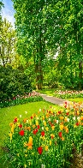  - Write a list of the flowers and trees that you found in your garden or on a walk.  - Draw and label a flower and a tree that you found on your walk or in the garden.
Learning Project to be done throughout the week
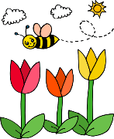
This is the second week of the project and aims to provide opportunities for your child to learn about earth. This week the focus is on minibeasts that are found in the garden and the different seasons of the year.

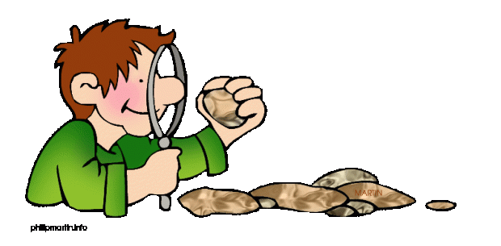
- Science: Go on a walk or look in the garden and name common flowers e.g. roses, daffodils that you see. Look at trees seen and name any that are deciduous (lose their leaves during the winter) and those that are evergreen. Talk together and identify leaves, blossom (if there is any), petals, fruit, roots, bulbs, seed, trunk, branches and stem of plants and trees.

- Music: Watch the video of the piece of music called ‘Weather’. Based upon Vivaldi’s four seasons. https://www.bbc.co.uk/teach/bring-the-noise/thunder-jam-weather/zk6pxyc Use kitchen equipment (pans, cutlery, pots to make instruments to make own spring and winter music. How is it different? Is some louder or quieter? Why?

- Geography: Identify and talk about the seasons. Which season are we in? Look outside. Can we see any signs of spring. What are they? Are there any insects? Where are they? https://www.bbc.co.uk/bitesize/topics/zkvv4wx/articles/zcx3gk7 complete the season quiz and put the seasons in order.

- Art: Look at Cezanne’s Basket of Apples picture. https://www.kid-facts.com/2015/06/the-basket-of-apples-cezanne.html Talk about what can be seen in the picture and how some of the objects look like they are titling e.g. the bottle. Explain how the picture is ‘still life’ because the fruit is not moving. Use fruit. Arrange it on a plate or in a bowl and create your own still life painting.

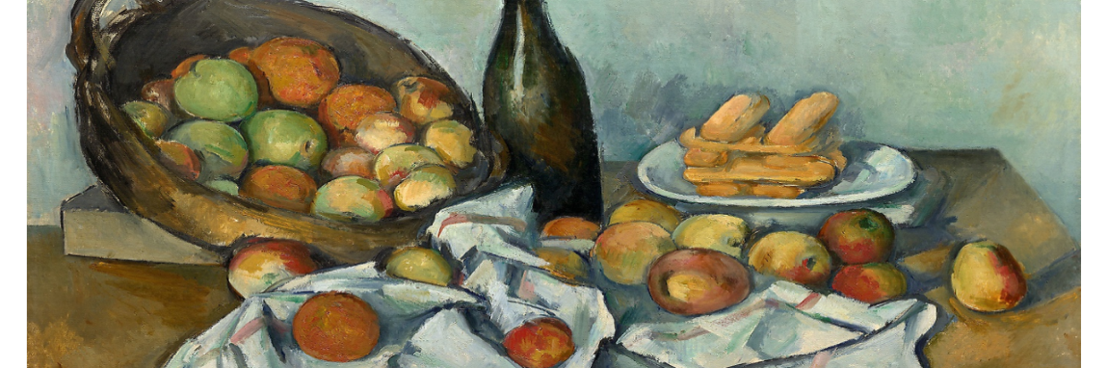

- Computing: complete the ‘What is an algorithm’ : https://www.bbc.co.uk/bitesize/topics/z3tbwmn/articles/z3whpv4. Explain to an adult what an algorithm is. Understand that the steps given need to be in the right order. Use Lego or building blocks or any kitchen equipment to make a model. Take a photo of each stage to recreate their model. Then show each photo to someone in the house to see if they can recreate the model. Were there any instructions (algorithms) missed out? What needs to be added?

- RE: Watch the link about how Christians believe God created the world. https://www.youtube.com/watch?v=_PBpCA2nxG8 Explain that Jewish, Muslim and Christian religions all believe that God created the world. There are slight differences in how they tell the story but it is mostly the same. In the bible it says the world is created in 7 days and in the Koran it claims that the world is created in 5 phases. Make a diary to retell the Christian story of creation in pictures and words.

- PE: Every day, Joe Wicks has a 30 minute workout at 9 am. Join in via YouTube

Family learning
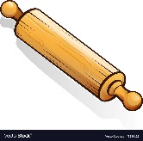
- Learn to use a new kitchen tool together e.g. whisk, rolling pin. Use to bake a cake or biscuits together and eat them!

