Learning Project Week 5 ‘Air’
Age Range Year 1
Weekly Maths Tasks – aim to do one per day | Weekly Reading Tasks – aim to do one per day
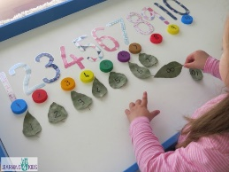  - Complete any maths work set by your school.  Try to do 10 minutes of arithmetic/ mental maths each day:  - Roll two dice. If you haven’t got two dice use https://www.virtualdiceroll.com/2/en/two-dice  Throw the dice 5 times. Add the dots and write down the answers. Now play with a grown up or brother or sister. Play 5 times each. Who gets the most dots each time?  - Roll two dice again. Subtract the smaller number from the bigger number. Record this in a number sentence.  - Captain Conjecture says, ‘If you add 0 to a number, the number stays the same.’ Do you agree? Explain your answer.  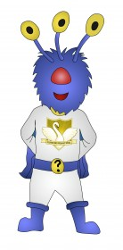  - Captain Conjecture says that ‘If you add six 0’s the answer is 6.’ Explain your answer.  - Use the first number sentence to complete the second number sentence.  4+3 = __  7 -__ = 4  7+__ = 9  9 - __ = 7  - White Rose Maths has daily maths lessons for you to work through:  https://whiterosemaths.com/homelearning/year-1/  Watch the video, pausing to do the activities when you are told. The BBC are providing free worksheets to support the White Rose Maths lessons. Access these here.  From May 4th, White Rose Maths are charging for their worksheets – your school may provide you with a code to access these – the BBC sheets are completely compatible with White Rose.  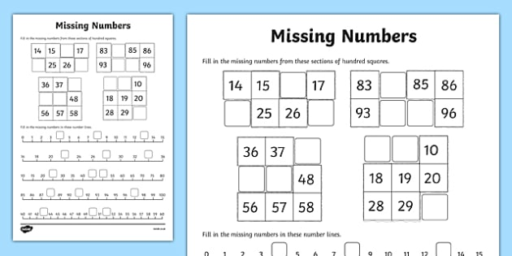 | 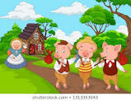  - Read The Three Little Pigs’ Follow the story. https://www.youtube.com/watch?v=jpEBv1GFte4&t=314s Join in where you can with’ Little Pig, Little pig, let me come in!’ and ‘I will huff and I’ll puff and I’ll blow your house down.’ Talk about the characters in the story. How did the third little pig keep tricking the wolf? Were the pigs right to choose their materials to build their houses?  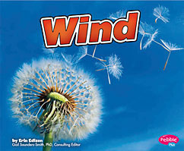  - Read ‘Wind’ https://readon.myon.co.uk/reader/index.html?a=wb_wind_f11 What have you learnt from this book about wind? Has this given you more knowledge about wind? Can you talk about different types of wind? Why do we need the wind?  - Read favourite books from home or ask a grown up to read to you. Are there any about wind?  https://home.oxfordowl.co.uk/reading/reading-age-5-6-year-1/  - Visit Oxford Owl for free eBooks that link to your child’s book band. You can create a free account.  Complete the linked Play activities for  each book.  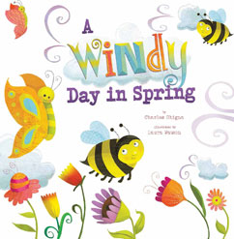  - Read ‘Windy days in Spring’ by yourself. https://readon.myon.co.uk/reader/index.html?a=sww_wind_s15 What does the warm wind do? Have you seen the wind doing any of these things? Can you find the words that rhyme? Where are they? (At the end of each sentence.)  Read the North Wind and the Sun by Aesop’s Fables. https://www.youtube.com/watch?v=uYCrXmvY5iA If no access to the book follow the link. What did the wind do to try and get the coat off the man? Why did it not work? What about the sun? Why was it a better action? Can you read any of the words in the text. What have you learnt from this story? Gentleness and kind persuasion win over threats and force.  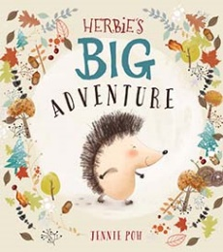  - Read Herbie’s Big Adventure What sort of book does this look like? Fact or fiction? What does the wind do to Herbie? How do you think he feels at different times through the story? Why? What Does Herbie find out about himself at the end of the story? https://readon.myon.co.uk/reader/index.html?a=fpb_herb_f16
Weekly Phonics Tasks – aim to do one per day | Weekly Writing tasks – aim to do one per day
Daily phonics - your child to practise  their sounds and blend words set by the school.  Interactive games found on link below.  - Floppy’s Phonics Sounds and Letters  - Jolly Phonics  - Letterland Phonics  - Letters and Sounds (supplemented by closely matched and fully decodable books)  - Phonics Bug  - Read Write Inc.  - Sound Discovery  - Sounds-Write  https://www.phonicsbloom.com/uk/game/list/phonics-games-phase-5  - Phase 5 phonics practise the sounds learning.  - Read tricky words:’ mouse, many, eyes, laughed, because’ Practise writing and spelling the words.  - Can you write any tricky words in sentences? How many can you write?  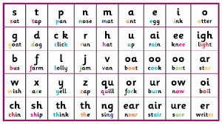 | - Look at your tomato seeds. Write how they are growing. Measure how tall they are, how many leaves they have and what they have needed to grow.  - Write your own Warm Wind…… poem following the style of the book ‘Windy Days in Spring.’ Can you think of your own ideas? Re-read the book to give you some help, talk to a grown up and look outside to see what is moving.  - From Aesop’s Fable ‘The sun and the wind’ create a story board to help re-tell the story. Re-tell the story to a grown up using different voices.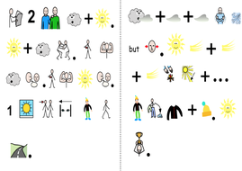  - Using the fable, change the characters in the story. Create another story map showing the new characters and the sequence of events based on the story of the sun and the wind for ideas.  - Write your own new version of the story following your new story map. Remember your full stops and capital letters.  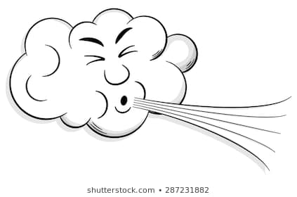
Learning Project to be done throughout the week
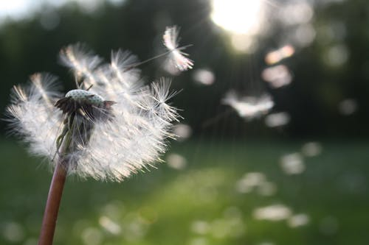
This project for the next two weeks aims to provide opportunities for your child to learn about wind and air. The focus for this week is wind.

- Geography: Watch the clip What is wind https://www.bbc.co.uk/programmes/p0113zqf Talk about the wind. Can we see it? When does the wind blow stronger? Go outside. What season are we in. What is the weather like today? Is it light air (number 1), a slight breeze (number 3) a strong breeze (number 6), a strong gale (number 9) or a hurricane (number 12). Record the wind using symbols that you choose. How are you going to make a strong breeze a different picture to a light breeze? Continue over the week. Is it sunny and windy? Or is it raining and windy? Every day you must say what number the wind is.
- Science: What happens when the wind blows really hard? Tress fall down, tiles come off roofs, etc) When is the wind useful? (wind turbines, blowing away rain clouds.) Why would some people need to know which direction the wind is blowing? (Pilots flying planes, sailors in boats.) Explain that wind direction can be measured using windsocks. Go outside. Can you feel the wind? What would it be like today if it was really windy? Would it be more enjoyable? Could we fly kites? Draw the direction of the wind outside with chalk and the time. Check the wind direction three times over the day. Morning, afternoon and tea-time. Does it change?
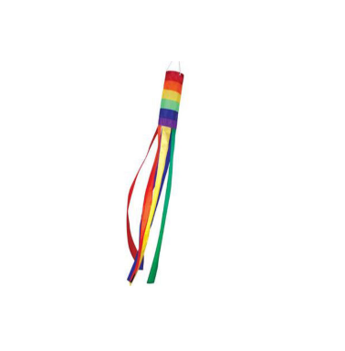
- Design and technology: Design and make your own windsock that you can put in the garden to tell the direction that the wind is blowing. Watch the clip Windsocks https://www.youtube.com/watch?v=EFBXRkKD2tI See what materials you can find e.g. fabric, toilet roll, paper. Design what you windsock will look like and make it. Think about how you are going to attach it and where you are going to put it. Take a picture of it when it is made and outside to send to your teacher. For some ideas you may wish to watch this or just make up your own! https://www.youtube.com/watch?v=0eQekeMktG8
- History: In 1987 there were terrible winds in the South East of England. Look at some of the photographs and talk about what you can see.
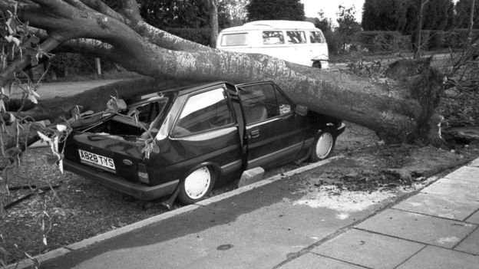
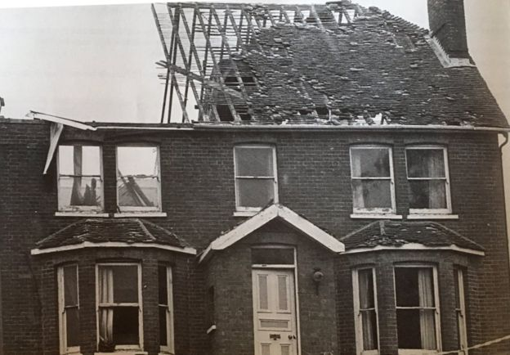

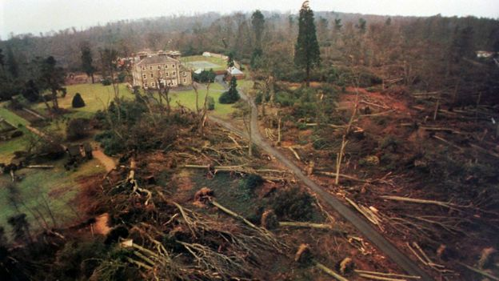
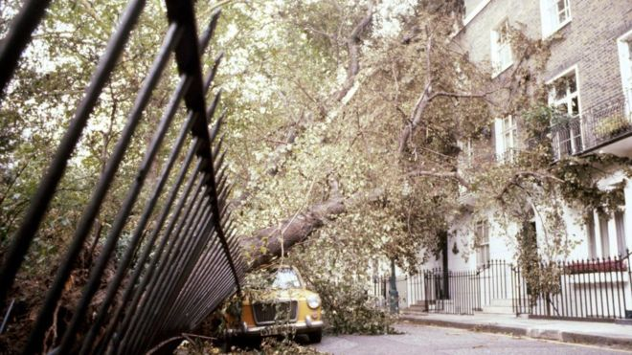

- This storm happened on the night of October 15th, 1987 into the early hours of October 16th. It was the worst storm in nearly 300 years. 22 people lost their lives in just 3 hours. Talk to a grown up. Does anyone remember the storm? Can you remember any storms where the wind caused damage? Pretend you an editor for the newspaper and you have to write a headline for The Great Storm, what would it be?

- Music: Listen to the music ‘Wind’ by Sylvain Guinet. https://www.youtube.com/watch?v=12DsNQlMTS8. Can you hear the tempo of the music when it goes fast and slow? Why is that? Does it remind you of the wind? What sort of wind? Is it more of a breeze or a gale? What would the tempo of the music be like if it was a hurricane? Why? Can you find any other pieces of music that remind you of the wind? What are they called and who was the composer? (The person who wrote the music.)

- RE: How should we care for others and the world and why is this important? How can we keep the world special? Muslims believe that we should look after the world for God the creator. Draw a picture of how you take care of our world.
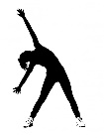
- PE: Every day, Joe Wicks has a 30 minute workout at 9 am. Join in via YouTube.
Family learning
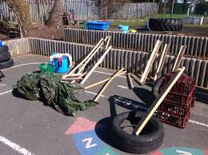
- Use different materials that you can find at home to create a structure that will keep a teddy bear safe in the wind. What are the best shapes? How tall is it going to be? What is the best material? Test your structure with a hairdryer! Can your structure stay up for longer than 2 minutes in the wind?

