Learning Project Week 1 ‘Earth’
Age Range Year 2
Weekly Maths Tasks – aim to do one per day | Weekly Reading Tasks – aim to do one per day
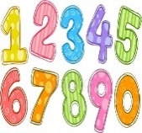  - Complete any maths work set by your school.  Try to do 10 minutes of arithmetic/ mental maths each day:  - In the garden there were some ants and blackbirds. Altogether there were 8 heads and 24 feet. How many blackbirds were there? Repeat with ants. Challenge – how many legs would there be if there were 10 ants?  - Each of you draw an addition grid like this:  Take turns to throw the dice with a brother, sister or parent, until it has been thrown four times in total. After you have collected all four numbers, each player must decide where to place them on his/her own grid.  Whoever has the sum closer to 100 wins.  - Play I’m 8. Find as many ways as possible to make the number 6 e.g. 10-2, 2+6, 2+2+2+2. 2x4 etc. Children to think of as many ways as they can and write the ways down.  - White Rose Maths has daily maths lessons for you to work through:  https://whiterosemaths.com/homelearning/year-2/  Watch the video, pausing to do the activities when you are told. The BBC are providing free worksheets to support the White Rose Maths lessons. Access these here.  From May 4th, White Rose Maths are charging for their worksheets – your school may provide you with a code to access these – the BBC sheets are completely compatible with White Rose. | - Year 2 children: Children to read  to parents daily. https://www.oxfordowl.co.uk/for-home/find-a-book/library-page/?view=image&query=&type=book&age_group=Age+6-7&level=&level_select=&book_type=&series=#  Visit Oxford Owl for free eBooks that link to your child’s book band. You can create a free account.  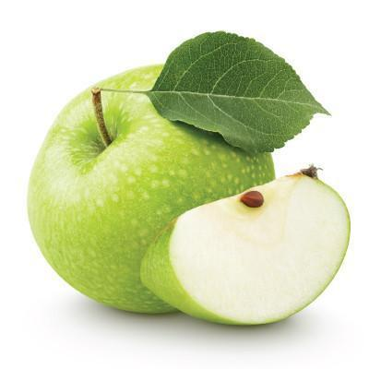  - Read ‘From Seed to Apple Tree’. Are there any words that you can read and sound out? Are there any words that you do not understand? Make a note and find the meaning. What sort of book is it? Fiction or non-fiction? What have you learnt from the book? What do apple seeds need when they are growing? https://readon.myon.co.uk/reader/index.html?a=as_apple_s09  - Read ‘Apples, Apples everywhere!’ https://readon.myon.co.uk/reader/index.html?a=uk_aut_apple_f10 What new information have you learnt about apples? How would you fee if you found a worm in your apple? Discuss apple bobbing. Play a game with your family. How hard is it to pick up an apple?  - Listen to ‘One Green Apple’ https://www.youtube.com/watch?v=WlK0FYn1aQk  Discuss how Farah feels at the beginning of the story and how she feels on the way home. How did Anna and Jim help Farah? Why is she happier at the end of the story?
Weekly Phonics Tasks – aim to do one per day | Weekly Writing tasks – aim to do one per day
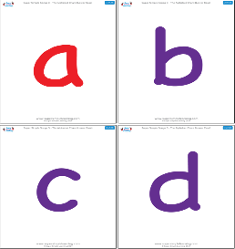  Daily phonics - your child to practise any sounds and blend words set by the school.  - Phase 6 phonics practise suffix endings of ed and ing  https://www.bbc.co.uk/bitesize/topics/z8mxrwx/articles/zwgbcwx recap on what a suffix is. Complete the quiz.  - Write 4 sentences by adding ed, ing to words.  - Practise words to read and spell from the Year 2 common exception word list.  - after  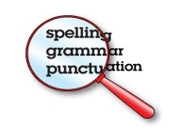  - again  - any  - bath  - beautiful  - because  - Write each word in a sentence. | 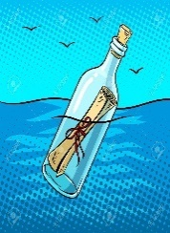  Write a message in a bottle from Christopher Columbus stating the journey and the islands discovered.  - Write an information sheet about Neil Armstrong and Christopher Columbus stating who they were, where they went, what they found and brought back, how they travelled.  - Keep a diary about planting the tomato seeds. Record where each seed is placed. Diary to be updated every week.  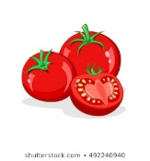  - Write instructions of how to play the apple bobbing game. Use subordinating (when, if, that, because) and co-ordinating conjunctions. (or, and, but) within the sentences.
Learning Project to be done throughout the week
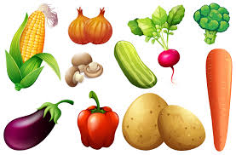
This project for the next two weeks aims to provide opportunities for your child to learn about earth. This week the focus is on plants and how they grow.

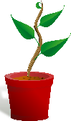
- Science: Look at the fruits and vegetables you have at home. Where are the seeds? Compare the size of the seeds. Grow some tomato plants. If you have a tomato at home, you can cut it open to find seeds. Plant the seeds in different ways:
- in a pot with some soil or compost. Water. Cover with a polythene bag and place on a warm sunny windowsill.
- In a pot with no soil or compost. Water. Cover with a polythene bag and place on a warm sunny windowsill.
- In a pot with some soil or compost. Water. Cover with a polythene bag and place in a dark cupboard eg airing cupboard.
- in a pot with some soil or compost. NO water. Cover with a polythene bag and place on a warm sunny windowsill.

Keep them damp (apart from d) and warm (indoors). Track their progress as they grow. Once they are established (this will take a few weeks!) try putting one outside. Which plant grows quickest? Which looks strongest? Which one will produce fruit first? Which one will produce the largest tomato? Why have some grown and some haven’t. What has the tomato needed to grow into a healthy plant?

- Art & Design: Make salt dough and design and create a flower. E.g. a sunflower. Follow the link. https://www.google.com/search?rlz=1C1CHBF_en-GBGB842GB842&sxsrf=ALeKk027ilvCFPuO160BoDmMpcFloodVAA%3A1585570617402&ei=OeOBXouRGLyj1fAP1rOy4Ac&q=salt+dou Then paint the flower.
- History: compare two great explorers Christopher Columbus and Neil Armstrong. Discuss who the men were and what they discovered. https://www.youtube.com/watch?v=Kmwriy3a6sc

https://www.youtube.com/watch?v=kbHD1rVCORE&list=PL5EA9543C6D382958&index=26&t=0s. What country did they come from? What was the famous thing that Neil Armstrong said? How old was he when he died? Research facts about the two men to create a comparison sheet in one of your writing tasks.

- Design and Technology: make a fruit salad. Adult supervision required. Practise using a knife to cut bite-sized pieces of fruit. Choose a variety of fruits and colours. Discuss seasonality of fruit choice: where does each fruit come from? What climate does it require? Which fruits are the healthiest? Do you know which ones contain more natural sugar?

- RE: It can be easy to be negative with the current situation Discuss finding things to be grateful for. Write a thank you prayer.

- PE: Every day, Joe Wicks has a 30 minute workout at 9 am. Join in via YouTube

Family learning
- Plan and hold a party for the people you live with: make invitations, menus and table decorations, prepare the food, prepare games to play. Enjoy yourselves!
- PSHCE: Your child may have concerns about the current situation. Childline has lots of advice about how to discuss it with your child. https://www.childline.org.uk/info-advice/your-feelings/anxiety-stress-panic/worries-about-the-world/coronavirus/

