Learning Project week 2 ‘Earth’
Age Range Year 2
Weekly Maths Tasks – aim to do one per day | Weekly Reading Tasks – aim to do one per day
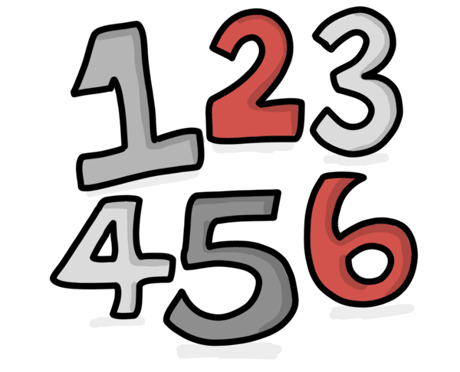  - Complete any maths work set by your school.  Try to do 10 minutes of arithmetic/ mental maths each day:  - Recap on odd and even numbers. https://www.bbc.co.uk/bitesize/topics/zknsgk7/articles/zt4jj6f Complete the quiz. Listen to the odd and even song. https://www.youtube.com/watch?v=zL9VIyziYko  - Complete the Always sometimes or Never problem about odd and even numbers. https://nrich.maths.org/12670  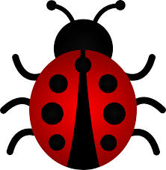  - A gardener saw 24 legs walk past his shed. How many creatures could he have seen? There were three spiders, four ants, a worm, two blackbirds, three ladybirds, a ladybird and a hedgehog in the garden. How many different answers can you find?  White Rose Maths has daily maths lessons for you to work through:  - https://whiterosemaths.com/homelearning/year-2/  Watch the video, pausing to do the activities when you are told. The BBC are providing free worksheets to support the White Rose Maths lessons. Access these here.  From May 4th, White Rose Maths are charging for their worksheets – your school may provide you with a code to access these – the BBC sheets are completely compatible with White Rose. | - Year 2 children: Children to read  to parents daily. https://www.oxfordowl.co.uk/for-home/find-a-book/library-page/?view=image&query=&type=book&age_group=Age+6-7&level=&level_select=&book_type=&series=#  Visit Oxford Owl for free eBooks that link to your child’s book band. You can create a free account.  - Read from caterpillar to 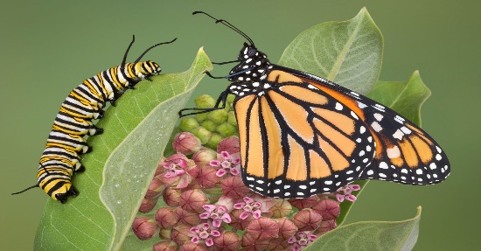butterfly: https://readon.myon.co.uk/reader/index.html?a=as_butte_f08  Recap on the life cycle of a butterfly. How many eggs do butterfly’s lay and where do they lay them? What might make a caterpillar take a long time to grow? What happens to the caterpillar’s skin when it grows? What happens inside a pupa? Can a butterfly fly straight away when it comes out of its shell?  - Read Tiny Workers https://readon.myon.co.uk/reader/index.html?a=bb_tworkers_f03 Where do ant’s build their homes? How do they eat? What is the job of the queen ant? What do worker ants do? Why are ants good for plants?  - Listen to the story Ant and the Grasshopper by Aesop Fable. What is a fable?  https://www.youtube.com/watch?v=_svBrlehmMo  What does the story teach you?  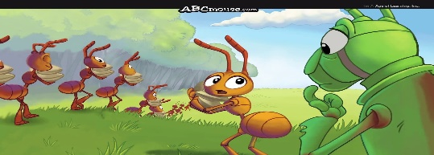
Weekly Phonics Tasks – aim to do one per day | Weekly Writing tasks – aim to do one per day
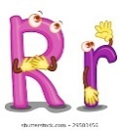  Daily phonics - your child to practise any sounds and blend words set by the school.  - Recap and discuss what a suffix is. recap on what a suffix is. Write 4 sentences by adding ‘er & ful’ to words that you choose. Look at how the meaning of the words are changed.  - https://www.phonicsbloom.com/uk/game/suffix-factory-set-1?phase=6 Play suffix factory (set 1) to practise the skills learnt.  - Practise words to read and spell from the Year 2 common exception word list.  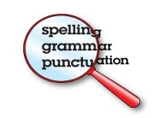  - behind  - both  - break  - busy  - child  - children  - Write each word in a sentence. | 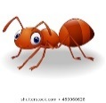  - Write 5 key facts about ants use the book Tiny Workers as a stimulus.  - Write an information leaflet about a Monarch butterfly. Write in full sentences using full stops and capital letters to describe how it turns from an egg to a butterfly.  - Explain what a fable is and write down the meaning.  - Write two fascinating facts that you have learnt about 2 different minibeasts and what they need to survive.  - Write instructions for how to bake a cake or biscuit that you have made as a family. Write the ingredients, the equipment and the instructions in order.  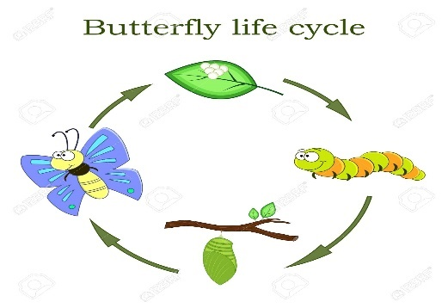
Learning Project to be done throughout the week
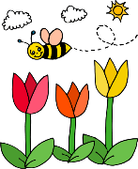
This is the second week of the project and aims to provide opportunities for your child to learn about earth. This week the focus is on minibeasts that are found in the garden and the different seasons of the year.

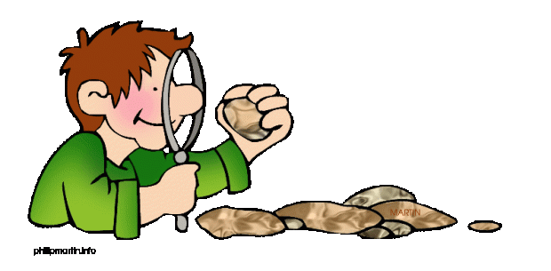
- Science: Go on a walk or look in the garden and look to see if you can find any habitats of minibeasts. Look under stones, plant pots. What do you find. Make a list of where you find the insects and what their habitat is like, e.g. dark, damp, open, sunny etc. Read https://www.theschoolrun.com/homework-help/minibeasts
Complete the activities.

- Music: Watch the video of the piece of music called ‘Weather’. Based upon Vivaldi’s four seasons. https://www.bbc.co.uk/teach/bring-the-noise/thunder-jam-weather/zk6pxyc Use kitchen equipment (pans, cutlery, pots to make instruments to make own spring and winter music. How is it different? Is some louder or quieter? Why?

- Geography: Identify and talk about the seasons. Which season are we in? Look outside. Can we see any signs of spring? What are they? Are there any insects? Where are they? https://www.bbc.co.uk/bitesize/topics/zkvv4wx/articles/zcx3gk7 complete the season quiz and put the seasons in order. Draw a diagram explaining the seasons and the weather patterns relating to each one. Read Seasons of the Year for support. https://readon.myon.co.uk/reader/index.html?a=mtime_ssnsy_s11

- Art: Look at Cezanne’s Basket of Apples picture. https://www.kid-facts.com/2015/06/the-basket-of-apples-cezanne.html Talk about what can be seen in the picture and how some of the objects look like they are titling e.g. the bottle. Explain how the picture is ‘still life’ because the fruit is not moving. Use fruit. Arrange it on a plate or in a bowl and create your own still life painting.

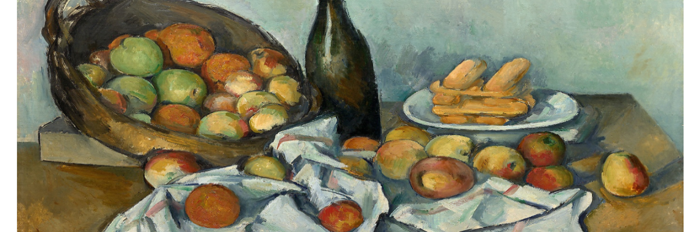

- Computing: complete the ‘What is an algorithm’ : https://www.bbc.co.uk/bitesize/topics/z3tbwmn/articles/z3whpv4. Explain to an adult what an algorithm is. Understand that the steps given need to be in the right order. Use Lego or building blocks or any kitchen equipment to make a model. Take a photo of each stage to recreate their model. Then show each photo to someone in the house to see if they can recreate the model. Were there any instructions (algorithms) missed out? What needs to be added?

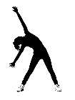
- RE: Watch the link about how Christians believe God created the world. https://www.youtube.com/watch?v=_PBpCA2nxG8 Explain that Jewish, Muslim and Christian religions all believe that God created the world. There are slight differences in how they tell the story but it is mostly the same. In the bible it says the world is created in 7 days and in the Koran it claims that the world is created in 5 phases. Make a diary to retell the Christian story of creation in pictures and words.

- PE: Every day, Joe Wicks has a 30 minute workout at 9 am. Join in via YouTube.
Family learning
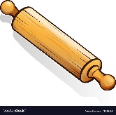
- Learn to use a new kitchen tool together e.g. whisk, rolling pin. Use to bake a cake or biscuits together and eat them!

