Learning Project Week 3 ‘Water’
Age Range Year 2
Weekly Maths Tasks – aim to do one per day | Weekly Reading Tasks – aim to do one per day
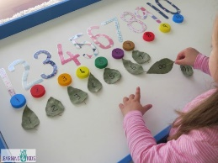  - Complete any maths work set by your school.  Try to do 10 minutes of arithmetic/ mental maths each day:  - Put a circle around the larger number. 50 or 48. 77 or 81. 78 or 87. Explain your answers.  - Write all the 2-digit numbers greater than 40 using these digits. 2,4,6,6.  How do you know you have them all? Prove it.  - Write the missing numbers.  - In the number 47, there are __ groups of 10 and __ ones.  - The number that is ten groups of 10 is ___.  - The number 75 shows __ in the tens place, and __ in the ones place.  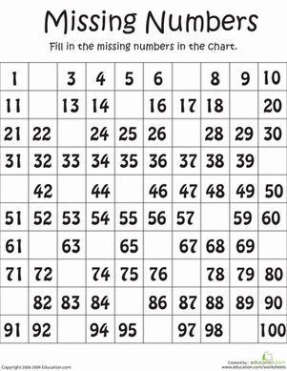  - Here is part of a number square.  What is the largest number on the whole square?  1 2 3 4 5 6  7 8 9 10 11 12  13 14 15 16  19 20 21  25 26  31 32  - When I count in tens from any number, the unit digit stays the same.  Do you agree?  Explain your reasoning.  - White Rose Maths has daily maths lessons for you to work through:  https://whiterosemaths.com/homelearning/year-2/  Watch the video, pausing to do the activities when you are told. The BBC are providing free worksheets to support the White Rose Maths lessons. Access these here.  From May 4th, White Rose Maths are charging for their worksheets – your school may provide you with a code to access these – the BBC sheets are completely compatible with White Rose. | 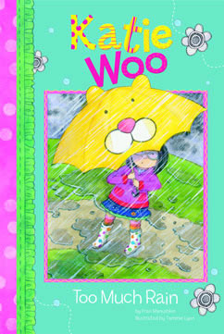  - Read ‘Katie Woo- Too much rain.’  https://readon.myon.co.uk/reader/index.html?a=kw_tomura_f09 Read a chapter every day. The flooding was scary for Katie Woo. Have you ever been scared by bad weather? What happened? Why was the photo album so important to Katie’s family? It felt strange for Katie’s family to sleep at the gym. Have you ever slept somewhere that felt strange? How do you think Katie Woo felt when she arrived back at her house?  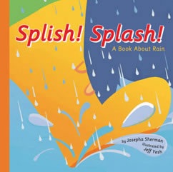  - Read ‘Splish Splash’ https://readon.myon.co.uk/reader/index.html?a=we_ssplash_f03 How does rain fall? Why do we need rain? What do you use rain for? When can rain be dangerous? What happens if there is not enough rain? Look up any saying about rain on the ‘other pages’ section of the book. Read ‘Will it rain soon?’ DO you know the sayings or any others? Read the glossary and check your understanding of the words. Were there any other new words? If so, look them up.  - Read favourite books from home or ask a grown up to read to you. Are there any about water?  - https://www.oxfordowl.co.uk/for-home/find-a-book/library-page/?view=image&query=&type=book&age_group=Age+6-7&level=&level_select=&book_type=&series=#Visit Oxford Owl for free eBooks that link to your child’s book band. You can create a free account.  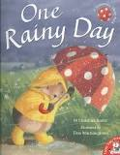  - Listen and follow the words to the story ‘One rainy day.’ Read the story along with the narrator. https://www.youtube.com/watch?v=RmLA8fdbscw How did hedgehog look after his friends? What things did hedgehog do to show that he is a kind animal? Are there any words that you didn’t understand? What do the words ‘twisting and twirling on the swirling waters’ make you think about how the water moves?  - Listen to the Bible Story Noah’s Ark https://www.youtube.com/watch?v=_vjjhMWJ2wE Use the link if there is no access to a bible. Why was Noah shocked by God’s words? Why was Noah chosen to build an ark? Did Noah know what an ark was? Can you explain what an ark is? What did God promise at the end? Why is the rainbow important?  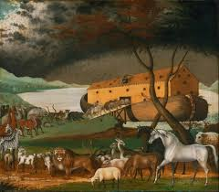
Weekly Phonics Tasks – aim to do one per day | Weekly Writing tasks – aim to do one per day
Daily phonics - your child to practise  any sounds and blend words set by the school.  - Recap and discuss what a suffix is. recap on what a suffix is. Write 4 sentences by adding ‘en’ ‘ly’ to words that you choose. Look at how the meaning of the words are changed.  - https://www.phonicsbloom.com/uk/game/suffix-factory-set-2?phase=6 Play suffix factory (set 2) to practise the skills learnt.  - Practise words to read and spell from the Year 2 common exception word list.  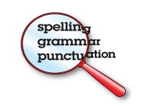  - beautiful  - Christmas  - class  - climb  - clothes  - Write each word in a sentence.  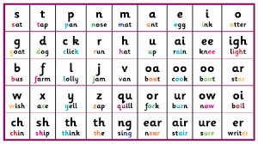 | 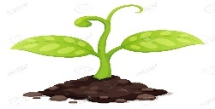  - Look at your tomato seeds. Write how they are growing. Measure how tall they are, how many leaves they have and what they have needed to grow. Explain the changes clearly and read back your sentences to check that they make sense.  - Write a list of five words that describe a rainstorm. Use the’ Katie Woo – Too much rain’ book to help you. Look the words up in a dictionary and find out their meaning.  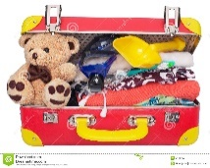  - From Katie Woo – Too much rain, Katie packed her bear, clothes, and some things for her cat. What would you pack if you needed to suddenly leave home? Make a list of objects and say why you would take them.  - From the book ‘One Rainy day’ Hedgehog was very helpful to his friends. Write sentences that are statements showing how you have been helpful whilst you have been at home. Think about how you have helped the grown ups in your house, your brothers or sisters, pets, grandparents etc. Try using ‘when, if, that or because’ in your sentences.  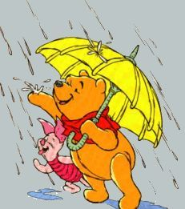  - Write a list of the properties that materials need to be waterproof. Find some things around your house that are waterproof and explain what it is that makes the water not soak through.  - Within the shape of a rainbow in each colour write sentences about your hopes for different people e.g. Hope for myself…, Hope for my family….., Hope for my friends……., Hope for my world etc.
Learning Project to be done throughout the week
This project for the next two weeks aims to provide opportunities for your child to learn about water. The focus for this week is rain.

- Science: Winne the Pooh needs a new umbrella as it has a hole in it. He looks around at home and can find a plastic bag, kitchen roll, some material, some cardboard and some tin foil. Which do you think will be waterproof and why? Write your thoughts down saying which you think will be waterproof and which you think will not be waterproof. Test the materials fairly with 10 drops of water each over a container. Which one was waterproof? Which one let water through and would make Winne the Pooh wet? Children to record their observations and findings saying why a material is waterproof.

- Art & Design: Use the 3 primary colours, red, blue and yellow. Mix red and blue together. Then red and yellow. Then blue and yellow. What new colours have you made? These are called secondary colours. Using the new secondary and the primary colours, can you paint a rainbow? What other colour do you need? How do you make it? Experiment and see if you can do it.
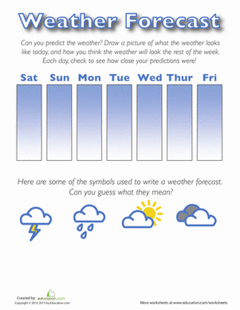

Geography: Find out the five-day weather forecast and what the predictions are. Record the weather for the next week. Create a weather chart over the week, showing the day, the date and the weather. Compare to London. What is the weather forecast predicted to be. Record what the weather is like in London.

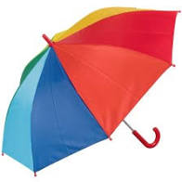
- Music: Listen to 2 minute pieces of Handel’s water music. Listen to the piece at 4 minutes and at 38 minutes. How are the two pieces different? What instruments can you hear in the two pieces of music. Can you hear the music becoming louder and quieter? How does it make you feel? Draw two pictures for each piece of music. https://www.youtube.com/watch?v=mAyiidg25uE

- Design and Technology: Using your knowledge from the science experiment, design and make a waterproof umbrella for a small toy to keep it dry. Design first, (by drawing) what you want it to look like. Then make your umbrella thinking carefully about cutting, joining, shaping and finishing. Make sure that it is strong enough to stay up and not be floppy! Evaluate by talking with a grown up to say whether it is as you wanted it to look. Take a photo and send it to your teacher!

- PSHE: How to wash your hands. Listen to the song ‘Wash my Hands’ YouTube 3 mins 20 secs https://www.youtube.com/watch?v=dDHJW4r3elE&vl=en Why is it important to wash hands? Are there any other times that you need to wash your hands. How do we wash hands properly? Put water in a bowl with some pepper. Put a finger (or hand in) the pepper acts like germs. Put soap into the bowl. What happens to the germs? Wash hands properly to get rid of the germs (pepper) off hands. Does anything else work to help wash the germs off? Does washing up liquid work? What about bubble bath?

- RE: The story about Noah is famous. It is a very old story, over 3000 years old ! You can find it in the bible. The story of Noah is about hope. Here are twelve things people hope for:
Health | peace | kindness | Love
Family | safety | pets | friends
fun | Food | holidays | fairness
Colour in the 7 boxes that have the most important things people hope for inside of them. Choose a good colour for each of your 7 words from the rainbow. EG red for love and blue for peace. Why did you leave some words out? Discuss with a grown up.
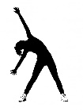
- PE: Every day, Joe Wicks has a 30 minute workout at 9 am. Join in via YouTube.
Family learning
- Design and build a shelter out of just newspaper and sticky tape. Make sure it is big enough to fit in everyone who lives with you. Think about what shapes you will need to construct to make it strong. CHALLENGE: can you make it waterproof?
This Photo by Unknown Author is licensed under CC BY-NC

- Lie on the ground and look for shapes in the clouds. Talk about the shapes you see. How does it make you feel? Do this as a family.

