Learning Project Week 4 ‘Water’
Age Range Year 2
Weekly Maths Tasks – aim to do one per day | Weekly Reading Tasks – aim to do one per day
- 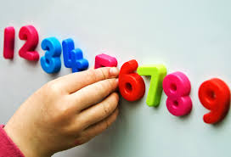Complete any maths work set by your school.  Try to do 10 minutes of arithmetic/ mental maths each day:  - Steve says, ‘My number has two tens and five ones.’ What is Steve’s number? Amy has two more tens than Steve. What is her number? Sam says, ‘My number has five tens.’ What numbers can it be? What numbers can’t it be?  - Think of an even number that is more than 30 and less than 50. And another. Can you find them all? How many are there? Explain your reasoning.  - Amy thinks of a number. Her number: is an even number is between 20 and 25 has two different digits. What is her number? Explain your reasoning.  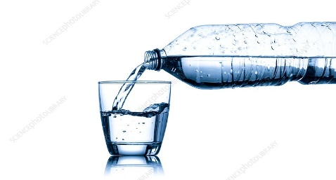  - A 1 litre bottle of water is full. A 2 litre bottle is half full. What is the same and what is different about both bottles?  - Use < > and = signs to make these number sentences correct.  3 tens __30 ones  2 tens __9 ones  4 tens __33 ones  3 tens and 2 ones__2 tens and 12 ones  4 tens and 3 ones __4 tens and 11 ones.  - White Rose Maths has daily maths lessons for you to work through: https://whiterosemaths.com/homelearning/year-2/  Watch the video, pausing to do the activities when you are told. The BBC are providing free worksheets to support the White Rose Maths lessons. Access these here.  From May 4th, White Rose Maths are charging for their worksheets – your school may provide you with a code to access these – the BBC sheets are completely compatible with White Rose. | - Listen to the story ‘The Journey Children’s Refugee Story’ https://www.youtube.com/watch?v=N4WyzqLXtqcTalk about what scared the children and made them sad. Talk about hope (refer to last week) and think about the hope that the children had. Discuss the feelings of the mum in the story. Was she really brave? When did she show that she wasn’t?  - Year 2 children: Children to read  to parents daily. https://www.oxfordowl.co.uk/for-home/find-a-book/library-page/?view=image&query=&type=book&age_group=Age+6-7&level=&level_select=&book_type=&series=#  - Visit Oxford Owl for free eBooks that link to your child’s book band. You can create a free account.  - Read ‘Brilliant boats’. 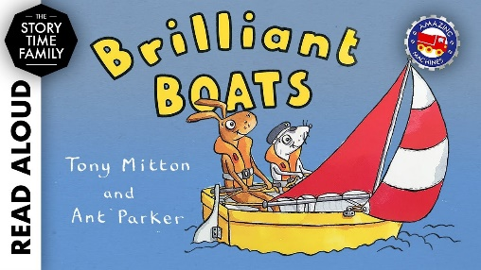https://www.youtube.com/watch?v=KK7Au1u-_xg  Do you think this will be a fact or fiction book? Why? What do you notice about the writing on each page? Which words rhyme? What do you learn about boats? What keeps a boat still on the water? What helps to make the boats move? Why do you have to wear a life jacket? What are other facts you have learned? Tell a grown up.  - Read ‘Big Boats’ https://readon.myon.co.uk/reader/index.html?a=big_boats_s10  What are the biggest boats that sail on the sea? Have you seen and read about boats that you haven’t heard of before? How many words can you read on a page? What does the word ‘glide’ mean? Explain the word ‘dive’. Are there other words that you do not understand? Look them up to find the meaning. Can you find any other books about boats? How do they compare to this one?  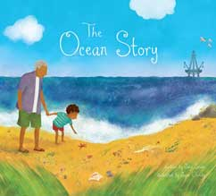  - Read ‘The Ocean Story’ https://readon.myon.co.uk/reader/index.html?a=pb_ocestor_s11 What have you learned about the ocean? Can you name some of the creatures who live in the ocean? How do dolphins communicate? What do we need to do to protect our oceans and creatures who live in it? Who causes the problems in the oceans? Relate this back to the earth learning about the creation. Why are we part of the ocean story?
Weekly Phonics Tasks – aim to do one per day | Weekly Writing tasks – aim to do one per day
Daily phonics - your child to practise  their sounds and blend words set by the school.  - Recap and discuss what a suffix is. recap on what a suffix is. Write 4 sentences by adding ‘ment’’ness’ to words that you choose. Look at how the meaning of the words are changed.  - Which are real words and which are not?  - laziment or laziness  - kindness or kindment  - quietness or quietment  - happiment or happiness  - disappointment or disappointness  - refreshness or refreshment  - Write each correct word in a sentence.  - Practise words to read and spell from the Year 2 common exception word list.  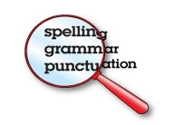  - cold  - could  - door  - even  - every  - Write each word in a sentence. | - Look at your tomato plants. Write how they are growing. What have you had to do to them now? Are they ready to plant in the garden? Measure the height again and record any changes. Add as much detail as possible by using descriptive language and add ‘or, and, but’ to your sentences to make them longer.  - Write a postcard to your grandparents, auntie or special friend. Linked to your geography work on oceans and continents, tell them what you are doing, who you are with and what you want to see. Try and write one sentence with a question mark and another with an exclamation mark.  - Write about two things that scare you on a monster shape. Show them to a grown up and talk about the scary things. Then screw up the monster and throw it away to get rid of the scary thoughts!  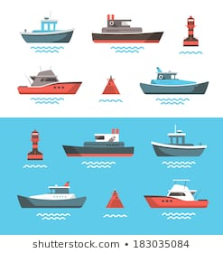  - Write a glossary about boats. Use some ideas from Brilliant boats and Big boats e.g. anchor and say what the objects are. Give an example for each word .e.g. In a sentence. The anchor is dropped from the boat to stop it from moving.  - Write a poem about a boat. Think about how you can make the poem rhyme like in Brilliant boats. When you have written your poem, read it aloud and ask a grown up to video it.
Learning Project to be done throughout the week
This is the second week of the project and aims to provide opportunities for your child to learn about water.
- Science: Recap knowledge on floating and sinking. Watch the video. https://www.youtube.com/watch?v=nwbIraFDjjU Use different materials crisp bag, foil, sponge, playdough, jelly, lolly pop sticks and fabric material. Sort all the objects into those that will float and sink. Test the materials. Using the objects that float, use your knowledge to sort into waterproof and not waterproof. Test the objects. Look around the home for other objects that you think will be suitable for making a boat and test their waterproof properties. Also test to see if the materials can be changed by stretching, squashing, bending or twisting. Decide which one you will use to make your boat! Show what you have found out in a table. E.g.
Material | Floats (Yes or No) | Waterproof (Yes or No) | Can the shape of the material be changed? E.g. squashed or bent?
Crisp bag
Foil
sponge
Jelly
Add other ideas of your own. At least 2.

- DT: Your job is to build a boat that will carry a small toy across the bath! It has to stay above the water. No sinking is allowed! Draw the design of your boat and label the materials. Use your materials and decorate it how you like. Make any changes that you need to make it float even better. Take a photo to prove that it works and send it to your teacher.

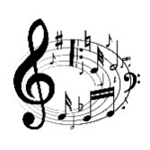
- Music: Listen to 2 minute pieces of Handel’s water music. Listen to the piece at 4 minutes and at 38 minutes. How are the two pieces different? What instruments can you hear in the two pieces of music. Can you hear the music becoming louder and quieter? How does it make you feel? Draw two pictures for each piece of music. Write a sentence for each picture saying how the different pieces make you feel.

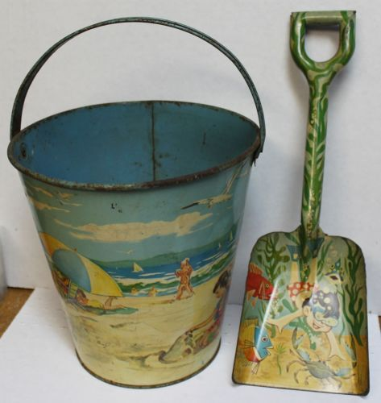
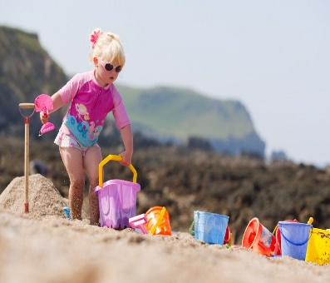
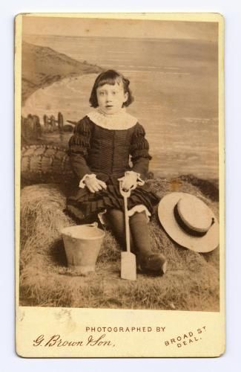
- History: Have you been to the seaside? If you wanted to dig in sand, what do you use? What are buckets and spades made of today? Look at the pictures above and say what is the difference in how people dressed for the seaside in the past and now. In the past buckets and spades were made from metal. Would that have made them heavy when filled with water and sand? What happens to metal when it mixes with salt water? Find out! https://www.tes.com/teaching-resource/ks1-seaside-holidays-in-the-past-powerpoint-6096493 click on the preview to see the PowerPoint.
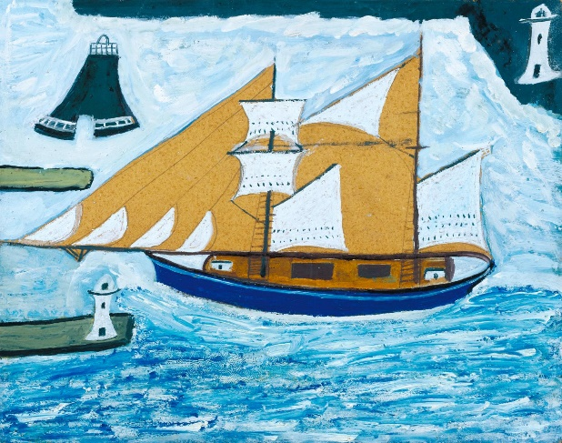
- Art: Look at Alfred Wallace’s ’ picture of the Blue Ship, St Ives. Is this a picture of a modern ship? What colours have been used. How do the colours make you feel? Which combinations of colours go well together? Use paint and use the colour blue. Add a tiny bit of white. What shade of blue have you got now? Repeat by adding a tiny drop of white, five times. Each time how the blue is getting lighter. Do the same with blue, adding a tiny bit of black. See how the blue gets gradually darker. Create a picture with your shades of light and dark blue.

- Geography: There are 7 continents and 5 oceans in our world. Can you look at the picture below and name them? Remember that the world is round and you are going to go on a journey in your boat. Tell me the route that you are going to take, past which continents and through which oceans. Can you name any countries that you are going past? Try and find the United Kingdom. DO not miss any oceans out!

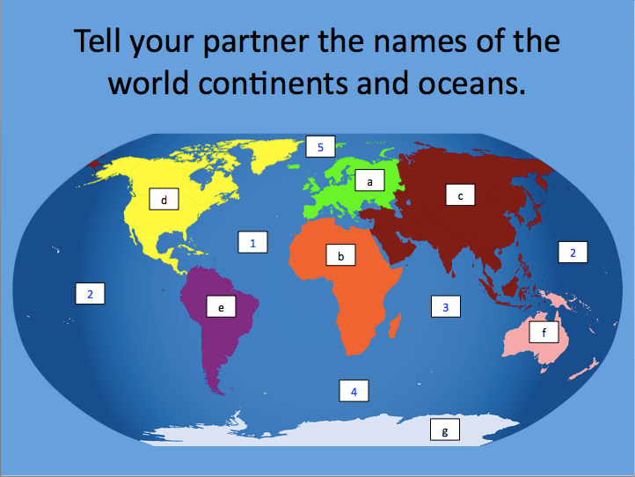

- Computing: complete the ‘What is code’ https://www.bbc.co.uk/bitesize/topics/z3tbwmn/articles/zykx6sg Explain to an adult what an computer code is. Understand that computer code is a set of rules or instructions. It is made up of words and numbers and when you put them in the right order it will tell your computer what you want to do. Watch the video on the site. Work with a grown up. Give them a set of instructions to pick up your favourite toy from your bed. E.g. Start at the door. Walk forward ten. Walk to the right 5. Bend forward. Pick up the toy. You then have to give instructions (clearly) for them to put it away where you want it. Your grown up then gives you instructions. Repeat with different instructions taking turns to make and follow. Keep it simple!
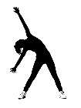
- PE: Every day, Joe Wicks has a 30 minute workout at 9 am. Join in via YouTube
Family learning
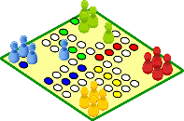
- Design, make and play a board game with the whole family. You could base it on a water adventure if you like or something completely different!
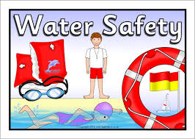
- Talk about water safety. What must you do near water? Talk about the four key water safety messages.

- Always swim in a safe place.
- Always swim with an adult.
- If you fall in, float, breathe, relax.
- If someone else in trouble, call 999

