Learning Project Week 5 ‘Air’
Age Range Year 2
Weekly Maths Tasks – aim to do one per day | Weekly Reading Tasks – aim to do one per day
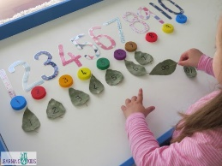  - Complete any maths work set by your school.  Try to do 10 minutes of arithmetic/ mental maths each day:  - Roll two dice. If you haven’t got a dice use https://www.virtualdiceroll.com/2/en/two-dice  Can you make a bigger/smaller total?  What is the highest total you could make?  What is the lowest total you could make?  If one dice shows 6, what could the other dice be showing?  How will you know when you've found all the totals? Prove it.  - Use two dice again. Find the difference between two numbers. Record your answers in number sentences. Prove that you have all the combinations.  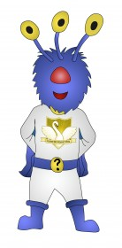  - Captain Conjecture says, ‘When I count in tens from any number the units digit stays the same.’ Do you agree? Explain your reasoning.  - Captain Conjecture says, ‘An odd number+ an odd number + an odd number = an even number.’ Is this sometimes, always or never true?  Explain your reasoning.  - Fill in the missing numbers and explain what you notice.  23+ __ = 30  43 + __ = 50  33 - __ = 30  53 – 3 = __  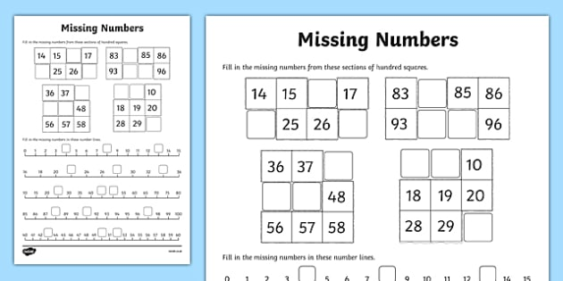  - White Rose Maths has daily maths lessons for you to work through:  https://whiterosemaths.com/homelearning/year-2/  Watch the video, pausing to do the activities when you are told. The BBC are providing free worksheets to support the White Rose Maths lessons. Access these here.  From May 4th, White Rose Maths are charging for their worksheets – your school may provide you with a code to access these – the BBC sheets are completely compatible with White Rose. | 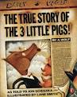  - Read The True Story of the 3 Little Pigs’ Follow the story. How does this story compare to the traditional tale about the Three Little Pigs? Do you believe the wolf? What is the wolf doing wrong when he is cooking? How should he sneeze and cough? https://www.youtube.com/watch?v=pFPjf9cz830  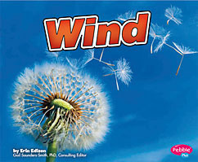  - Read ‘Wind’ https://readon.myon.co.uk/reader/index.html?a=wb_wind_f11 What have you learnt from this book about wind? Has this given you more knowledge about wind? Can you talk about different types of wind? Why do we need the wind?  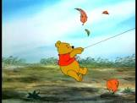  - Read favourite books from home or ask a grown up to read to you. Are there any about the wind? Try ‘Winnie the Pooh and the Blustery Day’ Read along with the book. What does blustery mean? What happened to Piglet? What problems did Pooh and Piglet cause? Was Owl pleased to see Pooh and Piglet? How do you know? Was Pooh scared? How do you know? https://www.youtube.com/watch?v=p60buJnFUuI  https://www.oxfordowl.co.uk/for-home/find-a-book/library-page/?view=image&query=&type=book&age_group=Age+6-7&level=&level_select=&book_type=&series=#Visit Oxford Owl for free eBooks that link to your child’s book band. You can create a free account.  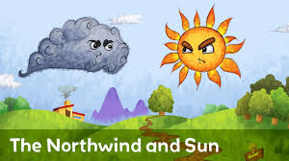  Read the North Wind and the Sun by Aesop’s Fables. https://www.youtube.com/watch?v=uYCrXmvY5iA If no access to the book follow the link. What did the wind do to try and get the coat off the man? Why did it not work? What about the sun? Why was it a better action? Can you read any of the words in the text. What have you learnt from this story? Gentleness and kind persuasion win over threats and force.  - Read The Wind by Robert Louis Stevenson  I saw you toss the kites on high  And blow the birds about the sky;  And all around I heard you pass,  Like ladies' skirts across the grass--  O wind, a-blowing all day long,  O wind, that sings so loud a song!  I saw the different things you did,  But always you yourself you hid.  I felt you push, I heard you call,  I could not see yourself at all--  O wind, a-blowing all day long,  O wind, that sings so loud a song!  O you that are so strong and cold,  O blower, are you young or old?  Are you a beast of field and tree,  Or just a stronger child than me?  O wind, a-blowing all day long,  O wind, that sings so loud a song!  What does the speaker compare the sound of the wind to? Can the speaker see the wind? What word did the poet use to describe that he couldn’t be seen? What does the author do at the end of each verse? Why does he do that?
Weekly Phonics Tasks – aim to do one per day | Weekly Writing tasks – aim to do one per day
Daily phonics - your child to practise  any sounds and blend words set by the school.  - Recap and discuss what a plural is. The rule is that most words add an ‘s’ e.g. ship to ships.  - Words ending in a hissing, buzzing or shushing sound add ‘es’ e.g. fish to fishes  Which ending will you add to these words? ball, cross, glass, cup, cake, dress, book, phone, dish, fuzz.  - Practise words to read and spell from the Year 2 common exception word list.  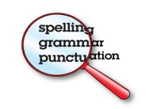  - everybody  - father  - find  - floor  - gold  - grass  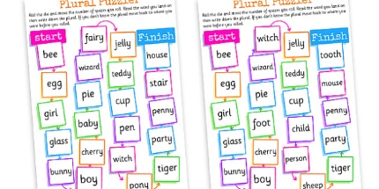  Write each word in a sentence. | 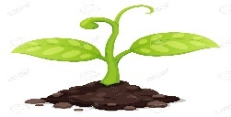  - Look at your tomato seeds. Write how they are growing. Measure how tall they are, how many leaves they have and what they have needed to grow. Explain the changes clearly and read back your sentences to check that they make sense.  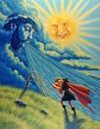  - Using the fable, The Sun and the Wind, change the characters in the story. Create another story map showing the new characters and the sequence of events based on the story of the sun and the wind for ideas.  - Write your own new version of the story following your new story map. Remember your full stops and capital letters.  - Write a different story for the Three Little Pigs? Can you make the Three Pigs the ‘bad’ characters in the story? Plan your story first. Try and ensure you have commands in your story e.g. Little Pig, Little Pig let me in!  - Children used to be told that, if they pulled silly faces, the wind would change and their faces would stay like that forever. Why is that a funny thing to say? Why do you think people told children that? Did they really believe it? Can you imagine what the world would be like if our faces stayed in the same position every time the wind changed direction? What if the wind also 'froze' our bodies? Our arms and legs? Or animals? Write a story about the day the wind froze your face and body. What happened? How did it end?
Learning Project to be done throughout the week
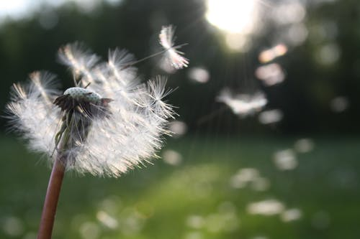
This project for the next two weeks aims to provide opportunities for your child to learn about wind and air. The focus for this week is wind.

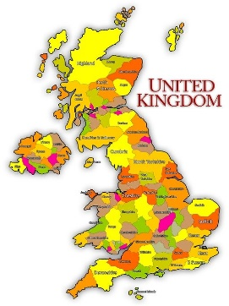
- Geography: Watch the clip What is wind? https://www.bbc.co.uk/programmes/p0113zqf Talk about the wind. Can we see it? When does the wind blow stronger? Go outside. What season are we in. What is the weather like today? Is it light air (number 1), a slight breeze (number 3) a strong breeze (number 6), a strong gale (number 9) or a hurricane (number 12). Look on a map. Find London and the Shetland and Orkney islands. Where is it windier and why? Write an explanation about the differences in the wind in these places.

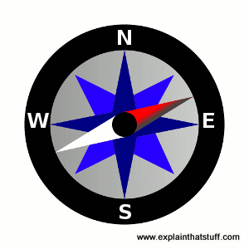
- Science: What happens when the wind blows really hard? Tress fall down, tiles come off roofs, etc) When is the wind useful? (wind turbines, blowing away rain clouds.) Why would some people need to know which direction the wind is blowing? (Pilots flying planes, sailors in boats.) Wind direction can be measured using windsocks. Go outside. Can you feel the wind? What would it be like today if it was really windy? Would it be more enjoyable? Could we fly kites? Draw the direction of the wind outside with chalk saying which compass direction it is (North, South, east or West) and the time. Check the wind direction three times over the day. Morning, afternoon and tea-time. Does it change?

- Design and Technology: Design and make your own windsock that you can put in the garden to tell the direction that the wind is blowing. Watch the clip Windsocks https://www.youtube.com/watch?v=EFBXRkKD2tI See what materials you can find e.g. fabric, toilet roll, paper. Design what your windsock will look like and make it. Think about how you are going to attach it and where you are going to put it. Take a picture of it when it is made and outside to send to your teacher. For some ideas you may wish to watch this or just make up your own! https://www.youtube.com/watch?v=0eQekeMktG8

- History: In 1987 there were terrible winds in the South East of England. Look at some of the photographs and talk about what you can see.
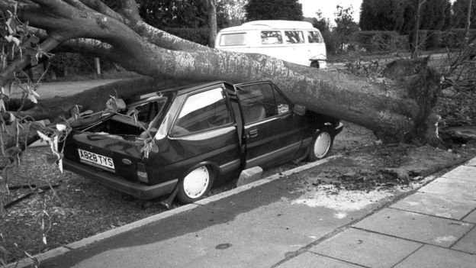
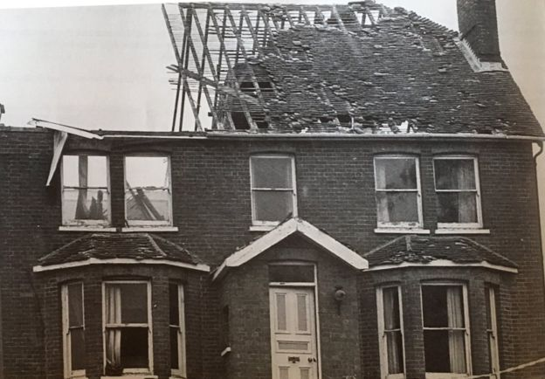
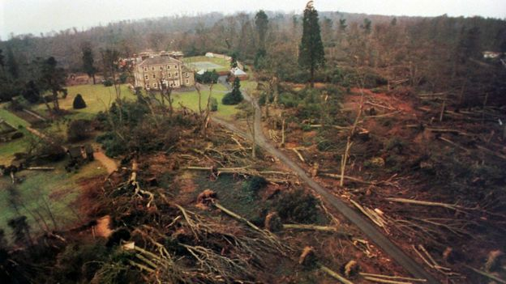
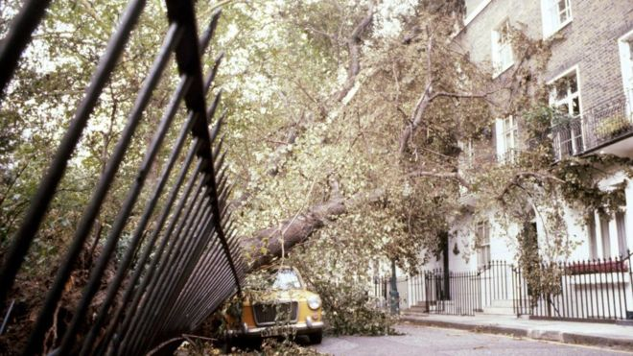

- This storm happened on the night of October 15th 1987 into the early hours of October 16th. It was the worst storm in nearly 300 years. 22 people lost their lives in just 3 hours. Talk to a grown up. Does anyone remember the storm? Can you remember any storms where the wind caused damage? Pretend you are an editor for the newspaper and you have to write a headline for each picture from The Great Storm, what would they be?

- Music: Listen to the music ‘Wind’ by Sylvain Guinet. https://www.youtube.com/watch?v=12DsNQlMTS8. Can you hear the tempo of the music when it goes fast and slow? Why is that? Does it remind you of the wind? What sort of wind? Is it more of a breeze or a gale? What would the tempo of the music be like if it was a hurricane? Why? Can you find any other pieces of music that remind you of the wind? What are they called and who were the composers? (The person who wrote the music.)
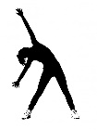
- RE: How should we care for others and the world and why is this important? How can we keep the world special? Muslims believe that we should look after the world for God the creator. Draw a picture of how you take care of our world.
- PE: Every day, Joe Wicks has a 30 minute workout at 9 am. Join in via YouTube.
Family learning
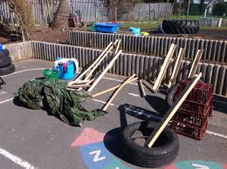
- Use different materials that you can find at home to create a structure that will keep a teddy bear safe in the wind. What are the best shapes? How tall is it going to be? What is the best material? Test your structure with a hairdryer! Can your structure stay up for longer than 2 minutes in the wind?

