Learning Project Week 7 ‘Fire’
Age Range Year 2
Weekly Maths Tasks – aim to do one per day | Weekly Reading Tasks – aim to do one per day
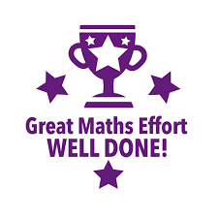  - Complete any maths work set by your school.  Try to do 10 minutes of arithmetic/ mental maths each day:  - Cut a square piece of paper as shown. Rearrange the pieces to make different shapes. What different shapes can you make?  Describe the properties of the shapes you make.  Can you make some shapes which have at least one line of symmetry?  - Captain Conjecture says, ‘All of these shapes are rectangles because they have four sides.’  A  B  C  Do you agree?  Explain your reasoning.  - Fill in the missing shape to complete the pattern.  Explain your reasoning  - Complete:  Half of 12 is ___  2/4 of 12 is ___  1/4 of 20 = ___  3/4 of 20 = ___  - 20 children are in a class and a quarter are girls. How many are boys? Show your working out.  - White Rose Maths has daily maths lessons for you to work through:  https://whiterosemaths.com/homelearning/year-2/  Watch the video, pausing to do the activities when you are told. The BBC are providing free worksheets to support the White Rose Maths lessons. Access these here.  From May 4th, White Rose Maths are charging for their worksheets – your school may provide you with a code to access these – the BBC sheets are completely compatible with White Rose. | 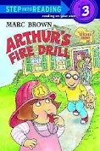  - Read ‘Arthur’s Fire Drill’ https://www.youtube.com/watch?v=rzbj0jYzRr8Follow the story. How does DW feel about Fire? Why is she scared about going to school? How did Arthur make DW feel better. Why did DW think there was a fire at the school? Did she change her mind about fires by the end of the story? Why?  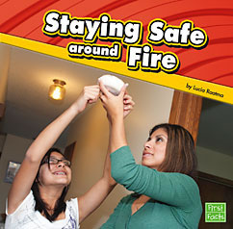  - Read ‘Staying Safe around Fire.’ What must you do if a fire happens? What is the number to ring if you find a fire? In the book it says 9-1-1- but that is in America. What number do we ring in the United Kingdom? https://readon.myon.co.uk/reader/index.html?a=ss_fire_f11What have you learnt from this book about fire?  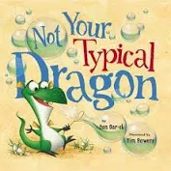  - Read favourite books from home or ask a grown up to read to you. Are there any about the fire? Try ‘Not your typical dragon’ https://www.youtube.com/watch?v=3j1KS7rXyjUListen to the story about Crispin. What did he breathe instead of fire? How did Crispin feel about not being able to breathe fire? Was the coach cross with Crispin? What word was used ? Why did Crispin run away? How do you know that Sir George would not give up? Why was Sir George pleased that Crispin couldn’t breathe fire? How did Crispin become a hero?  https://www.oxfordowl.co.uk/for-home/find-a-book/library-page/?view=image&query=&type=book&age_group=Age+6-7&level=&level_select=&book_type=&series=#Visit Oxford Owl for free eBooks that link to your child’s book band. You can create a free account.  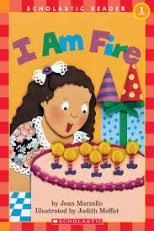  - Read I am Fire https://www.youtube.com/watch?v=EvmN99Zzmsw Read along with the book. Are there any new words in the book? What does harmful mean? Why can you not touch fire? What are the good things that fire does?  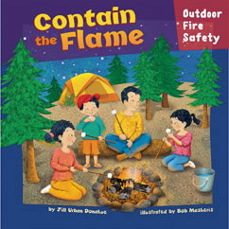  - Read Contain the Flame. How have the family made sure that the camp fire is safe? What could have happened if the whole family went to look for sticks? Why did dad put out the fire when there was a strong gust of wind? What did the wind do to the fire? What could have happened? https://readon.myon.co.uk/reader/index.html?a=htb_fire_f08
Weekly Phonics Tasks – aim to do one per day | Weekly Writing tasks – aim to do one per day
Daily phonics - your child to practise any sounds and blend words set by the school.  - Recap and discuss what a plural is. The rule is change ‘y to an i, and add es’  - Second rule is ‘if the word ends in a vowel +y add s to the word’  Which ending will you add to these words? Bay, baby, key, tray, city, fly, puppy, day.  - Practise words to read and spell from the Year 2 common exception word list.  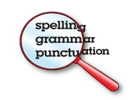  - kind,  - last,  - many,  - money,  - most,  - old  Write each word in a sentence.  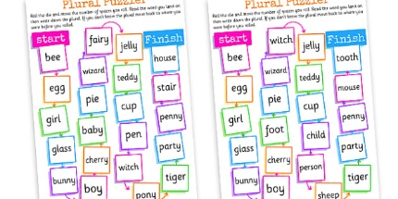 | 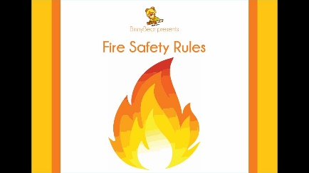  - Write your own Fire safety rules of what you would do if you found a fire, just like in Arthur’s story. Talk them through with people who live in your home. Put them up so that everyone knows what to do in a fire.  From the story, Not your typical Dragon,’ make a list of other things that Crispin could breathe and how Sir George and his father react. E.g. breathes marshmallows and they eat them!  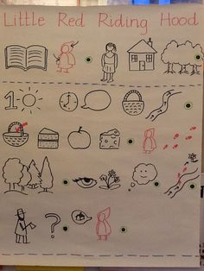  - Create a story map of Sir George and Crispin going on an adventure. Why are they going? Where are they going? What happens when they get there? (the problem) How is the problem solved? Talk your Story map through with your family.  - Write your story of Sir George and Crispin’s adventure. Remember to use full stops, capital letters, and an exclamation mark. Try and use some interesting descriptive words.  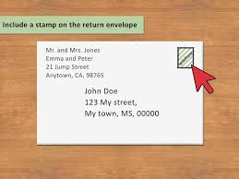  - Practise writing your address including the postcode. Learn it off by heart.
Learning Project to be done throughout the week
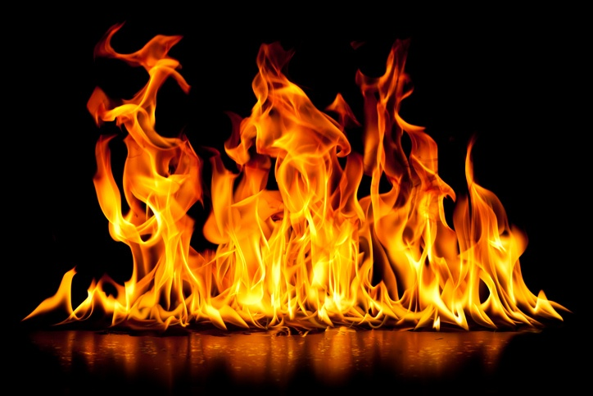
This project for the next two weeks aims to provide opportunities for your child to learn about fire. The focus for this week is the dangers of fire.
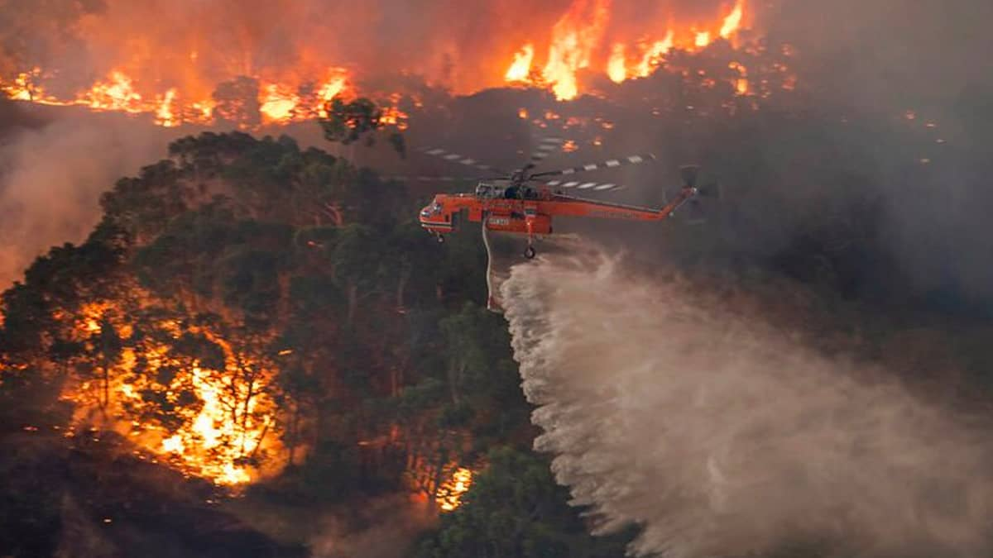

- Geography: This is a picture from the Australian bushfires that happened in Australia for many months. They happened when it was Winter in Australia and because it was warm and everything was dry, trees were able to catch fire more easily. The high temperatures and strong winds only made things worse. Many homes caught fire and were destroyed and people and animal wildlife have died. Look on a map and find out where Australia is, how much area was destroyed and find out what caused the terrible fires. Watch https://www.bbc.co.uk/newsround/51005074 and read https://www.bbc.co.uk/newsround/30682338 to find out more.

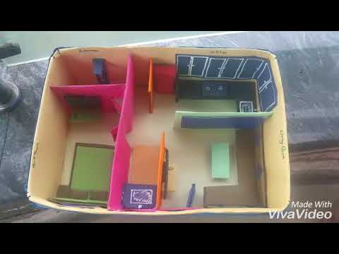
- Science: Identifying things in the house that could be a fire hazard if people are not careful. http://www.glosfire.gov.uk/cd_res/site/teacher/ks1/t1_hse_of_fire_hzds_gm.htm A hazard is something that might cause a fire. Discuss with a grown up how a candle left burning with no adult in the room, a tea towel too close to the hob, a lighter left laying around, a cigarette left smouldering on an overflowing ashtray, overloaded sockets, frayed cords on electrical items, leaving an iron unattended, cooking with no adult in the room and a fire without a fireguard, can all be dangerous. Have a look around your home with a grown up and see if you can see any fire hazards and talk about how you will correct them. Have you got a smoke alarm. Does it work? Test it with the grown up. Draw and label the fire hazards that you can think of and write why it is important to have a smoke alarm.

- Design and technology: Use a shoe box, cereal box, or any other box that you can find! Make a model of a house or two rooms with doors and windows. Make the doors and windows able to be opened. Think about the rooms that you have made. Is it a bedroom and kitchen? Or a lounge and bathroom? Cut out pictures and add them to your room so that it looks like a real house. Or make furniture or add any dolls house furniture. You may want to wallpaper the walls and add curtains too!

- History: How has fire been used through history? Look at the pictures and think about how fire has been helpful for keeping people warm, to help them see and cook. However, remember it can be dangerous! Never put things over lamps as they could catch fire. Never play with matches, Open fires must have a guard around them. Do not leave things too close to the cooker hob as they may catch fire and never leave candles unattended. Look at the pictures below.
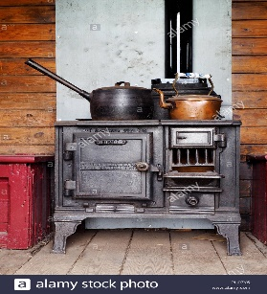
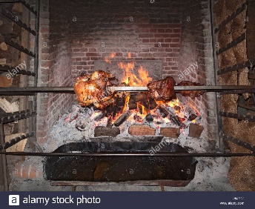

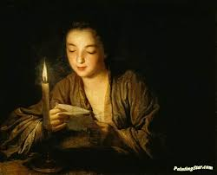
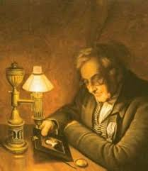
Can you see how the pictures are different for cooking and for reading? Talk to a grown up about which one is the oldest and newest for cooking and reading. Cut them out and put them in order for each activity to make a timeline. Now research and find out what they are called and see if you can find a date when they were used!

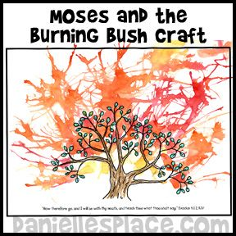
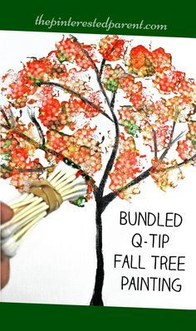
- RE: Watch the story of Moses and the Burning Bush. https://www.youtube.com/watch?v=omn08jyfN3sHow did God speak to Moses? How did God prove to Moses that people would believe him? Why did God get cross with Moses? Do you think Moses was scared when he first heard God’s voice? Was Moses worried about what God wanted him to do? Create a picture of the burning bush. You can paint it collage it or draw a picture of the bush and blow paint over it. Be as imaginative as you like!

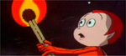
- PSHE – Watch Frances the Firefly clip http://www.glosfire.gov.uk/cd_res/site/films/francesthefirefly.mpeg Discuss the reasons why you should never play with matches with a grown up and remember that you should always say ‘NO!’ if anyone tries to persuade you. Design and make a poster warning people to NEVER play with matches.
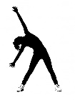

- PE: Every day, Joe Wicks has a 30 minute workout at 9 am. Join in via YouTube.
Family learning
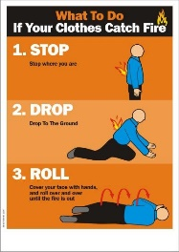
- Reinforce fire safety as a family. Practise the ‘Stop, drop and roll’ techniques so that everyone knows what to do if your clothes ever caught fire. DO NOT run around. Cover your face with your hands, lie down and roll around until the fire is out.
- To the tune of Three Blind Mice Learn the song.
Stop, Drop, Roll,
Stop Drop, Roll,
Here’s what to do,
If this should happen to you,
If ever your clothes should catch alight,
Don’t you panic and run in fright,
Because you know that it wouldn’t be right,
You stop, Drop, Roll

