Learning Project Week 8 ‘Fire’
Age Range Year 3
Weekly Maths Tasks – aim to do one per day | Weekly Reading Tasks – aim to do one per day
Try to do 10 minutes of arithmetic/ mental maths each day:  - https://www.topmarks.co.uk/maths-games/daily10  (Choose level 3 fractions)  - https://www.timestables.com/rally.html (a range of times tables games to test and challenge you!)  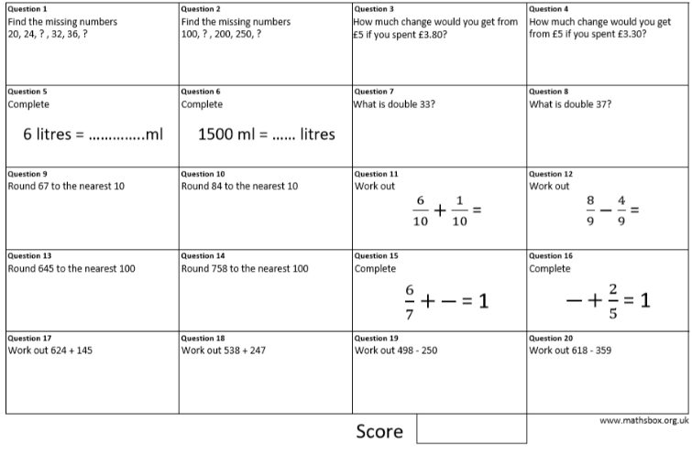  - Year 3 skills check: (answers published below) Reproduced by kind permission of mathsbox.org.uk  Answers from last week: 1. $\frac{2}{12}$ , 2. 417, 3. 93, 4. 111, 5. 24, 6. 435, 7. 174mm, 8. 11, 9. 4, 10. 31  - White Rose Maths has daily maths lessons for you to work through:  https://whiterosemaths.com/homelearning/year-3/  Watch the video, pausing to do the activities when you are told. The BBC are providing free worksheets to support the White Rose Maths lessons. Access these here.  From May 4th, White Rose Maths are charging for their worksheets – your school may provide you with a code to access these – the BBC sheets are completely compatible with White Rose.  Answers from above: 1. 28 & 40, 2. 150 & 300, 3. £1.20, 4. £1.70, 5. 6000ml, 6. 1.5 l, 7. 66, 8. 74, 9. 70, 10. 80, 11. $\frac{7}{10}$ , 12. $\frac{4}{9}$ , 13. 600, 14. 800, 15. $\frac{1}{7}$ , 16. $\frac{3}{5}$, 17. 769, 18. 785, 19. 248, 20. 259 | Try to read every day. There are some ideas here:  - This book is about volcanoes:  https://readon.myon.co.uk/reader/index.html?a=wwnd_wwve_s19  Read the story and answer the questions in the Critical Thinking Questions section in Other Pages.  - Audible have made all their children’s books free while schools are closed. Choose one and listen:  https://stories.audible.com/discovery  - Read a book of your choice to an adult. Talk about the story and the characters. Predict what you think might happen next. Explain why you like/ do not like the book.  - Read this poem about fire: https://clpe.org.uk/poetryline/poems/bush-fire  - Write down all the words and phrases used to describe fire.  - What is the effect of repeating some words (red, hot, wildly)?  - How does the poet make the fire sound like an animal? What words and phrases does she use?  - How do you feel about the Bushfire when you have read the poem? Can you explain why you feel that way?  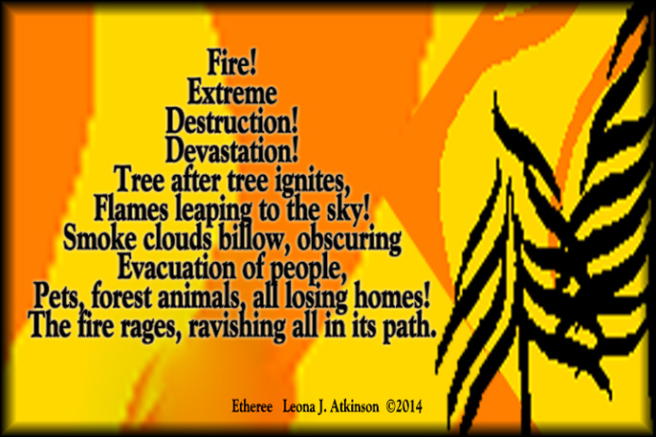  - Compare Bushfire with this poem:  What is the same? What is different? Do you think the shape of this poem is important? Explain your answer.
Weekly Spelling, Punctuation & Grammar Tasks – aim to do one per day | Weekly Writing tasks – aim to do one per day
- Choose some of these tasks to learn how to use the suffix -ly.  - Learn about homophones here. Watch the video clip and check you understand how to use there, their and they’re.  - Here are some common homophones. Draw a picture for each one. Use a dictionary to help if you are not sure:  - wear where  - plane plain  - right write  - hear here  - allowed aloud  - Now write a sentence using each homophone correctly.  Example: I never wear pyjamas to the supermarket.  - Play and practise words from the year 3 and 4 statutory spelling list. | Focus: poetry  - Look at this poem. It is called a Calligram or visual poem.  Calligrams are made up of words or phrases that describe the subject of the poem that are written in the shape of it.  Choose as many words or phrases as you can think of about fire and use them to write a fire calligram.  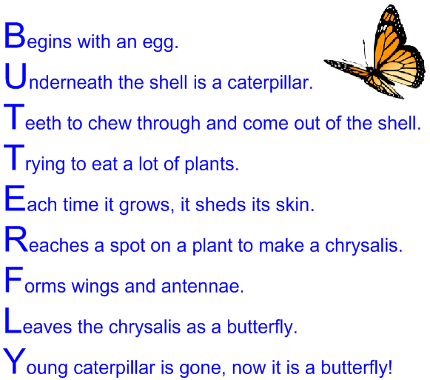  - Look at this poem. It is an Acrostic poem. The first letter of each line spells out the subject of the poem.  Use your ideas from yesterday and other vocabulary you can think of to write an acrostic poem called ‘Candlelight’.  Example: Casting a warm glow,  And flickering in the slightest draught.. etc.  - Look at this simple rhyming poem. Notice the rhyming pattern. Use the words and phrases about fire that you have been gathering over the last 2 days and write a poem called ‘Strike a Match’. Copy the rhyming pattern used here.  Example:  Strike a match  And you will see,  A sudden spark and flame set free;  - Watch the video clip of a volcanic eruption. As you watch, write down words and phrases to describe the effects of the eruption. Think about the sounds, the smells, the darkness, the fear you would feel. You will need these words and phrases for writing another poem tomorrow.  - Write a poem about volcanoes or Pompeii. You can choose whether to write a rhyming poem, a calligram or an acrostic poem. Make sure you use lots of detailed descriptive language to really create an image of the power, heat and destruction of a volcano. Write out your poem neatly and illustrate it.
Learning Project to be done throughout the week
- Science: There are 3 states of matter: solid, liquid or gas. Find 3 examples of each one around your home (you may have to think creatively about gas!). How do you know they are solid, liquid or gas? Watch this video and then see if you need to re-think what each object is you found. Read the definitions of solids, liquids and gases after the video and try the online game to check. Using those definitions, add: sugar, rice, margarine to your lists. What makes these difficult to classify?
You are going to investigate the effect changing temperatures can have on a state of matter. In our water topic, you learned about the water cycle and how water changes between the 3 states: ice, water and steam. Now you are going to look at other liquids and how they behave.
You will need: a variety of different liquids e.g. water, syrup, tomato sauce, vegetable oil, cream and a tray.
- Put a measured spoonful of each liquid at the top of a tray making sure it is the same amount of each liquid.
- Tip the tray and lean it against a book allowing the liquids to run down the tray. Which liquid moves the fastest? Which liquid moves slowest? If you have a stopwatch, record the time taken by each liquid. Record your results in a table (see below).
- Now put the liquids in the fridge for the same amount of time (at least 1 hour but better if longer).
- Which do you think will pour quickest now? How will the cold temperature affect their pouring rate? Make a prediction.
- Repeat the experiment. Did the liquids behave in the same way after they had been cooled? Compare the times of each liquid and write a sentence to explain what happened to each one.
- Write your conclusion and answer this question: What effect do cold temperatures have on the rate liquids move down a slope?
Liquid | Time taken at room temperature | Time taken at fridge temperature
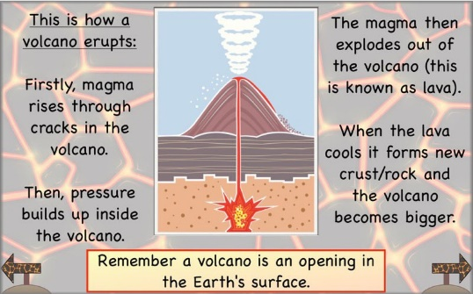
CHALLENGE: what do you think would happen if you put the liquids in the freezer instead? What would happen if you heated them? Make a prediction and try it out adult supervision required for these options.

- Geography: Look at this explanation of how a volcano erupts.

Now copy this diagram and label it with the following features:
- Main vent
- Secondary vent
- Crater
- Secondary cone
- Layers of ash and lava
- Ash clouds
- Ash
- Volcanic bombs
- Lava flow
- Magma chamber
CHALLENGE: Look at this image:
- What can you see happening?
- What can you infer?
- What do you predict will happen?
Use what you learned in your reading book ‘The World’s Worst Volcanic Eruptions’ to help you with this.

- History: Almost 2000 years ago, Mount Vesuvius in Italy erupted and covered the town of Pompeii in metres of ash. Watch this video clip which recreates what happened. Explore the city’s remains here. What do the remains tell us about life in Pompeii in the past? This tragic event has actually helped historians. Explain how. By looking at the images, what can you infer (work out) about life in Pompeii? What clues can you see? Look at clothes, buildings, foods, homes, etc.
CHALLENGE: what kinds of things do you still not know from the images?
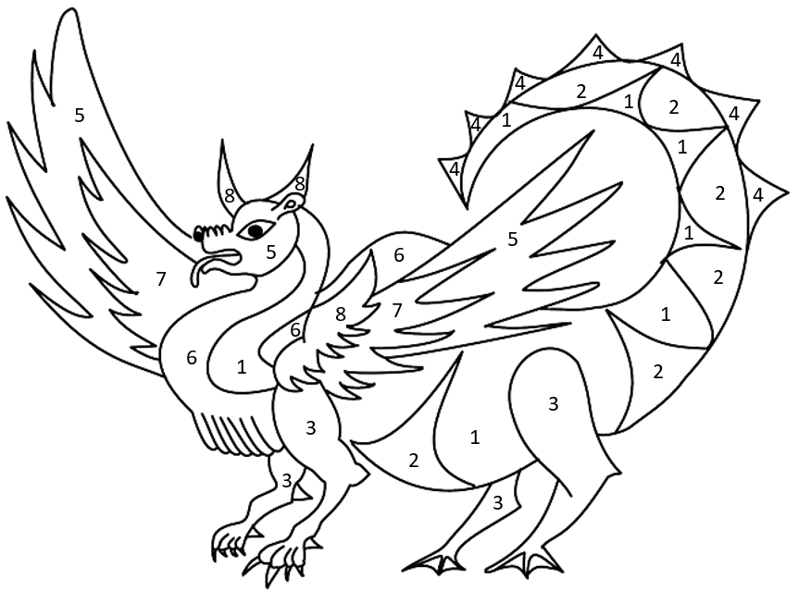
- French: Watch this video from “How to Train Your Dragon” in French. How much of it do you understand? Why? What does it tell you about communicating in a different language? How do Krokmou (Toothless) and Harold (Hiccup) communicate in the clip? Now watch this clip introducing colours in French and repeat each word when told to. Stop the clip at 3:10.

Colour in the picture of the dragon using the key:
un – rouge cinq - violet
deux – orange six - jaune
trois – vert sept - noir
quatre - bleu huit – marron

If you cannot print, draw a picture of a dragon and colour it in. Label the colours in French.
- Computing: Complete the Minecraft ‘hour of code’ coding activities.
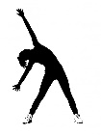
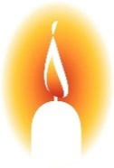
- RE: Candles play an important role in celebrations in several religions. Find out about candles in: Judaism (the menorah), Hinduism (diva), Christianity (advent crown). What does the fire in the candle symbolise for each religion?

- PE: Every day, Joe Wicks has a 30-minute workout at 9 am. Join in via YouTube.

Family learning
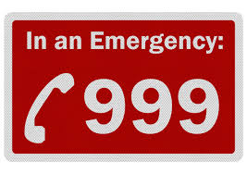
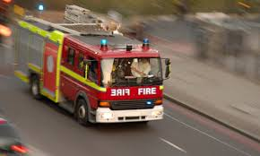
- Practise phoning the fire brigade if there was a fire. Prepare a script that would be used in an emergency and act it out with each other with one person being the operator and the other person reporting the fire. Remember your address!

Talk as a family about the different escape routes out of your home if there was a fire. What would you do? How would you exit if it was smoky?

- PSHCE: Your child may have concerns about the current situation. Childline has lots of advice about how to discuss it with your child. https://www.childline.org.uk/info-advice/your-feelings/anxiety-stress-panic/worries-about-the-world/coronavirus/.

