Learning Project Week 1 ‘Earth’
Age Range Year 4
Weekly Maths Tasks – aim to do one per day | Weekly Reading Tasks – aim to do one per day
Try to do 10 minutes of arithmetic/ mental maths each day:  - https://www.topmarks.co.uk/maths-games/daily10  (Choose level 4 addition)  - https://www.timestables.com/rally.html (a range of times tables games to test and challenge you!)  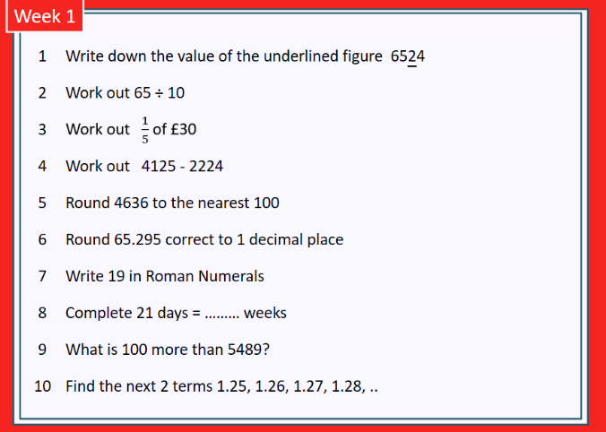  - Year 4 skills check: (answers published next week) reproduced with kind permission from mathsbox.org.uk  - White Rose Maths has daily maths lessons for you to work through:  https://whiterosemaths.com/homelearning/year-4/  Watch the video, pausing to do the activities when you are told. The BBC are providing free worksheets to support the White Rose Maths lessons. Access these here.  From May 4th, White Rose Maths are charging for their worksheets – your school may provide you with a code to access these – the BBC sheets are completely compatible with White Rose. | Try to read every day. There are some ideas here:  - This book is all about dinosaurs and fossils:  https://readon.myon.co.uk/reader/index.html?a=dm_trexa_s15  - Read 2 chapters each day and tell an adult about what has happened so far.  - Predict what you think might happen next.  - Explain why you like/ do not like the book.  - Explain what you already know about the characters: how do you know this?  - Write a review of the book when you have finished it.  - Audible have made all their children’s books free while schools are closed. Choose one and listen:  https://stories.audible.com/discovery  - Read the text about Fossils and answer the questions. Choose the level of text (1, 2 or 3 stars). Go to www.twinkl.co.uk/offer and enter the code Parentstwinklhelps. Download the Fossils text and questions for free. Answers provided. https://www.twinkl.co.uk/resource/fossils-worksheet-t2-s-865
Weekly Spelling, Punctuation & Grammar Tasks – aim to do one per day | Weekly Writing tasks – aim to do one per day
- https://spellingframe.co.uk/spelling-rule/8/1-Adding-suffixes-beginning-with-vowel-letters-to-words-of-more-than-one-syllable work through the tasks to learn how to add suffixes.  - Practise using different types of adjectives: https://www.childrensuniversity.manchester.ac.uk/learning-activities/languages/words/adjective-detective/  - Now write 5 sentences about your day/ week using interesting adjectives. Can you use a comparative adjective? A superlative?  - Practise words from the year 3 and 4 statutory spelling list: https://spellingframe.co.uk/spelling-rule/26/25-Word-list-years-3-and-4---a-to-bi-  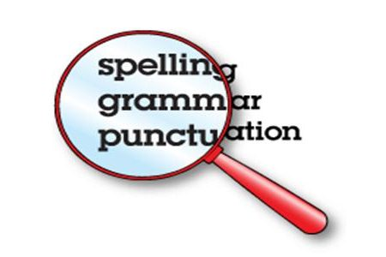  - How many words can you make from the letters in: tyrannosaurus rex? | Focus: Non-Fiction  - Dig a small hole in some soil. Use your senses and write a list of adjectives to describe the soil. Expand your adjectives into descriptive phrases using similes and adverbs,  E.g.: as crumbly as sherbet, the dry soil falls gracefully.  - Find 5 different rocks/ stones. Describe each one and compare using comparative adjectives (see SPAG section) and comparative conjunctions, e.g. The large, smooth pebble is as black as coal whereas the tiny, sharp stone is paler than a ghost.  - Watch the clip about Mary Anning: https://www.bbc.co.uk/programmes/p015gn89 make notes about important events in her life. Write a biography of her life. Use fronted adverbials followed by commas to start sentences, e.g. At the age of 15 months, … Deep inside the rocky cliffs, …… etc.  - Watch this Newsround clip: https://www.bbc.co.uk/newsround/47710225 Do you think there should be a statue of Mary Anning? Why? Convince me!  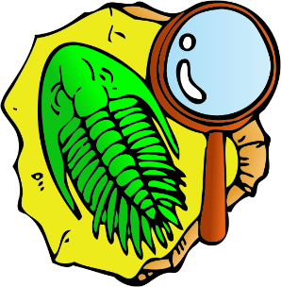  - Who would you like to see a statue of in your town? Write a letter to me persuading me why you think the statue should be built! Choose someone who you admire and explain why he/ she is so important to you, the community or the World. Explain where it should be situated and why.
Learning Project to be done throughout the week
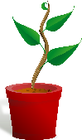
- Science: Look at the fruits and vegetables you have at home. Where are the seeds? Compare the size of the seeds. Find out about the different ways seeds are moved around in nature. Grow a pepper plant. If you have a pepper or chilli at home, you can cut it open to find seeds. Plant the seeds in pots with some soil or compost. Keep them damp and warm (indoors). Track their progress as they grow. Once they are established (this will take a few weeks!) try putting one outside. Which plant grows quickest? Which looks strongest? Which one will produce fruit first? Which one will produce the largest fruit? If you don’t have a pepper, try tomatoes, melon or even cherries.

- Art & Design: Make salt dough and design and create a fossil. Follow these instructions: https://jennyirvine.com/make-salt-dough-fossils/

- History: How was Mary Anning’s childhood different to yours? Compare aspects of her life with yours, e.g. clothes, home, education, hobbies, etc. Explain why Mary Anning was so extraordinary for the time: what made her so special? Explain why you think she was not recognised at the time.

- Design and Technology: Make rock cakes. Adult supervision required. Learn how to use a “rubbing-in” method. https://www.bbc.co.uk/food/recipes/rock_cakes_03094

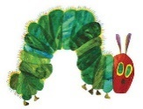
- MFL: Fruits: play the matching game: http://www.crickweb.co.uk/ks2french.html . Join in with this song about fruit: https://www.youtube.com/watch?v=nJ03KjwiIVM Watch the story: https://www.youtube.com/watch?v=xBpHkMgWld8 . Watch again – try to join in!

- RE: It can be easy to be negative with the current situation Practise finding things to be grateful for. Every day think of at least one thing that you are thankful for and make a list.

- PE: Every day, Joe Wicks has a 30 minute workout at 9 am. Join in via YouTube.
Family learning
- Plan and hold a party for the people you live with: make invitations, menus and table decorations, prepare the food, prepare games to play. Enjoy yourselves!

- PSHCE: Your child may have concerns about the current situation. Childline has lots of advice about how to discuss it with your child. https://www.childline.org.uk/info-advice/your-feelings/anxiety-stress-panic/worries-about-the-world/coronavirus/

