Learning Project Week 2 ‘Earth’
Age Range Year 4
Weekly Maths Tasks – aim to do one per day | Weekly Reading Tasks – aim to do one per day
Try to do 10 minutes of arithmetic/ mental maths each day:  - https://www.topmarks.co.uk/maths-games/daily10 (Choose level 4 subtraction)  - https://www.timestables.com/rally.html (a range of times tables games to test and challenge you!)  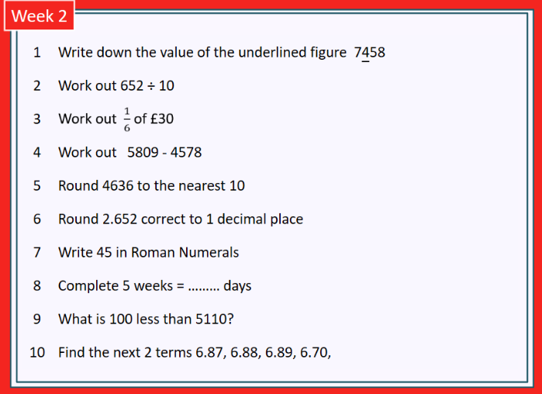  - Year 4 skills check: (answers published next week) Reproduced with kind permission from mathsbox.org.uk  - Answers from last week: 1. 20, 2. 6.5, 3. £6, 4. 1901, 5. 4600, 6. 65.3, 7. XIX, 8. 3, 9. 5589, 10. 1.29, 1.3  - White Rose Maths has daily maths lessons for you to work through:  https://whiterosemaths.com/homelearning/year-4/  Watch the video, pausing to do the activities when you are told. The BBC are providing free worksheets to support the White Rose Maths lessons. Access these here.  From May 4th, White Rose Maths are charging for their worksheets – your school may provide you with a code to access these – the BBC sheets are completely compatible with White Rose. | Try to read every day. There are some ideas here:  - This book is all about Earthquakes:  https://readon.myon.co.uk/reader/index.html?a=afn_shear_f10  - Read 2 chapters each day and tell an adult about what has happened so far.  - Predict what you think might happen next.  - Explain why you like/ do not like the book.  - Explain what you already know about the characters: how do you know this?  - Write a review of the book when you have finished it.  - Audible have made all their children’s books free while schools are closed. Choose one and listen:  https://stories.audible.com/discovery  - Read a book of your choice to an adult. Talk about the story and the characters. Predict what you think might happen next. Explain why you like/ do not like the book.  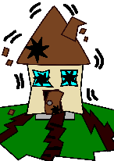  - Read the text about Earthquakes and answer the questions. Choose the level of text (1, 2 or 3 stars). Go to www.twinkl.co.uk/offer and enter the code Parentstwinklhelps. Download the Earthquakes text and questions for free. Answers provided. https://www.twinkl.co.uk/resource/t2-e-2222-earthquakes-ks2-differentiated-reading-comprehension-activity
Weekly Spelling, Punctuation & Grammar Tasks – aim to do one per day | Weekly Writing tasks – aim to do one per day
- https://spellingframe.co.uk/spelling-rule/9/2-The-I-sound-spelt-y-elsewhere-than-at-the-end-of-words work through the tasks to learn how to spell words with y as I sound.  - http://www.scootle.edu.au/ec/viewing/L935/index.html Lots of tasks here to keep you busy while learning how to write a newspaper report.  - Practise words from the year 3 and 4 statutory spelling list: https://spellingframe.co.uk/spelling-rule/44/26-Word-list-years-3-and-4---br--to-ce-  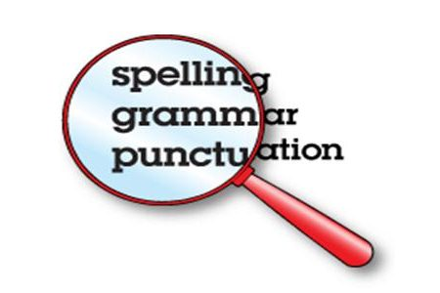 | Focus: Newspaper report  - Watch the video about earthquakes https://www.youtube.com/watch?v=CtBXTvtFaCU Write down what you would see, hear and feel during an earthquake. Use expanded noun phrases, e.g. the swinging lights dance and cast eerie moving shadows across the shaking walls.  - Look at the pictures here: https://www.3dgeography-pictures.co.uk/earthquake-pictures choose two or three and write 5 descriptive sentences about each one. E.g. As the rumbling earth slowly liquefied, the abandoned car drifted gradually into the melted land.  - Watch this Newsround clip: https://www.bbc.co.uk/newsround/35512446 Write a headline for an article you could write about this earthquake. Write down 3 phrases from the report that you could use in a report about an earthquake.  - Plan and write a newspaper report about an earthquake that happened near your house. (You will need to use your imagination!) Think about what the effects would be on your house, your school, places you play, etc. Interview a “witness” to find out what they “saw”, “heard”, “felt”. Make sure you use correct speech punctuation for any quotes you include. You will need to do this task over a couple of days. Include: headline, introduction, report of what happened, pictures with captions, quotes from a witness, report of results and explain what will happen next.
Learning Project to be done throughout the week
- Science: Watch the video about the rock cycle: https://www.youtube.com/watch?v=jP1qbwSGmNs.
Now make your own rock cycle using sweets: https://www.youtube.com/watch?v=g93jXTUv_RQ adult supervision required to make igneous rock. Draw and label a diagram of the rock cycle. You could include photographs of the rocks you “made”.

- Music: Watch the video of the piece of music called “Earth”. https://www.bbc.co.uk/teach/ten-pieces/classical-music-hans-zimmer-earth/zh4k382 As you listen, draw what you visualise on a large sheet of paper. Use different colours to show the mood/ atmosphere of the piece. Now listen carefully to the first part of the piece. The slow build-up of sound is called a “shimmer”. Try to recreate this with objects at home. You could use: Lego in a tub, coins in a jar, cutlery, etc. Think about how to create an effective crescendo (gradual increase in volume).

- Geography: Look at the different models of earthquakes you can make: https://www.3dgeography.co.uk/earthquake-models. Choose one and construct it! Make labels to explain what is happening at each part of your model. Alternatively, draw a diagram of how an earthquake happens.

- Design and Technology: make jam tarts. Adult supervision required. https://www.bbcgoodfood.com/recipes/valentines-day-jam-tarts Practise rubbing in, rolling out and using a cutter safely.

- Computing: complete the “Sequencing” express course in coding: https://studio.code.org/s/pre-express-2019

- RE: look out of your window at the world around you. Think about ways you can care for the world outside. Make a list of things you and your family can do to make a difference. Talk to the people you live with about things you can do even while you are at home.

- PE: Every day, Joe Wicks has a 30 minute workout at 9 am. Join in via YouTube.
Family learning
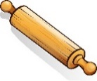
- Learn to use a new kitchen tool together e.g. whisk, rolling pin. Use to bake a cake or biscuits together and eat them!

- PSHCE: Your child may have concerns about the current situation. Childline has lots of advice about how to discuss it with your child. https://www.childline.org.uk/info-advice/your-feelings/anxiety-stress-panic/worries-about-the-world/coronavirus/

