Learning Project Week 3 ‘Water’
Age Range Year 4
Weekly Maths Tasks – aim to do one per day | Weekly Reading Tasks – aim to do one per day
Try to do 10 minutes of arithmetic/ mental maths each day:  - https://www.topmarks.co.uk/maths-games/daily10  (Choose level 4 ordering)  - https://www.timestables.com/rally.html (a range of times tables games to test and challenge you!)  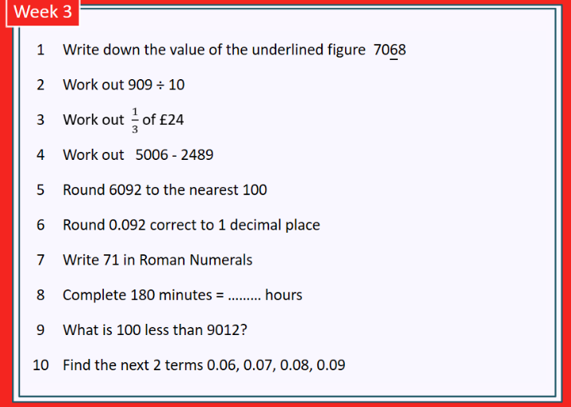  - Year 4 skills check: (answers published next week) Reproduced with kind permission from mathsbox.org.uk  Answers from last week: 1. 400, 2. 65.2, 3. £5, 4. 1231, 5. 4640, 6. 2.7, 7. XLV, 8. 35 days, 9. 5010 10. 6.71, 6.72  - White Rose Maths has daily maths lessons for you to work through:  https://whiterosemaths.com/homelearning/year-4/  Watch the video, pausing to do the activities when you are told. The BBC are providing free worksheets to support the White Rose Maths lessons. Access these here.  From May 4th, White Rose Maths are charging for their worksheets – your school may provide you with a code to access these – the BBC sheets are completely compatible with White Rose. | Try to read every day. There are some ideas here:  - This book is all about Water:  https://readon.myon.co.uk/reader/index.html?a=hop_hydros_f17  - Read it and write down all the ways that water is used that are mentioned.  - Answer the Critical Thinking questions in the “other pages” section.  - Explain the difference between groundwater and surface water.  - Audible have made all their children’s books free while schools are closed. Choose one and listen:  https://stories.audible.com/discovery  - Read a book of your choice to an adult. Talk about the story and the characters. Predict what you think might happen next. Explain why you like/ do not like the book.  - Read the text about Water and answer the questions. Choose the level of text (1, 2 or 3 stars). Go to www.twinkl.co.uk/offer and enter the code Parentstwinklhelps. Download the Water text and questions for free. Answers provided.
Weekly Spelling, Punctuation & Grammar Tasks – aim to do one per day | Weekly Writing tasks – aim to do one per day
- Work through the tasks to learn how spell words with the “u” sound spelled “ou”.  - Practise using different types of causal conjunctions. Download the PowerPoint and follow the instructions to learn how to use causal conjunctions to explain how or why something happened. You will need these conjunctions in your writing this week.  - Play and practise words from the year 3 and 4 statutory spelling list.  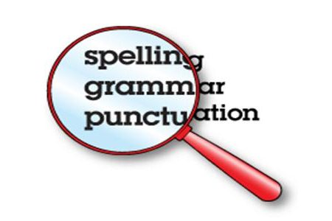  - How many words can you make from the letters in: evaporation? | Focus: Fiction  - Run your hand under the tap and feel the water flowing over your fingers. Describe what you can see, hear, feel, taste. Be as descriptive as possible, and use fronted adverbials, e.g. As it falls gracefully from the tap, the whispering, crystal-clear water slips through my fingers and creates a perfect tiny ocean. Now find some ice: how does it compare? Write sentences to describe the ice.  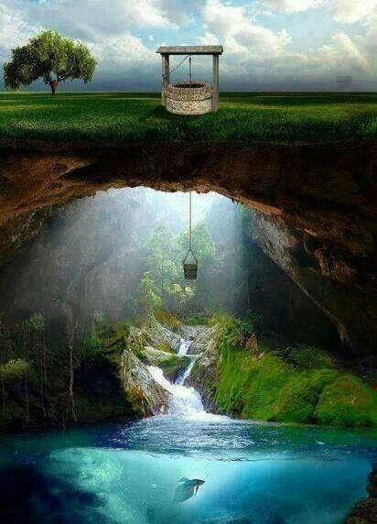  - Look at this image: write a description of the picture. Use your senses to write in detail using adjectives, similes, adverbs. Try to start your sentences with fronted adverbials followed by a comma, e.g.: Above the secret cavern,…  Below the surface of the crystal-clear water, …. Etc.  - Imagine you discovered this secret underground world under the well. Write a story about the day you fell down the well. What did you find down there? Describe how you felt when you were down there. How did you get out? Will you go back?  - Plan and write a story called ‘The Adventures of a Raindrop.’ Imagine you are a droplet of water. Describe all the adventures you have in your life: swimming in the ocean, being heated up and floating up into the sky, forming clouds with lots of your friends, falling back to earth, flowing into a river and eventually back home to the ocean. Describe each part as if you are there! Watch this video again to remind yourself about what happens. Try to include causal conjunctions and fronted adverbials. You could illustrate your story or even turn it into a book! This task will probably take you more than one day.
Learning Project to be done throughout the week
- Science: Look at the water experiments in this book: https://readon.myon.co.uk/reader/index.html?a=des_lplan_f15 Follow the instructions to complete 3 experiments. You may need adult supervision for some of them. Can you explain what is happening in each experiment using words from the water cycle? Draw diagrams to show what you did for each experiment and write sentences to explain what you think has happened.

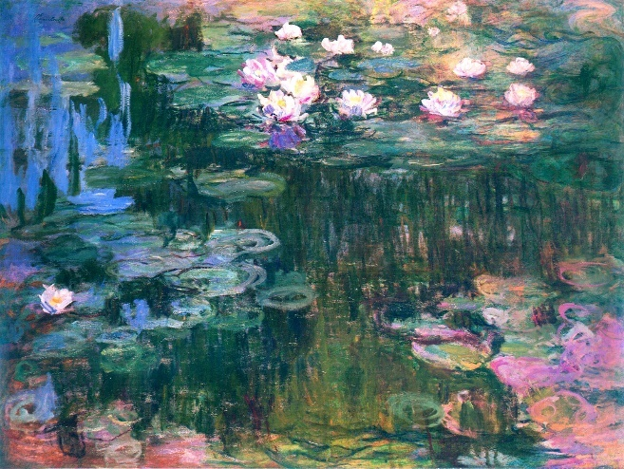
- Art & Design: Look closely at Monet’s famous paintings of waterlilies. He painted several paintings of waterlilies in his career. This style of painting is called Impressionism and it changed the artworld at the time (late Victorian era). Click on the links on the image here to find out more about Impressionism and Monet’s work.

Try to recreate the piece of work. There is a great tutorial here. (Click on the black dot at the bottom left of the painting). Don’t worry if you don’t have exactly the same materials as the artist on the clip – just use whatever paint and brushes you have and do your best.

- Geography: read the water book again: https://readon.myon.co.uk/reader/index.html?a=hop_hydros_f17 . Draw a diagram of the water cycle. If you need some help, watch this. Make sure you use the vocabulary: evaporation, condensation, precipitation.

- Design and Technology: Watch this video about bridges. Find examples on the internet or in books of examples of each type of bridge mentioned: beam, truss & suspension. Design and make a bridge at home. You could use sticks, pencils, rolled up pieces of paper or even spaghetti! Experiment with different designs to see which is strongest. See if you can make a bridge strong enough to hold a can of beans. Draw a picture of your finished design and take a photograph if you can. Annotate your design to show what you did to ensure it was strong.
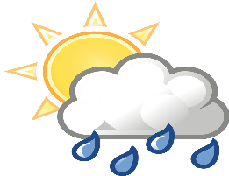
- French: the weather: watch the video to introduce the weather phrases and repeat each phrase as you hear it. Then complete this worksheet. Now try to join in with this song. In French, tell an adult about what the weather is like every day.

- RE: Water is important to lots of different faiths. Find out about these sources of water and why they are important to different faiths: the river Ganges, the River Jordan, the well of Zamzam. CHALLENGE: try to find where they are in the world on a map.

- PE: Every day, Joe Wicks has a 30- minute workout at 9 am. Join in via YouTube.
Family learning
- Design and build a shelter out of just newspaper and sticky tape. Make sure it is big enough to fit in everyone who lives with you. Think about what shapes you will need to construct to make it strong. CHALLENGE: can you make it waterproof? (You will need to add some other materials to help)
This Photo by Unknown Author is licensed under CC BY-NC

- PSHCE: Your child may have concerns about the current situation. Childline has lots of advice about how to discuss it with your child. https://www.childline.org.uk/info-advice/your-feelings/anxiety-stress-panic/worries-about-the-world/coronavirus/

