Learning Project Week 4 ‘Water’
Age Range Year 4
Weekly Maths Tasks – aim to do one per day | Weekly Reading Tasks – aim to do one per day
Try to do 10 minutes of arithmetic/ mental maths each day:  - https://www.topmarks.co.uk/maths-games/daily10  (Choose level 4 partitioning)  - https://www.timestables.com/rally.html (a range of times tables games to test and challenge you!)  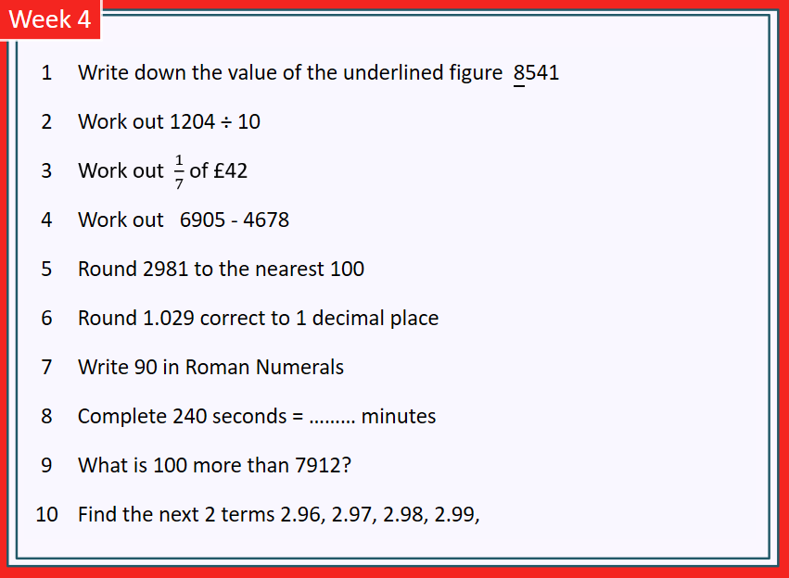  - Year 4 skills check: (answers published next week) Reproduced with kind permission from mathsbox.org.uk  Answers from last week: 1. 60, 2. 90.9, 3. £8, 4. 2517, 5. 6100, 6. 0.1, 7. LXXI, 8. 3 hrs, 9. 8912 10. 0.1, 0.11  - White Rose Maths has daily maths lessons for you to work through:  https://whiterosemaths.com/homelearning/year-4/  Watch the video, pausing to do the activities when you are told. The BBC are providing free worksheets to support the White Rose Maths lessons. Access these here.  From May 4th, White Rose Maths are charging for their worksheets – your school may provide you with a code to access these – the BBC sheets are completely compatible with White Rose. | Try to read every day. There are some ideas here:  - This book is an adventure about rafting:  https://readon.myon.co.uk/reader/index.html?a=jm_whico_s11  - Read 2 chapters each day. Each day, make predictions about what you think will happen next. What are the clues that tell you what may happen?  - When you have finished reading, answer the 3 discussion questions in the “other pages” section.  - Find 10 words in the text that tell you that water can be dangerous, e.g.: rushing, difficult, etc. You can use these words in your writing tasks.  - Audible have made all their children’s books free while schools are closed. Choose one and listen:  https://stories.audible.com/discovery  - Read a book of your choice to an adult. Talk about the story and the characters. Predict what you think might happen next. Explain why you like/ do not like the book.  - Read the text about Oceans and answer the questions. Choose the level of text (1, 2 or 3 stars). Go to www.twinkl.co.uk/offer and enter the code Parentstwinklhelps. Oceans text Click and download text and questions for free Answers provided.
Weekly Spelling, Punctuation & Grammar Tasks – aim to do one per day | Weekly Writing tasks – aim to do one per day
- Choose some of the tasks to learn how to use some more prefixes.  - Remind yourself how to use speech marks: https://www.bbc.co.uk/bitesize/clips/zvftsbk .  - Look at the book “Whitewater Courage” in the “reading” tasks. Find 5 examples of speech and check they follow the rules from the video. Now try writing 5 sentences of your own using speech marks. Watch the video again to check you have got them right!  - Try this online quiz to see if you can use speech marks correctly: https://www.educationquizzes.com/ks1/english/speech-marks/  - Play and practise words from the year 3 and 4 statutory spelling list.  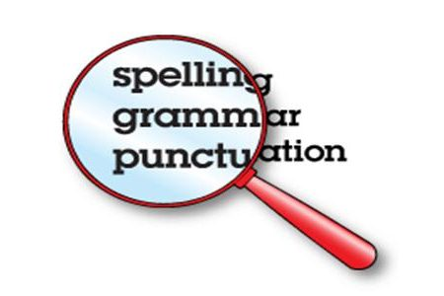 | Focus: Fiction  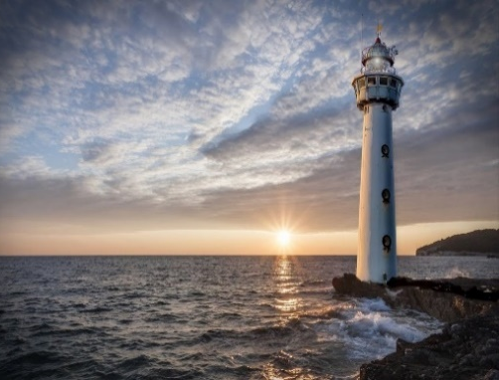  - Look at this image: Write descriptive phrases to describe the scene. Use similes, powerful adjectives, adverbs and fronted adverbials. E.g. Standing tall and proud on its solid base, the snow-white lighthouse watches patiently over the calm sea, waiting for any sign of impending doom.  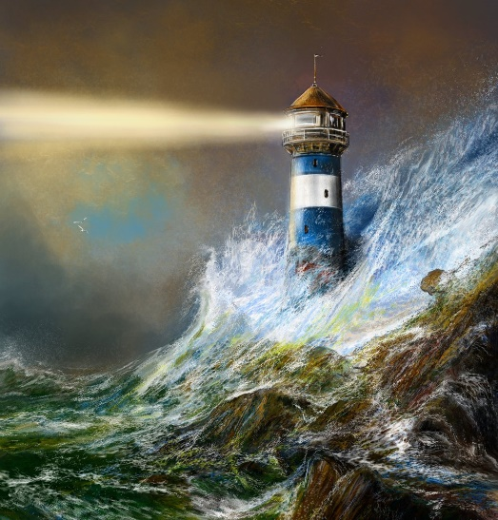  - Look at this image: Write descriptive phrases to describe this scene. Use dramatic words to convey the danger (look at the words you found in the reading book Whitewater Courage.)  E.g. With a deafening roar, another immense wave crashed over the fragile-looking lighthouse yet it resisted all attempts by the vicious storm to destroy it.  - Watch the video about the lighthouse. What kind of person is the lighthouse keeper? Use expanded noun phrases to describe his appearance and also his personality.  - Plan and write the story of the lighthouse from the film. Describe the lighthouse, the weather, the keeper. Include some of the work you have done earlier in the week. Include the lighthouse keeper’s thoughts using speech marks. E.g. “Oh no, what shall I do?” wondered the lighthouse keeper, panicking. When you have finished, read your story to the people in your home. You could play the Storm music in the background to add drama and atmosphere to your story!
Learning Project to be done throughout the week
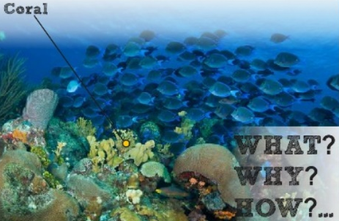
- Science: Look at this picture. What is it? Why do you think that? How can you find out?
Sort these things into groups “living” or “non-living”: sand, salt, anchor, driftwood, sea grass, paper, fossil, shell, feather, seaweed, clown fish, penguin, killer whale. Explain why you made those choices.

- Science: Now look at the classification key and use it to classify the following living things: mantis shrimp, sea slug, sea grass, crown-of-thorns-starfish, staghorn coral, clownfish, phytoplankton, parrotfish, tiger shark, Triton’s trumpet, dolphin, manta ray, boulder coral, noddy, green turtle. You may need to research each creature to help you. Use the internet or any books you have at home to help.

- Music: Watch the video of the full performance of the piece of music “Storm” by Benjamin Britten. The piece “tells” the story of a storm at sea. Imagine the storm as you listen for the first time. Watch the video introduced by Leanne & Sarah. It explains the music to you. As you listen, can you hear the same melody being repeated several times? This is called the Chorus. How many times in the piece can you hear it? Find something at home you could use as a percussion instrument (a drum could be made from a bowl or pan). Listen to the piece again and every time you hear the chorus, join in with the rhythm of it. You could also sing the words “Here comes a wave, here comes a big one!” along with it if you prefer. Halfway through the piece, the pace slows down. What do you think is happening on the sea at this time? At the end (the Coda), the piece speeds up again. What do you think happened? What makes you think that?

- PSHCE: Watch the video about Guti. https://cafod.org.uk/Education/Primary-teaching-resources/Water
After watching Guti’s story, how do you feel? Think about how the arrival of water changed Guti’s life. Think about: health, education, food, hygiene, time, effort. Do you take water for granted? Imagine what your life would be like without a tap at home. Share your thoughts about this issue with the people in your home.

- Geography: oceans – identifying oceans of the world and habitats within oceans.
- CHALLENGE: Find the oceans on a map.

- Look at the diagram of different ocean habitats. Copy it onto paper. Label with a name from the left hand column and a description from the right hand column. CHALLENGE: do some research to find what creatures live in each ocean habitat.

- Computing: Complete the “loops” course at: https://studio.code.org/s/pre-express-2019

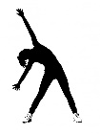
- RE: water is used in religious ceremonies for many faiths: baptism for Christians, cleansing for Jews and Wudu for Muslims. Find out 3 facts about each of these activities. CHALLENGE: Why do you think water is so important in these rituals?

- PE: Every day, Joe Wicks has a 30 minute workout at 9 am. Join in via YouTube.
Family learning
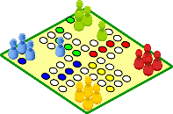
- Design, make and play a board game for the whole family. You could base it on a water adventure if you like or something completely different!

- PSHCE: Your child may have concerns about the current situation. Childline has lots of advice about how to discuss it with your child. https://www.childline.org.uk/info-advice/your-feelings/anxiety-stress-panic/worries-about-the-world/coronavirus/ .
You could also try using stories to help address any worries. There are some options here: https://www.youtube.com/watch?v=TQ0wyzjr5mg https://www.youtube.com/watch?v=VCyiiHI2SJU

