Learning Project Week 5 ‘Air’
Age Range Year 4
Weekly Maths Tasks – aim to do one per day | Weekly Reading Tasks – aim to do one per day
Try to do 10 minutes of arithmetic/ mental maths each day:  - https://www.topmarks.co.uk/maths-games/daily10  (Choose level 4 digit values)  - https://www.timestables.com/rally.html (a range of times tables games to test and challenge you!)  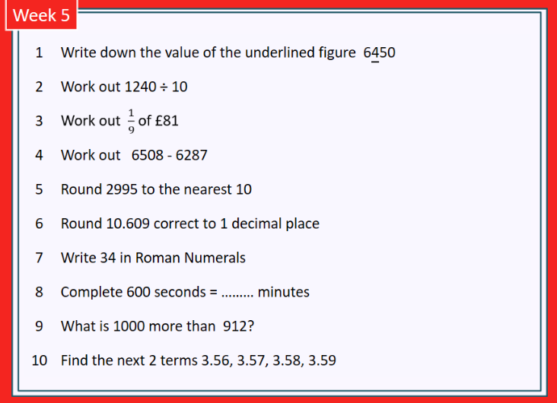  - Year 4 skills check: (answers published next week) Reproduced by kind permission of mathsbox.org.uk  Answers from last week: 1. 8000, 2. 120.4, 3. £6, 4. 2227, 5. 3000, 6. 1, 7. XC, 8. 4, 9. 8012, 10. 3 3.01  - White Rose Maths has daily maths lessons for you to work through:  https://whiterosemaths.com/homelearning/year-4/ Watch the video, pausing to do the activities when you are told. The BBC are providing free worksheets to support the White Rose Maths lessons. Access these here.  From May 4th, White Rose Maths are charging for their worksheets – your school may provide you with a code to access these – the BBC sheets are completely compatible with White Rose. | Try to read every day. There are some ideas here:  - This book is about ears and hearing:  https://readon.myon.co.uk/reader/index.html?a=inbod_whyear_s11  - Read a few sections each day. At the end of each day, write quiz questions you could ask someone about the facts in the book. Try quizzing someone at home and see what they know about sound and ears.  - When you finish the book, explain why it is important to look after your ears.  - Audible have made all their children’s books free while schools are closed. Choose one and listen:  https://stories.audible.com/discovery  - Read a book of your choice to an adult. Talk about the story and the characters. Predict what you think might happen next. Explain why you like/ do not like the book.  - Read the text about the Sense of Hearing and answer the questions. Choose the 3 stars level text. Go to www.twinkl.co.uk/offer and enter the code Parentstwinklhelps. Download the Sense of Hearing Text and questions for free. Answers provided.
Weekly Spelling, Punctuation & Grammar Tasks – aim to do one per day | Weekly Writing tasks – aim to do one per day
- Choose some of these tasks to learn how to use some more prefixes.  - Watch the video that explains what a preposition is. Now make a list of as many prepositions as you can think of.  - Look at the reading book ‘Why Do My Ears Pop?’ from the reading tasks. Can you spot the prepositions in the book?  - Write 10 sentences using different prepositions about this picture:  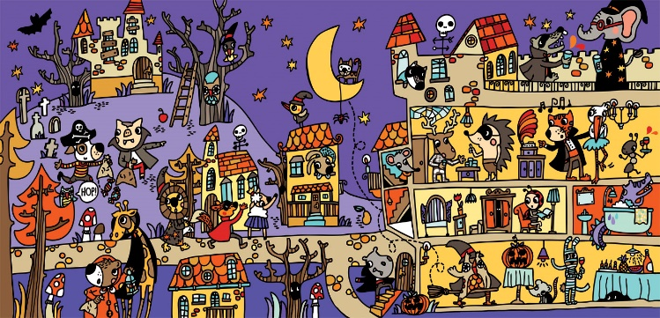  Example: The cat is sitting on the moon and dangling a spider from a string.  - Play and practise words from the year 3 and 4 statutory spelling list.  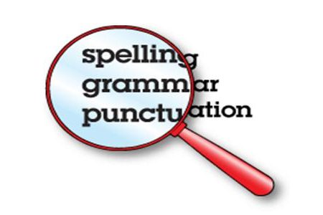 | Focus: Non-Fiction  - Go outside if you can (otherwise go into a room alone). Sit quietly and listen to everything around you. Make a quick list of all the sounds you hear. Focus on even the quietest rustle. Then write a sentence about each sound to describe what made it. Try to use similes, fronted adverbials, expanded noun phrases and adverbs. E.g.: As dry as paper, the crispy leaves rustle gently in the warm breeze.  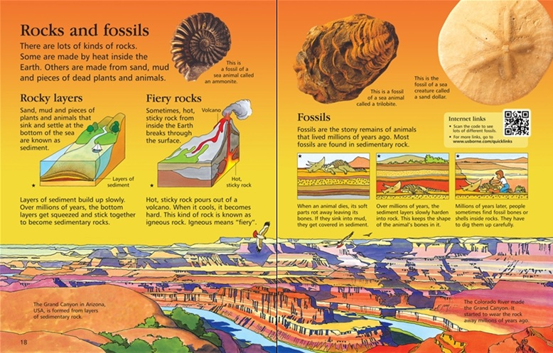  - Look at this image. It is a page from a non-fiction book. What features can you see? What is the job of each feature? E.g.: sub-headings tell you what each section of text is about.  - Watch the video about exploring the ear and write a description of a journey into an ear! Imagine what you would see, hear, smell, feel at each point on your journey. Use prepositions to explain where you are at each point of the journey: behind the ear drum, along the ear canal, etc.  - Plan and write a report (like the Rocks and Fossils text above) that explains how we hear things. You can use any information sources you have used this week. Make sure you have a title, introduction, sub-headings, diagrams with labels and give lots of facts. Make your work attractive so that people want to read it. This piece of work will probably take you 2 sessions to complete.
Learning Project to be done throughout the week
- Science: place one finger on your throat or Adam’s apple and hum. You should be able to feel a vibration. Now stretch a rubber band between your fingers and pluck it. You should now see, feel, and hear the vibrations. A vibration is a rapid back-and-forth motion. When you hum or speak, it makes the vocal cords in your throat vibrate. When you pluck the rubber band, it vibrates. The vibrations from an object, such as a rubber band or vocal cords eventually reach our ears by vibrating the air and we hear them as sounds. If there was no air, we could not hear anything! Watch this video to get a better explanation. Today you are going to make an ‘ear’ to see how we hear things.
You will need: a cardboard tube, an elastic band, sticky tap, a plastic bag or clingfilm, a piece of thick card, some kitchen foil, paper.
Follow these instructions to construct your ‘ear’. It is important that the bag is secured as tightly as possible to the tube. Attach the wishbone shape using tape, being careful not to puncture the bag. Keep it at right angles to the tube. Attach the wishbone to the foil with tape, keeping it at right angles again.

Before doing step 5, try talking into the tube. What happens to the bag? Touch it as you talk. What happens to the foil? Try talking from the side of the tube (not directly into it). What happens now? Add the paper cone and try again. What has changed?

Now watch this video and see if you can identify which parts of a human ear are represented in your model. Draw your ‘ear’ and label it with the correct words: pinna, ear canal, ear drum, ossicles. CHALLENGE: write sentences to explain what each part of the ear does.
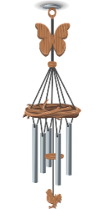
- Design & Technology: Design and make a windchime. Use objects you have at home to make a windchime that you could hang in your garden or in a window. Think about which objects will make the loudest sounds (remember what you have learned in science about vibrations). Experiment with different objects and different ways of hanging them to create the best sounds. Draw a picture of your windchime and label it. Would you make any changes if you made it again? Explain why.
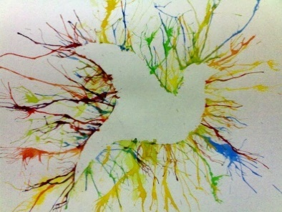
- Art: Look at this painting. It was created using a blow technique over a stencil. Practise the blow technique a few times before trying with a stencil. Use wet paint and blob it on the paper before blowing the paint with a straw. It’s easier if you cut the straw quite short first. Experiment with how to blend the colours using just your breath. When you are happy with your technique, create a stencil shape on card. Lay it carefully on the paper (you may want to blu-tack it in place). Use the blow technique to paint over and around the stencil. When the paint dries, remove the stencil and admire your art.
Day | Scale Force | Evidence
Monday | 2 | Leaves are rustling and petals are moving.

- Geography: Read about the Beaufort Scale. This is used to classify windspeed. Keep a wind diary for a week by observing the effect the wind has on things outside. Here is an example:

CHALLENGE: look at these cloud types and keep a diary of the clouds you see each day too.

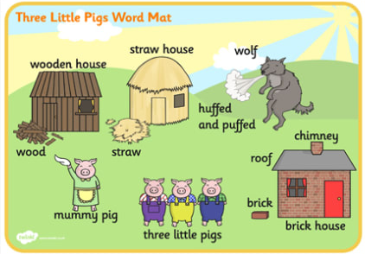
- French: Watch the video of the 3 little pigs in French. There are English sub-titles to help you understand. Watch again and match these French words to the English ones in this picture.
- Trois petits cochons 7. Maman cochon
- paille 8. Une maison en paille
- soufflé et soufflé 9. Une maison en bois
- loup 10. Une maison en briques
- bois 11. brique
- La grande cheminée 12. toit
Draw a cartoon strip of the story and label it in French.
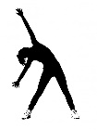
- RE: Watch the video story of Jesus Calms the Storm . What qualities did Jesus show in this event that made the disciples want to follow Him? What did the disciples learn from Jesus through what He did and said in the boat? Today, Christians find this story comforting. Why do you think this is? Do you know of any other stories about Jesus that may inspire people to lead a Christian life?

- PE: Every day, Joe Wicks has a 30-minute workout at 9 am. Join in via YouTube.
Family learning
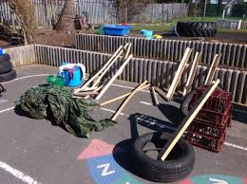
- Use different materials that you can find at home to create a structure that will keep a teddy bear safe in the wind. What are the best shapes? How tall is it going to be? What is the best material? Test your structure with a hairdryer! Can your structure stay up for longer than 2 minutes in the wind?

- PSHCE: Your child may have concerns about the current situation. Childline has lots of advice about how to discuss it with your child. https://www.childline.org.uk/info-advice/your-feelings/anxiety-stress-panic/worries-about-the-world/coronavirus/ .

