Learning Project Week 6 ‘Air’
Age Range Year 4
Weekly Maths Tasks – aim to do one per day | Weekly Reading Tasks – aim to do one per day
Try to do 10 minutes of arithmetic/ mental maths each day:  - https://www.topmarks.co.uk/maths-games/daily10  (Choose level 4 rounding)  - https://www.timestables.com/rally.html (a range of times tables games to test and challenge you!)  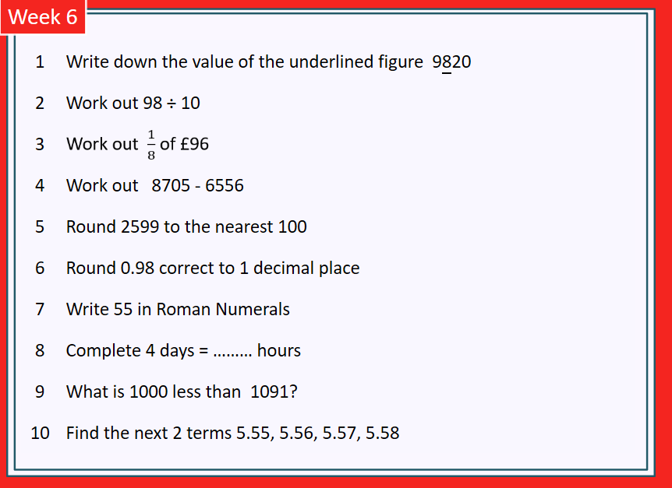  - Year 4 skills check: (answers published next week) Reproduced by kind permission of mathsbox.org.uk  Answers from last week: 1. 400, 2. 124, 3. £9, 4. 221, 5. 3000, 6. 10.6, 7. XXXIV, 8. 10, 9. 1912, 10. 3.6, 3.61  - White Rose Maths has daily maths lessons for you to work through:  https://whiterosemaths.com/homelearning/year-4/ Watch the video, pausing to do the activities when you are told. The BBC are providing free worksheets to support the White Rose Maths lessons. Access these here.  From May 4th, White Rose Maths are charging for their worksheets – your school may provide you with a code to access these – the BBC sheets are completely compatible with White Rose. | Try to read every day. There are some ideas here:  - This book is about the science of flying:  https://readon.myon.co.uk/reader/index.html?a=tscbh_flght_s12  - Read 2 sections each day. At the end of each day, write quiz questions you could ask someone about the facts in the book. Try quizzing someone at home and see what they know about sound and ears.  - The author asks lots of questions throughout the book. Why do you think she does that? What effect do the questions have on the reader?  - Find 3 examples of humour (being funny) in the book. Why do you think the writer uses humour in a non-fiction book? What effect does it have on the reader?  - Audible have made all their children’s books free while schools are closed. Choose one and listen:  https://stories.audible.com/discovery  - Read a book of your choice to an adult. Talk about the story and the characters. Predict what you think might happen next. Explain why you like/ do not like the book.  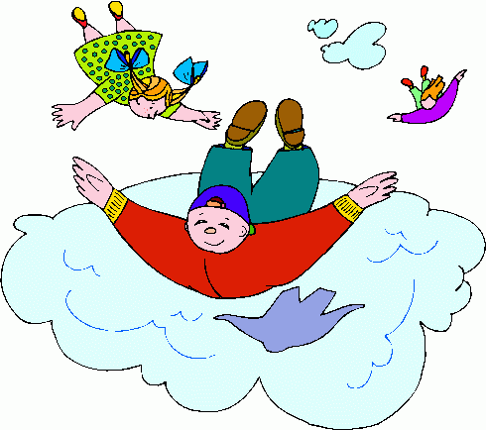  - Read the text about Daedalus and Icarus and answer the questions. Choose the 3 stars level text. Go to www.twinkl.co.uk/offer and enter the code Parentstwinklhelps. Download the text and questions for free. Answers provided.
Weekly Spelling, Punctuation & Grammar Tasks – aim to do one per day | Weekly Writing tasks – aim to do one per day
- Choose some of these tasks to learn how to use some more prefixes.  - Watch the video that explains what an expanded noun phrase is. In the last part of the video, adding more information is advised. This is done using a prepositional phrase (you learned about prepositions last week).  - Try drawing your own character like the one in the video and writing an expanded noun phrase to describe it. Make sure you include a prepositional phrase too.  - Underline the expanded noun phrases in these sentences, the first one is done for you:  - The colourful socks under the bed were as smelly as an old piece of cheese.  - Dark as night, the enormous, echoey cave under the waterfall welcomed me in.  - Our dilapidated house at the end of the road was cold and draughty.  - I hate gloopy, thick custard on trifle.  - I have five muscular, athletic sisters who live at home with me.  - Those miniature green frogs under the cold rocks scare me.  - Whenever I eat vanilla ice cream from a cone I get a terrible headache.  - Today, I opened all my wonderful presents from my parents and ate delicious lemon cake.  - Green monsters from Outer Space are sadly not real, but I wish they were!  - I would love to swim in a cool refreshing river with my friends, but we’re not allowed.  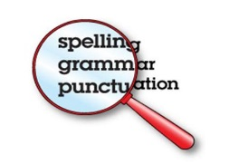  - Play and practise words from the year 3 and 4 statutory spelling list. | Focus: Non-Fiction  - Go outside if you can or look out of the window. Watch for anything you can see ‘flying’ in the air (birds, insects, aeroplanes, etc.). Some things might just be falling or floating (leaves, petals, etc.) but you can include these. Write down as many verbs to describe their flight as you can think of. E.g. bees – hovering, zooming, etc. petals – floating, twisting, drifting, etc. You may want to use a thesaurus to help. This is a free online thesaurus that presents the ideas visually.  - Look at the pictures of aircraft through the ages: https://www.dkfindout.com/uk/transport/history-aircraft/. Write expanded noun phrases about each picture. Try to include prepositional phrases for each one too, e.g. The blue, cloth balloon filled with hot air could float for short distances.  - Watch the video about how aeroplanes have been developed. At the end, it asks you about how you think air travel will evolve next. Design an aircraft of the future, what will make it special? Draw a picture of it and write a paragraph to explain why it will be so good.  - Watch the video again and think about how you are going to present this information to readers in your non-fiction report this week. Select 5 or 6 sections that you could write paragraphs about. These will be your sub-headings. Examples: The Wright Brothers, Aircraft at war, etc. Make brief notes about each one. You could also add information from here: https://www.dkfindout.com/uk/transport/history-aircraft/  - Write your report that explains the history of flight. You can use any information sources you have used this week. This website will also help you with your facts: https://www.theschoolrun.com/homework-help/history-of-flight Make sure you have a title, introduction, sub-headings, diagrams with labels and give lots of facts. Make your work attractive so that people want to read it.
Learning Project to be done throughout the week
- Science: Look at these pictures of animals’ ears. What do you notice about their size, shape and position?
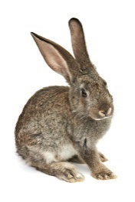
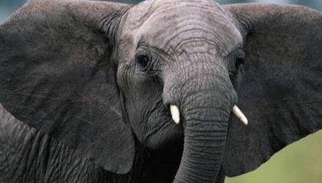
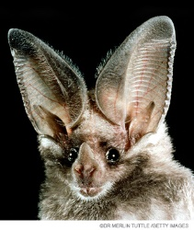
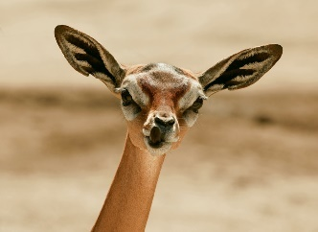

Compare them to a human ear. Watch this video clip that explains how the fennec fox’s ears work.
In this session, you are going to conduct an investigation to discover how size and shape of ears can affect your ability to hear.

You will need: 6 coins, paper, cardboard tubes, sticky tape, a scarf to use as a blindfold, someone to help you. You will need to be in an uncarpeted room (or outside) for this investigation.
Sit on a chair and ask someone to blindfold you. Ask your helper to stand behind your chair, 2 or 3 paces away from you. Ask them to drop a coin either to the right or left. Listen carefully and see if you can tell which side the coin was dropped. Your helper should record how many you got correct (out of 6).
Drop number | Right or Wrong?

Now repeat the investigation but this time cover one ear (putting your hand tightly over it). How many did you get right this time? Look at and compare your results. What do they tell you about your hearing? Why do you think humans and most animals have 2 ears?

Now you are going to see if you can improve your hearing by constructing a device. Use any materials you have at home: cardboard tubes, paper, plastic bottles, paper cups, foil, etc. (Think about what you learned about sound last week to help you to choose the best material). Think about the size and shapes of animal ears. What shape do you think will be most effective? Construct your device and repeat your coin experiment. Draw your device and label it. Was your device effective? How do you know? What would you change if you made another device? Why?

- History: Explore the history of flight using this great interactive ‘book’: https://www.dkfindout.com/uk/transport/history-aircraft/ Use the information you find to construct a timeline of the developments made. Illustrate your work.
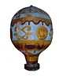
Example:
1783 the first hot air balloons
were invented by the Montgolfier
brothers.

CHALLENGE: watch this video clip about air travel in Great Britain and write a paragraph explaining how the invention of the aeroplane changed people’s lives.
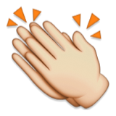
- Music: join in with this online Body Percussion lesson. You will learn how to make different pitch sounds using just your body. Thinking about how sound is produced using vibrations will help you to join in. You will also learn about rhythm, pulse, beat and volume. It is also great fun! If you clap for the NHS on Thursdays, maybe you could do a rhythm you have learned on here this week!

Day of the week | Online communication used
- PSHCE: Record how the people in your house communicate online during the course of the week. This could include email, messaging apps, social media, chat forums, gaming, etc. Are you surprised by how much online communication happens? Explain your answer. Now think about how each of these methods of communication could be used to be unkind to people. How would you respond if you saw it happening? What is the first thing you should do if you think someone is being unkind online to you or someone else?

- Computing: Complete the ‘events’ course at: https://studio.code.org/s/pre-express-2019

- RE: Watch the video story of The Night Journey . In this story, Muhammad is transported to Jerusalem and then to Heaven in one night. How does the story help Muslims to understand the nature of God? Does this story help Muslims to visualise God? Compare this story with others you know about people or prophets who communicated with God, e.g. Moses receiving the 10 commandments. What are the similarities/ differences between these stories?

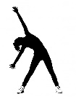
- PE: Every day, Joe Wicks has a 30-minute workout at 9 am. Join in via YouTube.
Family learning
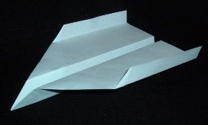
- Design and make a paper aeroplane. Decorate it and test it. Which member of the family has made the best paper aeroplane that travels the furthest?

- PSHCE: Your child may have concerns about the current situation. Childline has lots of advice about how to discuss it with your child. https://www.childline.org.uk/info-advice/your-feelings/anxiety-stress-panic/worries-about-the-world/coronavirus/ .

