Learning Project Week 7 ‘Fire’
Age Range Year 4
Weekly Maths Tasks – aim to do one per day | Weekly Reading Tasks – aim to do one per day
Try to do 10 minutes of arithmetic/ mental maths each day:  - https://www.topmarks.co.uk/maths-games/daily10  (Choose level 4 multiplication)  - https://www.timestables.com/rally.html (a range of times tables games to test and challenge you!)  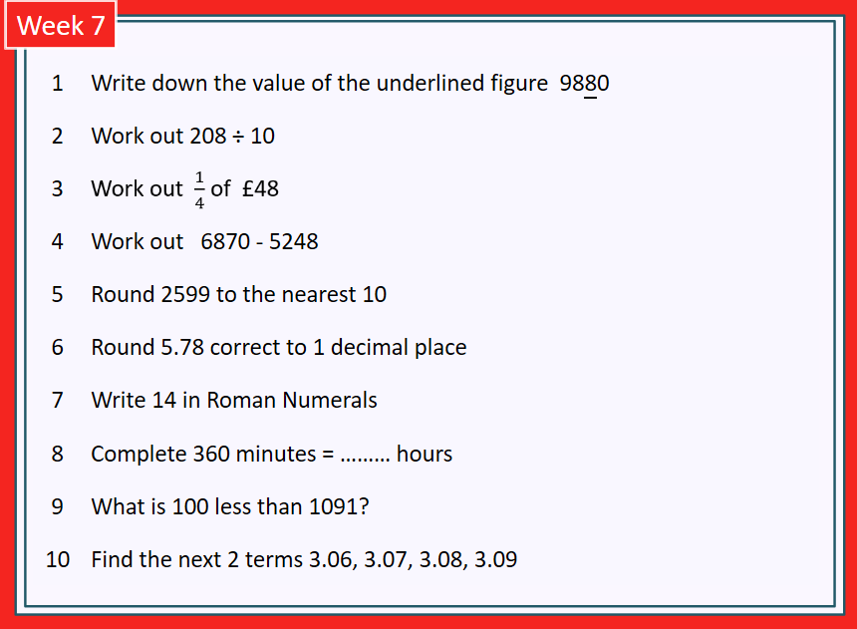  - Year 4 skills check: (answers published next week) Reproduced by kind permission of mathsbox.org.uk  Answers from last week: 1.800, 2. 9.8, 3. £12, 4. 2149, 5. 2600, 6. 1, 7. LV, 8. 96, 9. 91, 10. 5.59 5.6  - White Rose Maths has daily maths lessons for you to work through:  https://whiterosemaths.com/homelearning/year-4/  Watch the video, pausing to do the activities when you are told. The BBC are providing free worksheets to support the White Rose Maths lessons. Access these here.  From May 4th, White Rose Maths are charging for their worksheets – your school may provide you with a code to access these – the BBC sheets are completely compatible with White Rose. | Try to read every day. There are some ideas here:  - This story is called The Firebird:  https://www.theguardian.com/childrens-books-site/ng-interactive/2016/jan/30/extract-firebird-usborne-10-ten-minute-stories-national-storytelling-week  Read the story and answer these questions:  - What kind of story is it? How do you know?  - What kind of man is the king in the story? Choose 3 adjectives to describe him.  - In the story, what clues are there that the Firebird has magical properties?  - In what ways does the wolf help Ivan in his quest?  - Which words used to describe Koshchey tell you he is bad?  - What clues are there in the story that tell you it is a Russian tale?  - Audible have made all their children’s books free while schools are closed. Choose one and listen:  https://stories.audible.com/discovery  - Read a book of your choice to an adult. Talk about the story and the characters. Predict what you think might happen next. Explain why you like/ do not like the book.  - Read another version of the Firebird story. At the end of each part of the story, compare this version with the first one you read. What is the same, what is different? How does it change the story?  There are often different versions of traditional stories because originally they were not written down, but passed on from person to person, village to village and each story-teller might change the story slightly.  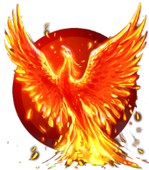  CHALLENGE: Can you think of differences in versions of traditional tales that you have heard? E.g. Little Red Riding Hood, Jack and the Beanstalk, Aladdin?
Weekly Spelling, Punctuation & Grammar Tasks – aim to do one per day | Weekly Writing tasks – aim to do one per day
- Choose some of these tasks to learn how to use the suffix -ation.  - Learn about verbs here. Watch the video clips and complete activity 1.  - Practise writing in the simple past tense. Example:  Present: Peter is writing a letter to his gran.  Simple past: Peter wrote a letter to his gran.  Put these sentences into past tense:  - Jerry has chickenpox.  - He has 174 itchy red spots covering his body.  - Jerry’s mum keeps rubbing lotion on the spots but they still itch him.  - Jerry tries hard not to scratch his spots but it is very difficult.  - Jerry’s dad says he looks like a pink and red leopard.  - Jerry’s dad starts to itch and scratch.  - Jerry’s dad catches chickenpox!  - Mum puts lotion on Dad’s spots.  Most verbs only need to have -ed added. Which ones here need a different form?  - Write 10 sentences in the past tense about this picture:  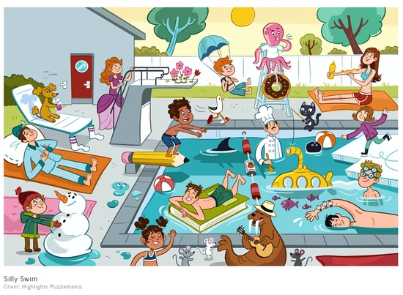  Example: Loudly the walrus played the guitar beside the noisy swimming pool full of people.  - Play and practise words from the year 3 and 4 statutory spelling list. | Focus: letter-writing  - Look at the pictures of the Firebird from the two versions of the story.  Write descriptive sentences about the firebird. Use your senses to describe its appearance, how it moves, how it sounds and its magical properties. Use: fronted adverbials, similes, expanded noun phrases and interesting adjectives. E.g. From out of the gloomy shadows, almost soundlessly, the magnificent creature swooped and glided, its fiery feathers casting twisting shadows on the dew-covered grass.  - Choose either Ivan or the Princess:  Write a description of the character you have chosen. Think about what s/he looks like and what type of personality they have: brave, kind, generous, cruel, weak, etc. Use similes, powerful adjectives and expanded noun phrases. E.g. As brave as a lion, Ivan rode into the ominous forest full of unknown dangers, determined to find the majestic Firebird.  - In the story, we do not know how or why the Princess was taken to Koshchey’s palace. Imagine what might have happened and write a short version of the events.  - When we write letters, we use first person (I). Choose to be Ivan or the Princess and write 10 sentences using first person and past tense to explain the outline of what happened to you in this story.  - Plan and write a letter from one of the characters in the Firebird story. You could choose Ivan and write a letter home to your father telling him about the adventures you have had. Or you could be the princess and tell your father about the terrible wizard and how Ivan rescued you. Start with Dear Father and end with something appropriate: fond wishes, with love, etc.
Learning Project to be done throughout the week
- Science: The Firebird’s feather keeps Ivan warm during his quest. How can we keep warm in cold weather? You are going to investigate which materials will keep you warmest on a cold day. You will need: some water, a freezer, 5 identical cups or containers, a variety of materials to test e.g.: kitchen roll, tin foil, a woolly glove, a piece of cotton, some bubble wrap.
- First predict which material will keep your water warmest. Which will be least effective at keeping your water warm?
- Put the same amount of tap water into the cups or containers.
- Wrap each container or cup in a different material.
- Put the containers into the freezer.
- After 15 minutes, check the water. Has one frozen yet? Keep checking the containers every 15 minutes. Which one freezes first? Which one takes longest to freeze?
Material | Time taken to freeze in minutes
- Record your results in a table:
- Write your conclusion: which material will keep you warmest in cold weather? How do you know? Was your prediction correct?
- Explain why it was important to use the same amount of water in each cup and why the cups had to be identical. What else could you do to ensure it was a fair test?

- Art and Design & Technology: When traditional tales were told originally, the storytellers often had puppets that they used to bring their story to life. Design and make a Firebird puppet. You can choose how you want to make it. You could use: paper plates, tubes, paint and feathers or make a sock, glove or finger puppet and practise some sewing skills.
Can you make the puppet move? How will you do this? There are some ideas in these pictures:
When you have made your puppet, can you act out the story for the people at your home to watch? You could also play the Firebird music as you perform with your puppet (see below)
Evaluate your puppet: are your pleased with it? Does it look how you want it to? Does it move how you want it to? What would you change if you made another one?
- Music: Stravinsky wrote a piece of music called The Firebird. Listen to it here: https://www.bbc.co.uk/teach/ten-pieces/classical-music-primary-igor-stravinksy-firebird-ks2/zbsf3k7 Claudia Winkleman explains the story and how the music works to tell the story. Then watch the full version and imagine the story, drawing images from the story as you go. You may prefer to read the story from one of the versions you have looked at earlier in the week as you listen first. When in the music do you think Ivan meets the Firebird? When does he meet the wolf? When does he defeat the wizard?
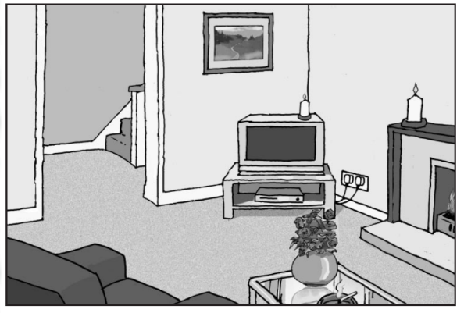
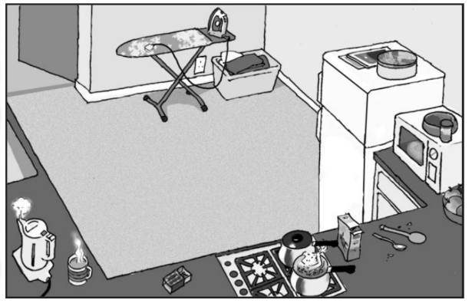
- PSHCE: Look at these pictures of rooms in a house. Identify fire risks in each room. Why could each thing start a fire? Look around your own home with an adult. Are there any fire risks in your house? Do you have smoke detectors fitted? How often do the adults test them? The advice is to have smoke detectors on every floor of your house and to test them every month. Write some fire safety advice to the people who live in the rooms above.

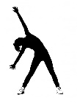
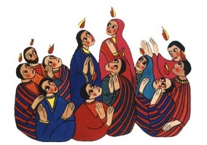
- RE: Watch the video story of Pentecost . Pentecost is the festival when Christians celebrate the gift of the Holy Spirit. It is celebrated on the Sunday 50 days after Easter (the name comes from the Greek pentekoste, "fiftieth"). Pentecost is regarded as the birthday of the Christian church, and the start of the church's mission to the world. How do you think the disciples felt when the flames appeared? Why was it important for the disciples to speak in different languages? The colour red is used as a symbol of Pentecost. Why do you think this is?

- PE: Every day, Joe Wicks has a 30-minute workout at 9 am. Join in via YouTube.
Family learning
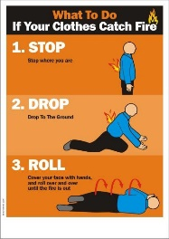
- Reinforce fire safety as a family. Practise the ‘Stop, drop and roll’ techniques so that everyone knows what to do if your clothes ever caught fire. DO NOT run around. Cover your face with your hands, lie down and roll around until the fire is out.
- To the tune of Three Blind Mice Learn the song.
Stop, Drop, Roll,
Stop Drop, Roll,
Here’s what to do,
If this should happen to you,
If ever your clothes should catch alight,
Don’t you panic and run in fright,
Because you know that it wouldn’t be right,
You Stop, Drop, Roll

- PSHCE: Your child may have concerns about the current situation. Childline has lots of advice about how to discuss it with your child. https://www.childline.org.uk/info-advice/your-feelings/anxiety-stress-panic/worries-about-the-world/coronavirus/.

