Learning Project Week 1 ‘Earth’
Age Range Year 5
Weekly Maths Tasks – aim to do one per day | Weekly Reading Tasks – aim to do one per day
Try to do 10 minutes of arithmetic/ mental maths each day:  - https://www.topmarks.co.uk/maths-games/daily10  (Choose level 5 addition & subtraction)  - https://www.timestables.com/rally.html (a range of times tables games to test and challenge you!)  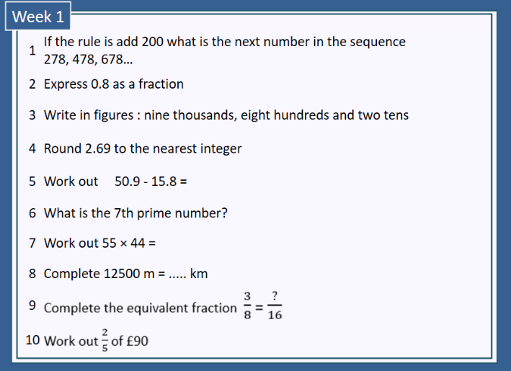  - Year 5 skills check: (answers published next week) Reproduced with kind permission from mathsbox.org.uk  - White Rose Maths has daily maths lessons for you to work through:  https://whiterosemaths.com/homelearning/year-5/  Watch the video, pausing to do the activities when you are told. The BBC are providing free worksheets to support the White Rose Maths lessons. Access these here.  From May 4th, White Rose Maths are charging for their worksheets – your school may provide you with a code to access these – the BBC sheets are completely compatible with White Rose. | Try to read every day. There are some ideas here:  - This book is all about a miner:  https://readon.myon.co.uk/reader/index.html?a=fofk_jhen_s19  Read the book then answer the questions in the “visual questions” section. Choose the “Other Pages” tab when you have finished reading to access the questions.  - Audible have made all their children’s books free while schools are closed. Choose one and listen:  https://stories.audible.com/discovery  - Read a book of your choice to an adult. Talk about the story and the characters. Predict what you think might happen next. Explain why you like/ do not like the book.  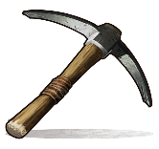  - Read the text about Mining and answer the questions. Choose the level of text (2 or 3 stars). Go to www.twinkl.co.uk/offer and enter the code Parentstwinklhelps. Download the Mining text and questions for free. Answers provided. https://www.twinkl.co.uk/resource/au-t2-h-5316-gold-rush-australia-differentiated-activity-sheets  This Photo by Unknown Author is licensed under CC BY-SA-NC
Weekly Spelling, Punctuation & Grammar Tasks – aim to do one per day | Weekly Writing tasks – aim to do one per day
- https://spellingframe.co.uk/spelling-rule/7/37-Endings-which-sound-like-spelt-cious-or-tious work through the tasks to learn how to add suffixes.  - Practise using active and passive: https://www.youtube.com/watch?time_continue=38&v=ZnL689Mpzew&feature=emb_logo Watch the video and write 5 simple sentences in the active.  - Now change those sentences to passive,  e.g. Jack climbed the tree. (active)  The tree was climbed by Jack. (passive)  - Practise words from the year 5 and 6 statutory spelling list: https://spellingframe.co.uk/spelling-rule/42/53-Word-list-years-5-and-6---a-to-av-  - Practise more passive/ active sentences: https://www.englishgrammar.org/active-passive-voice-worksheet-8/  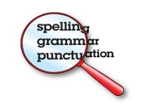 | Focus: Persuasion  - Watch the video about persuasive techniques in writing: https://www.youtube.com/watch?v=nRAtS4s_Dr8 Choose 3 of the techniques and write examples for each one.  - Watch the video about persuasion again: https://www.youtube.com/watch?v=nRAtS4s_Dr8 Use as many of the techniques as you can to persuade people to stay at home and help the NHS.  - Read these Newsround reports: https://www.bbc.co.uk/newsround/48254801 https://www.bbc.co.uk/newsround/51858259  Do you think we should be mining the moon? Why? Convince me!  - Imagine that an important mineral was found near your home. Write a list of advantages and disadvantages of building a mine to extract the mineral. Think about effects on local people, local industry, local transport, health, jobs, etc.  - Would you want the council to build a mine to extract the mineral? Write a letter to the council persuading them why it would (not) be a good idea to build it. Use persuasive devices to make your argument stronger: exaggeration, rhetorical questions, triples, repetition, emotive vocabulary, etc.  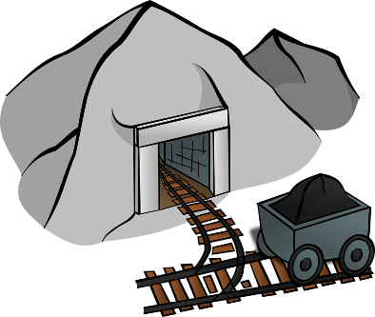
Learning Project to be done throughout the week
- Science: Look at the fruits and vegetables you have at home. Where are the seeds? Compare the size of the seeds. Try planting seeds from different fruits and vegetables you have at home. Compare how each plant grows. Keep them damp and warm (indoors). Which plant grows quickest? Which looks strongest? Which one will produce fruit first? Find out about the life cycles of the plants you are growing. Draw a diagram that shows how each plant reproduces. This website may help: http://theseedsite.co.uk/lifecycle.html

- Art & Design: Make salt dough https://www.bbcgoodfood.com/howto/guide/how-make-salt-dough-recipe and design and create a flower. When it is baked, you can paint it.

- History: Derbyshire has a strong history of mining. Watch this video that describes what conditions were like for lead miners when they moved to Wales looking for work. https://www.youtube.com/watch?v=J4PzHGLvWB4 How is your life different to the boy interviewed in the clip? Think about: home, school, clothes, food, hygiene, transport. Find similarities and differences and illustrate your work.

- Design and Technology: Make fruit crumble. Adult supervision required. Learn how to use a “rubbing-in” method and practise knife skills to prepare the fruit. https://www.bbcgoodfood.com/recipes/apple-blackberry-crumble

- MFL: Fruits: play the matching game: http://www.crickweb.co.uk/ks2french.html . Join in with this song about fruit: https://www.youtube.com/watch?v=nJ03KjwiIVM Write sentences about the fruits that you like. CHALLENGE: add a colour to your sentences, e.g. J’aime les pommes rouges. J’aime les bananes jaunes, etc. Now watch the story: https://www.youtube.com/watch?v=xBpHkMgWld8 . Watch again – try to join in!

- RE: It can be easy to be negative with the current situation Practise finding things to be grateful for. Every day think of at least one thing that you are thankful for and make a list.

- PE: Every day, Joe Wicks has a 30 minute workout at 9 am. Join in via YouTube.
Family learning
- Plan and hold a party for the people you live with: make invitations, menus and table decorations, prepare the food, prepare games to play. Enjoy yourselves!
- PSHCE: Your child may have concerns about the current situation. Childline has lots of advice about how to discuss it with your child. https://www.childline.org.uk/info-advice/your-feelings/anxiety-stress-panic/worries-about-the-world/coronavirus/

