Learning Project week 3 ‘Water’
Year 5
Weekly Maths Tasks – aim to do one per day | Weekly Reading Tasks – aim to do one per day
Try to do 10 minutes of arithmetic/ mental maths each day:  - https://www.topmarks.co.uk/maths-games/daily10  (Choose level 5 ordering)  - https://www.timestables.com/rally.html (a range of times tables games to test and challenge you!)  - Year 5 skills check: (answers published next week) Reproduced with kind permission from mathsbox.org.uk  Answers from last week: 1. 188, 2. $\frac{1}{10}$, 3. 10904, 4. 76, 5. 3.1, 6. 19, 7. 1539, 8. 0.5km, 9. 24, 10. £32  - White Rose Maths has daily maths lessons for you to work through:  https://whiterosemaths.com/homelearning/year-5/  Watch the video, pausing to do the activities when you are told. The BBC are providing free worksheets to support the White Rose Maths lessons. Access these here.  From May 4th, White Rose Maths are charging for their worksheets – your school may provide you with a code to access these – the BBC sheets are completely compatible with White Rose. | Try to read every day. There are some ideas here:  - This book is all about an adventure at sea:  https://readon.myon.co.uk/reader/index.html?a=jm_shipw_s09  Read the book then answer the discussion questions. Choose the “Other Pages” tab when you have finished reading to access the questions.  - Audible have made all their children’s books free while schools are closed. Choose one and listen:  https://stories.audible.com/discovery  - Read a book of your choice to an adult. Talk about the story and the characters. Predict what you think might happen next. Explain why you like/ do not like the book.  - Read the text about Water and answer the questions. Choose the level of text (1, 2 or 3 stars). Go to www.twinkl.co.uk/offer and enter the code Parentstwinklhelps. Download the text and questions for free. Answers provided.
Weekly Spelling, Punctuation & Grammar Tasks – aim to do one per day | Weekly Writing tasks – aim to do one per day
- Work through these tasks to learn how to add suffixes -ent, -ant, -ence, -ance.  - Relative clauses add information to sentences by using a relative pronoun such as who, that or which.  Relative pronoun Noun that the pronoun refers to  who Refers to a person  which Refers to an animal, place or thing  that Can refer to a person, place or thing  The relative clause is used to add information about the noun, so it must be ‘related’ to the noun.  Here are some examples of relative clauses (in purple):  If you are unsure about relative clauses, this video may help.  Write 10 sentences using relative clauses about this picture:  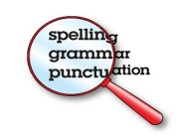  - Practise words from the year 5 and 6 statutory spelling list: https://spellingframe.co.uk/spelling-rule/55/55-Word-list-years-5-and-6---conv--to-en- | Focus: Fiction  - Run your hand under the tap and feel the water flowing over your fingers. Describe what you can see, hear, feel, taste. Be as descriptive as possible, and use fronted adverbials, e.g. As it falls gracefully from the tap, the whispering, crystal-clear water slips through my fingers and creates a perfect tiny ocean. Now find some ice: how does it compare? Write sentences to describe the ice. Watch (from a safe distance) steam as it rises from a kettle: write sentences to describe this form of water.  - Read the adventure story ‘Shipwreck’ again. Imagine you were adrift in a boat at sea. What 5 objects would you want with you? Make a list and explain why you would want each thing.  - Imagine being shipwrecked like the children in the story. Pretend you are in the raft, staring up at the sky, miles from anywhere, surrounded by the ocean. What would you be able to see? hear? smell? touch? How would you be feeling? Write a detailed description. Use similes and metaphors to bring your writing to life. E.g. The sea is an endless mirror, reflecting the silvery-glow of the moon in an otherwise black universe.  - Plan and write a story about being shipwrecked. Your plan needs an introduction, build-up, dilemma, resolution and ending.  In your introduction, explain why you are on the boat. In the build-up, describe the events leading up to the shipwreck. The dilemma is the part where you describe how you were shipwrecked- be descriptive! Then explain the difficulties of being shipwrecked: lack of food, water, keeping safe and warm. In the resolution, explain how you are rescued. In the ending explain what happened when you got home; what did you learn from the experience? This task will take you more than one day to complete.  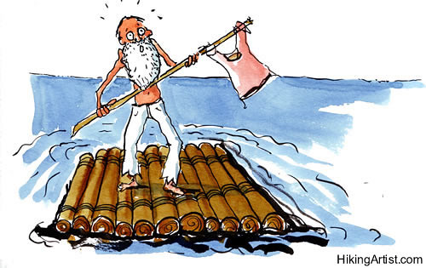  Use lots of description to add detail. Try to use some relative clauses too.
Learning Project to be done throughout the week
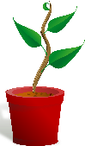
- Science: 1. Watch this video about plants. If you have the resources at home, try to recreate the experiment (any pale-coloured flower should work – or even celery!). Think about what the experiment tells you about what happens inside a plant. How is water transported in plants? Draw a diagram of the experiment and write sentences to explain what happens in the plant.

- 2. Draw and label the parts of the plant. This video clip may help you. CHALLENGE: explain what the function of each plant part is. Extra information to help: The hollow cells in the stems are called xylem. Xylem is a tissue in the plant which transports substances that plants need to live. Substances that xylem transports include water and minerals obtained through the plant's roots, as xylem runs from the roots to the stems and leaves.

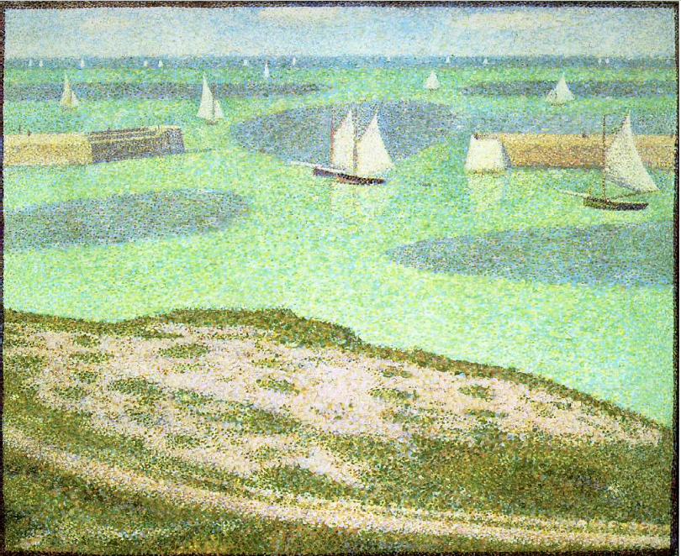
Art: Look closely at Georges Seurat’s famous paintings of Port-en-Bessin. Georges-Pierre Seurat, (2 December 1859 – 29 March 1891) was a French post-impressionism painter and many of his paintings depicted water scenes. He painted for a time with the Impressionist painters, Monet and Renoir His scientific ideas about colour then led him to develop a different painting technique. He painted in tiny dots of colour, with the theory that the viewer's eye would mix them. This technique is called ‘pointillism’.

Try to recreate the piece of work. Watch this video that focuses on his technique in more detail.
If you don’t have any paint at home, felt-tips or pencil crayons will work just as well.

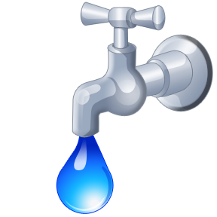
- PSHCE: Water is used in many more ways than we even realise. The average British family uses around 450 litres per day at home. Think of the ways we use water:
Teeth brushing: 12 litres (if you run the tap)
Flushing the toilet: 13 litres per flush
Shower: 50 litres average
Dishwasher: 15 litres per cycle
Drinking: 2 litres per person
Laundry: 55 litres per load

Water is fundamental to life. What if our access was cut off? Imagine all the ways our daily routines would change. How much water does your family use? How many times would you have to go to the river or waterhole to get dirty water? The risks are huge — every day nearly 1,000 children die from diarrhoea due to poor water, sanitation, and hygiene.

Watch the videos here. Compare Cheru’s life with Kamama’s. What differences have water made to Kamama’s life? How will Kamama’s future be different to Cheru’s? Think about: health, education, jobs, hygiene, food, etc.

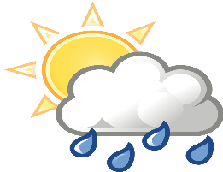
- Geography: Watch this video about rivers. Draw a diagram of a river and label it with the features mentioned: source, channel, floodplain, meander, canyon, waterfall, mouth. CHALLENGE: write a short description of each feature of a river.

- French: the weather: watch the video to introduce the weather phrases and repeat each phrase as you hear it. Then complete this worksheet. Now try to join in with this song. In French, tell an adult about what the weather is like every day.

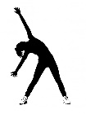
- RE: Water is important to lots of different faiths. Find out about these sources of water and why they are important to different faiths: the river Ganges, the River Jordan, the well of Zamzam. CHALLENGE: try to find where they are in the world on a map.

- PE: Every day, Joe Wicks has a 30- minute workout at 9 am. Join in via YouTube.
Family learning
- Design and build a shelter out of just newspaper and sticky tape. Make sure it is big enough to fit in everyone who lives with you. Think about what shapes you will need to construct to make it strong. CHALLENGE: can you make it waterproof? (You will need to add some other materials to help)
This Photo by Unknown Author is licensed under CC BY-NC

- PSHCE: Your child may have concerns about the current situation. Childline has lots of advice about how to discuss it with your child. https://www.childline.org.uk/info-advice/your-feelings/anxiety-stress-panic/worries-about-the-world/coronavirus/

