Learning Project Week 7 ‘Fire’
Age Range Year 5
Weekly Maths Tasks – aim to do one per day | Weekly Reading Tasks – aim to do one per day
Try to do 10 minutes of arithmetic/ mental maths each day:  - https://www.topmarks.co.uk/maths-games/daily10  (Choose level 5 multiplication)  - https://www.timestables.com/rally.html (a range of times tables games to test and challenge you!)  - Year 5 skills check: (answers published next week) Reproduced by kind permission of mathsbox.org.uk  Answers from last week: 1. 224, 2. $\frac{1}{10}$, 3. 16504, 4. 3, 5. 26.1, 6. 19, 7. 2856, 8. 6.5km, 9. 6, 10. 10  - White Rose Maths has daily maths lessons for you to work through:  https://whiterosemaths.com/homelearning/year-5/  Watch the video, pausing to do the activities when you are told. The BBC are providing free worksheets to support the White Rose Maths lessons. Access these here.  From May 4th, White Rose Maths are charging for their worksheets – your school may provide you with a code to access these – the BBC sheets are completely compatible with White Rose. | Try to read every day. There are some ideas here:  - This book is all about the Sun:  https://readon.myon.co.uk/reader/index.html?a=gst_soss_f17  Read the book and answer the questions in the Quiz section. Go to Other Pages to find it.  - Audible have made all their children’s books free while schools are closed. Choose one and listen:  https://stories.audible.com/discovery  - Read a book of your choice to an adult. Talk about the story and the characters. Predict what you think might happen next. Explain why you like/ do not like the book.  - Read the text about The Sun and answer the questions. Choose the level of text (1, 2 or 3 stars). Go to www.twinkl.co.uk/offer and enter the code Parentstwinklhelps. Download the text and questions for free. Answers provided.
Weekly Spelling, Punctuation & Grammar Tasks – aim to do one per day | Weekly Writing tasks – aim to do one per day
- Choose some of these tasks to learn how to use the suffix -fer.  - Learn about modal verbs here. Watch the video clips and complete the activity.  - Modal verbs always work with another verb. Underline the modal verb in these sentences:  - Rachel must do her homework.  - Dad might help her.  - Mum can’t help her.  - Her brother will not help her.  - Rachel might finish it soon.  - Insert a suitable modal verb in these sentences (there may be more than one possible answer):  - Look! I ______ see the sea!  - You are good at rugby – you ______ be on the team.  - I’m so hungry, I ________ eat a horse!  - If I were you, I ________ have a rest.  - Tomorrow Jack _______ get up early.  - We _______ find some fossils today.  - You ______ drink plenty of water.  - Mum says you ______ leave the table.  - Watch out! You ________ fall!  - Children _________ watch too much TV.  - Play and practise words from the year 5 and 6 statutory spelling list. | Focus: letter-writing  - Explore these images of the Sun. Write descriptive phrases and sentences to describe what you see. Use similes, metaphors, personification and powerful words to communicate the drama. Example: Like a writhing ball of burning snakes, the Sun squirms and spouts blazing fountains into the depths of Space.  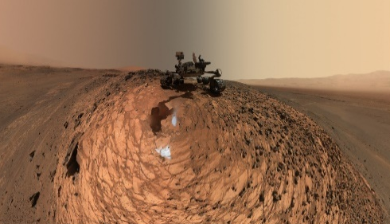  - Mars is another planet in our Solar System. That means it also orbits our Sun. Scientists have sent robots to Mars to explore for us. Look at the picture and wonder at the pink sand, the curious markings on the ground and the dusty skies. Write sentences to describe what you see. Example: As dry as the Sahara, the pink Martian desert stretches itself as far as the rosy horizon and rolls on endlessly.  - Some people believe that humans will travel to Mars in the future. Read this opening to a short story:  The Wait by Doug Goodman  Tom just wanted to walk. For eight months, he’d floated through space. Now he was stuck in a capsule on Sol 1 waiting for his body to readjust to gravity. Months ago, he had started this journey to Mars with the goal of walking on the red planet. Like his 10- year- old self, Tom just wanted to run outside and play in the dust.  After all that time spent in Space, the landing had been pure adrenaline rush. In his life, he knew he’d never ride a more thrilling roller coaster. After the parachutes deployed and saved them all, they successfully crashed onto Mars. That was 22 long hours ago. Soon, it would be time to suit up and make that first walk. What was it Commander Harrison had said? “One last step, one new beginning.” That had a nice ring to it.  He stared out of the porthole window at the Martian landscape. Commander Harrison looked at him. “When we step outside that door, we will be the first humans ever to walk on another planet.”  Continue the story now: what will Tom see when the door opens? What will he hear? How will he feel? What will he do first?  - When we write letters, we use first person (I). Choose to be Tom or Commander Harrison and write 10 sentences using past tense about what you did on your first day on Mars. Include as much detail as possible.  - Imagine you have gone to Mars to live with your family. Write an email from you to a family member back home on Earth. Tell them about your journey to Mars and about what life is like on the planet. What is the view? What do you eat and drink? Do you go to school? How do you get around? Be as creative as you can!
Learning Project to be done throughout the week
- Science: The Sun, like all stars, is a huge ball of fire in the sky. Watch this clip that tells you more and complete the sentences under the video. Watch this clip to remind you about why we have day and night. From Earth, we can see that the Sun is round, but for many years, people believed that the Earth is flat. Watch this clip that explains how Aristotle worked out that the Earth must be a sphere. Draw diagrams and write sentences that explain the 3 pieces of evidence he discovered that proved to him that the Earth is round like the Sun. Now watch this clip that explains why shadows change size and shape throughout the day. You are going to investigate how we can prove that the Earth is rotating. On a sunny day, at 9am, place an object outside in a place where it will be in the Sun for the whole day (if possible). Draw around the shadow of the object (in chalk or place the object on paper and draw on the paper) and label the shadow as 9am. Leave the object in exactly the same place all day. Repeat this every hour of the day until sunset. What do you notice about the shadow size, shape, position, definition? How does this investigation prove that the Earth is rotating?

Draw a diagram showing what you did. Write sentences to explain what the investigation showed you. Use vocabulary from the video clips to help you to write your explanation. Explain why is was important that you kept the object in exactly the same place all day.
REMEMBER IT IS DANGEROUS TO LOOK AT THE SUN.

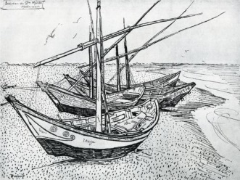
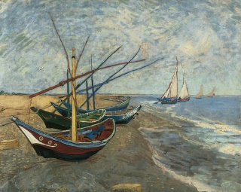
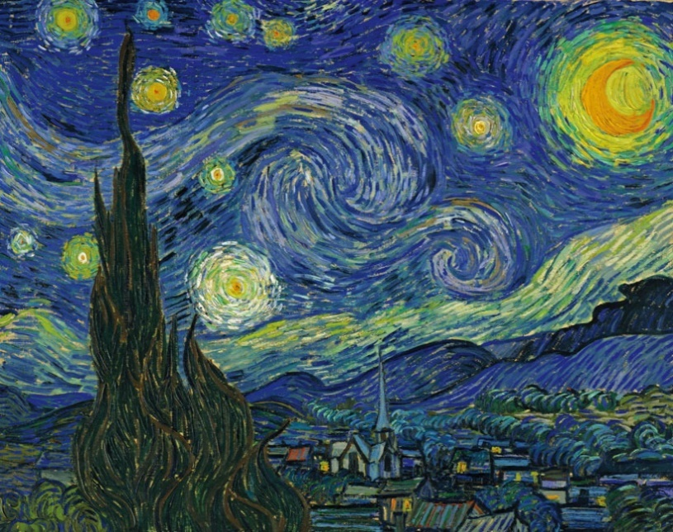
- Art and Design: Look at this famous painting from 1899 called ‘Starry Night’ by Vincent Van Gogh. Van Gogh was a ‘Post- Impressionist’ painter (like Seurat who used Pointillism). He is most famous for paintings like ‘Still Life: Vase with Twelve Sunflowers’ and ‘Starry Night’. Post-Impressionism focused on line, colour and emotion. What emotions do you feel when you look at the painting? Look at these pictures and see how Van Gogh used line drawings before he painted:
Now watch this clip that brings the painting to life. What do you notice about the effect of the lines of colour used by Van Gogh? Try to recreate this painting using the lines of colour in the same style as Van Gogh. Pencil crayon, pastels or paint would all work well.

- Music: Beethoven wrote a piece of music in 1802 that became known as the Moonlight Sonata. Shortly after composing it, his hearing began to deteriorate and eventually he became completely deaf. Amazingly, he continued to compose despite never being able to hear what he was creating. You can hear Moonlight Sonata playing in the background of the Starry Night clip above. Listen to it carefully and think about the mood that the music creates. It is only played on one instrument: the piano. This means it sounds quite simple: what is the effect of using just one instrument? The pulse of the piece is slow and you can hear a constant steady rhythm played in sequences of 3 notes keeping that pulse. Listen to the whole piece and count 1-2-3 throughout along with those sequences. Notice that on the ‘1’, there is a slightly louder emphasis. Tap along with the pulse, putting a stronger beat on number ‘1’ each time. You could use anything to tap on that you think would create a sound that fits with the atmosphere of the piece. Think carefully about your choice.

- PSHCE: Look at these pictures. Decide what order they should be in to tell a story. What is the story? Write a short caption for each picture. Think carefully about the story and answer:

- Why do you think the young people became involved in the event?
- Do you think they intended the outcome to happen?
- What are the consequences of the young peoples’ actions for themselves and the community?
- What would be the consequences of a school burning down?
- What could they have done to change the outcome?
- What strategies could you use if you find yourself in similar situations?
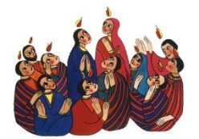
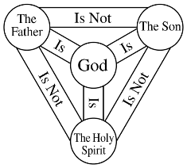
- RE: Watch the video story of Pentecost . Pentecost is the festival when Christians celebrate the gift of the Holy Spirit. It is celebrated on the Sunday 50 days after Easter (the name comes from the Greek pentekoste, "fiftieth"). Think about the meaning of this festival and answer the questions below.
- How do you think the disciples felt when the flames appeared?
- Why do you think Pentecost is regarded as the birth of the Christian church?
- Why was it important for the disciples to speak in different languages?
- The colour red is used as a symbol of Pentecost. Why do you think this is?
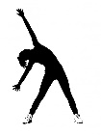
- Other symbols of Pentecost are: a dove, flames, wind. Why do you think these symbols are associated with Pentecost?
- Why do you think Christians believe that the Holy Spirit is real?

- PE: Every day, Joe Wicks has a 30-minute workout at 9 am. Join in via YouTube.
Family learning
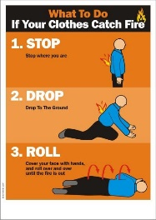
- Reinforce fire safety as a family. Practise the ‘Stop, drop and roll’ techniques so that everyone knows what to do if your clothes ever caught fire. DO NOT run around. Cover your face with your hands, lie down and roll around until the fire is out.
- To the tune of Three Blind Mice Learn the song.
Stop, Drop, Roll,
Stop Drop, Roll,
Here’s what to do,
If this should happen to you,
If ever your clothes should catch alight,
Don’t you panic and run in fright,
Because you know that it wouldn’t be right,
You Stop, Drop, Roll

- PSHCE: Your child may have concerns about the current situation. Childline has lots of advice about how to discuss it with your child. https://www.childline.org.uk/info-advice/your-feelings/anxiety-stress-panic/worries-about-the-world/coronavirus/.

