Learning Project Week 8 ‘Fire’
Age Range Year 5
Weekly Maths Tasks – aim to do one per day | Weekly Reading Tasks – aim to do one per day
Try to do 10 minutes of arithmetic/ mental maths each day:  - https://www.topmarks.co.uk/maths-games/daily10  (Choose level 5 Division)  - https://www.timestables.com/rally.html (a range of times tables games to test and challenge you!)  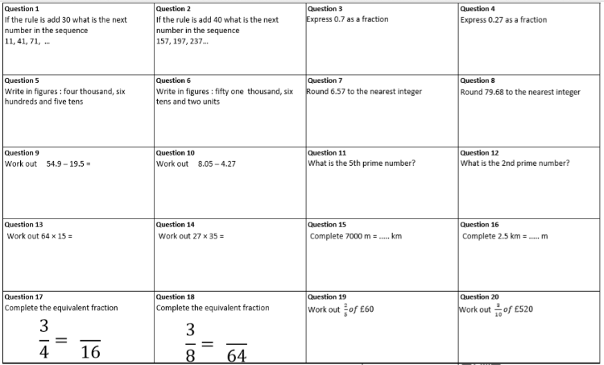  - Year 5 skills check: (answers published below) Reproduced by kind permission of mathsbox.org.uk  Answers from last week: 1. 166, 2. ½, 3. 8480, 4. 395, 5. 50, 6. 5, 7. 1440, 8. 4.5km, 9. 81, 10. 22  - White Rose Maths has daily maths lessons for you to work through:  https://whiterosemaths.com/homelearning/year-5/  Watch the video, pausing to do the activities when you are told. The BBC are providing free worksheets to support the White Rose Maths lessons. Access these here.  From May 4th, White Rose Maths are charging for their worksheets – your school may provide you with a code to access these – the BBC sheets are completely compatible with White Rose.  Answers from above: 1. 101, 2. 277, 3. $\frac{7}{10}$, 4. $\frac{27}{100}$, 5. 4650, 6. 51062, 7. 7, 8. 80, 9. 35.4, 10. 3.78, 11. 11, 12. 3, 13. 960, 14. 945, 15. 7, 16. 2500, 17. 12, 18. 24, 19. £24, 20. £156 | Try to read every day. There are some ideas here:  - This story is about Firestormers :  https://readon.myon.co.uk/reader/index.html?a=fs_ffront_f16  Read chapters 1 & 2: How would you describe Jason’s dad? Do you think Jason has a good relationship with him? Find and copy phrases from the text that prove your answer. Why does Jason lose confidence? Find and copy phrases that show Jason is worried he is not good enough.  Read chapters 3 & 4: How does Jason try to overcome his feelings? What decisions does he make?  Read chapters 5 & 6: Why does Sergeant Rodgers disobey Jason? What do you think has happened? What clues are there?  Read chapters 7 & 8: Why does Jason want to go after Rodgers? Why does he decide not to? Is it the right decision?  - Audible have made all their children’s books free while schools are closed. Choose one and listen:  https://stories.audible.com/discovery  - Read a book of your choice to an adult. Talk about the story and the characters. Predict what you think might happen next. Explain why you like/ do not like the book.  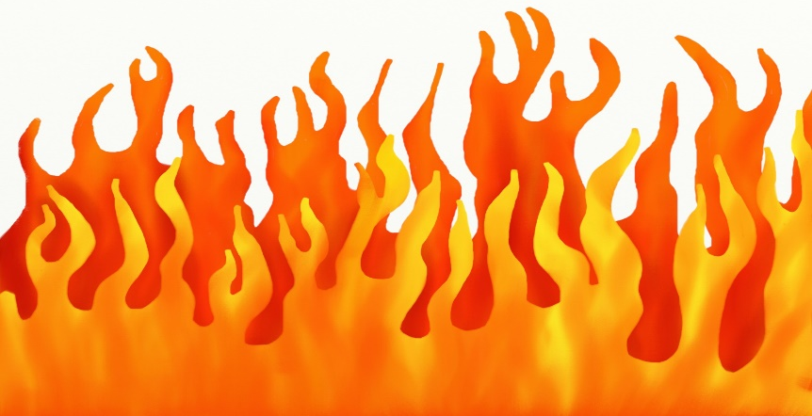  - Read the poem called The Tyger and answer the questions. Choose the 1 star level text. Go to www.twinkl.co.uk/offer and enter the code Parentstwinklhelps. Download the Poem and questions for free. Answers provided.
Weekly Spelling, Punctuation & Grammar Tasks – aim to do one per day | Weekly Writing tasks – aim to do one per day
- Choose some of these tasks to learn how to use a hyphen.  - Recap on active and passive verbs here. Watch the video clip and check you understand the difference between active and passive verb forms.  - Are these sentences active or passive?  - Harry Kane scored an amazing goal.  - The gardener mowed the lawn.  - Reading is liked by all children.  - The children did not like the film.  - The car was driven by an 18 -year- old male.  - The burglary was committed by an elderly man.  - Fish swim in the sea.  - Happily, the children skipped to school.  - The washing was drying on the line.  - Birds build nests in the Spring.  - Now put these active sentences into the passive.  - Miss Goody smiled at the children.  - Mr Meany bellowed at the class.  - Mrs Kind helped the children with their maths.  - Mr Nice gave the children extra playtime.  - Mum baked cookies as a treat.  - Dad cooked burgers on the barbecue.  - I bought eggs and bread at the shop.  - Kate made a cup of tea.  - My brother turned on the light.  - Tom opened the fridge.  - Play and practise words from the year 5 and 6 statutory spelling list.  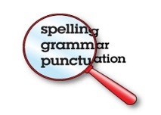 | Focus: poetry  - Watch this clip of flames. Write phrases and sentences to describe the fire. Use powerful similes, metaphors, adjectives, alliteration and personification. Example: Crackling like raindrops falling on rooftops, the orange flames dance deftly in the darkness.  - Read this rhyming poem. Look at the rhyming pattern. Write a poem called ‘Campfire’ following the rhyming pattern. Use some of the words and phrases you created in the task above. Example:  The fire spits and glows with a spark.  The grey smoke drifts into the night.  Its voice is husky, soot and dark  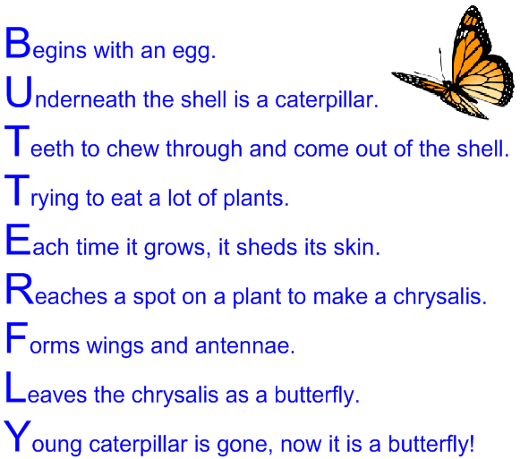  risen to the sky like a kite.  - Look at this poem. It is an Acrostic poem. The first letter of each line spells out the subject of the poem.  Use your ideas from task 1 and other vocabulary you can think of to write an acrostic poem called ‘Candlelight’.  Example: Casting a warm glow,  And flickering in the slightest draught.. etc.  - Look at this free verse poem. Free verse does not have a rhyme or rhythm. The only consideration is where to put line breaks. Poets often do this where there is a natural pause. Otherwise, there are no rules!  Write a free verse poem about a bushfire.  - This week, you have written 3 poems. Choose your favourite and copy it up neatly and illustrate it. Now learn the poem by heart to recite to your family. You could add actions or sound effects to the poem to add drama and atmosphere to your performance. You could video yourself to show your teacher. For tips on how to perform poetry from Michael Rosen, watch this clip.
Learning Project to be done throughout the week
- Science: What is fire? It’s actually not a ‘thing’ but a chemical reaction that releases heat and light. Watch this video that explains what fire is in detail (some parts of it are quite complicated, but it’s worth watching to the end). With adult supervision try the experiments with the candle flames to see the water vapour, soot and wax within the flame.
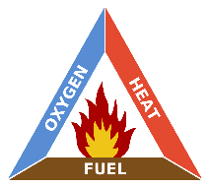
This diagram, called the Fire Triangle, shows the 3 vital things needed to create fire: oxygen, heat and fuel. If one of the 3 things is missing, a fire will go out. Think about ways we can stop the candle burning:
When we blow out the candle what are we stopping?
When we put water on the candle what are we stopping?
When we use a candlesnuffer what are we taking away?
When the candle has no more wax and burns right to the end what has been taken away?

You are going to carry out an investigation into fire. YOU WILL NEED ADULT SUPERVISION AND WATER ON STANDBY IN CASE OF ACCIDENTS.
You will need: a candle, 3 different-sized jars or sturdy glasses, a stopwatch.
What do you think will happen when you put the jar or glass over the candle? How do you think the size of jar/ glass will affect what happens? Make a prediction.
Carry out the investigation and observe the results carefully. What did you notice? Record your results in a table. Can you explain why this happened using the Fire Triangle diagram to help. Was your prediction correct?
CHALLENGE: Can you use the Fire Triangle to help you explain how bush fires happen? How do they start? Why are they so difficult to put out?

- Geography: Deserts are some of the hottest places on Earth. Watch this clip which explains what deserts are like.
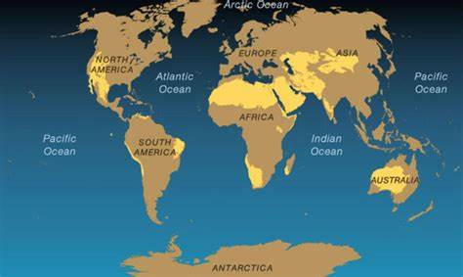
Locate these deserts on this map and label them:
1. Sahara, 2. Atacama, 3. Mojave, 4. Gobi, 5. Kalahari, 6. Arabian, 7. Namib, 8. Somali, 9. Turkestan, 10. Thar, 11. Great Sandy.

Write 10 facts about deserts mentioned in the clip.
CHALLENGE: Explain why deserts are growing and what people could do to stop desertification.

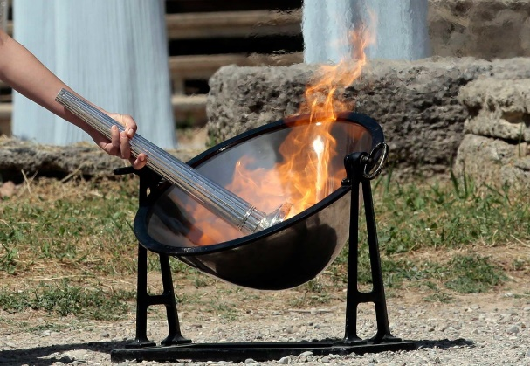
- History: Look carefully at this image. What can you see happening? What questions would you like to ask about the picture? What can you infer from the picture? What clues help you?

Now look on the next page to find out more.

The picture shows the lighting of the Olympic Flame on Mount Olympus in Greece. The flame is lit using the power of the Sun on a mirror so that the flame is pure. Summer 2020 should have seen the Olympic Games take place in Japan, but because of Coronavirus, it cannot happen. Read this information about the Ancient Olympic Games:
The Olympic Games as we know them today have a long history which goes back to ancient times. Although some elements of these Games were revived “as they were” when the modern Olympic Games were created, others were removed or modified. Everything started in the Peloponnese, in Greece, some 3,000 years ago. Sports competitions were organised at Olympia and were named after their location, hence their name of “Olympic” Games. Nobody knows exactly when they began, but the first written mention of them dates back to 776 BC. Historically, the Games were created to provide unity to the Greek world, which, at that time, was split into city-states which were constantly at war. These Games were held every four years.
The information we have today about the ancient Olympic Games comes mainly from the many descriptions of them in ancient literature, as well as from objects found at archaeological digs (statues, vases, coins and tools).
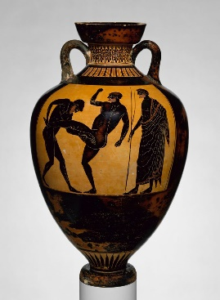
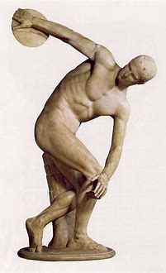
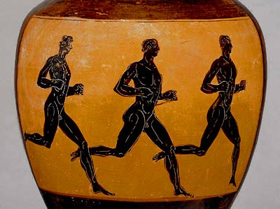
Look at these artefacts and think about what they tell you about the Ancient Olympic Games:
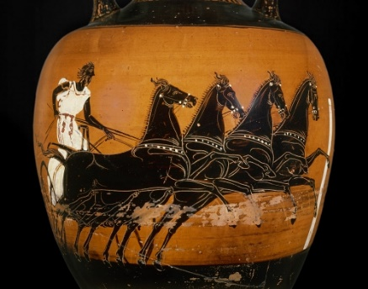
A bronze statue

Some ancient Greek pots discovered near Olympus

CHALLENGE: What don’t the pictures tell you? What else could historians use to find out more information about the Ancient Olympic Games?
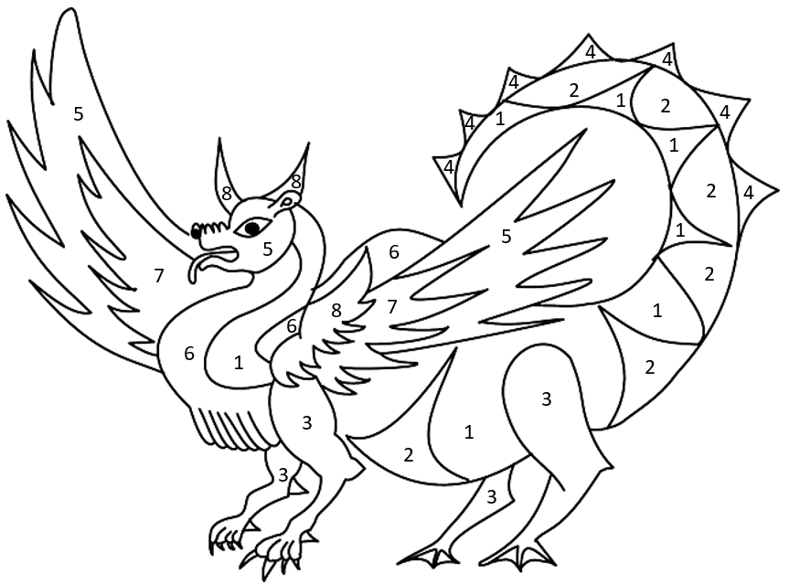
- French: Watch this video from “How to Train Your Dragon” in French. How much of it do you understand? Why? What does it tell you about communicating in a different language? How do Krokmou (Toothless) and Harold (Hiccup) communicate in the clip? Now watch this clip introducing colours in French and repeat each word when told to. Stop the clip at 3:10.

Colour in the picture of the dragon using the key:
un – rouge cinq - violet
deux – orange six - jaune
trois – vert sept - noir
quatre - bleu huit – marron

If you cannot print, draw a picture of a dragon and colour it in. Label the colours in French.
- Computing: Complete the Minecraft ‘hour of code’ coding activities.
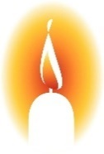
- RE: watch this video clip of a fire ritual in a Hindu temple. Read this information about Agni and answer the questions below.
When Hindus light a fire in their homes they will typically pray to Agni (the Hindu god of fire) and ask for his protection. Agni, and thus fire, is a symbol used in many Hindu ceremonies that form a rite of passage; births, marriages and funerals. The reason for this is because of the four elements, (earth, water, air, fire) fire is the only element that cannot be polluted.
In the writings of Swami Vishwananda it is said: “What is offered into a fire is consumed by the fire and goes upward to the gods, to the sky and heavens.”
Fire is associated with light which in turn is associated with knowledge. Even today we use the light bulb as a symbol when we have a good idea. As the God of Fire, Agni is therefore regarded as the God of Knowledge that guides us along the path the truth. He is said to grant wishes to his followers but on the condition that they make sacrifices. Contrary to popular belief, making sacrifices does not mean killing other living animals, but to give up material desires.

Watch the clip again: what do you think people are burning in this ritual? Why? What other things are happening during this ritual? Why would this event be important for the people attending?
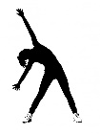
- PE: Every day, Joe Wicks has a 30-minute workout at 9 am. Join in via YouTube.

Family learning
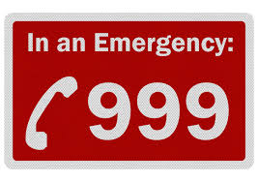
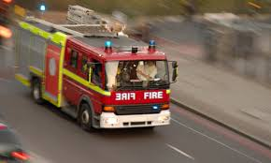
- Practise phoning the fire brigade if there was a fire. Prepare a script that would be used in an emergency and act it out with each other with one person being the operator and the other person reporting the fire. Remember your address!

Talk as a family about the different escape routes out of your home if there was a fire. What would you do? How would you exit if it was smoky?

- PSHCE: Your child may have concerns about the current situation. Childline has lots of advice about how to discuss it with your child. https://www.childline.org.uk/info-advice/your-feelings/anxiety-stress-panic/worries-about-the-world/coronavirus/.

