Learning Project Week 2 ‘Earth’
Age Range Year 6
Weekly Maths Tasks – aim to do one per day | Weekly Reading Tasks – aim to do one per day
Try to do 10 minutes of arithmetic/ mental maths each day:  - https://www.topmarks.co.uk/maths-games/daily10 (Choose level 6 subtraction)  - https://www.timestables.com/rally.html (a range of times tables games to test and challenge you!)  - Year 6 skills check: (answers published next week) Reproduced with kind permission from mathsbox.org.uk  Answers from last week: 1. 61.5, 2. 1$\frac{1}{2}$ , 3. 11.25, 4. £20:£100, 5. 3.5, 6. 1.3, 7. 28%, 0.3, $\frac{2}{5}$, 8. 180, 9. 27, 10. 1$\frac{3}{5}$  - White Rose Maths has daily maths lessons for you to work through:  https://whiterosemaths.com/homelearning/year-6/  Watch the video, pausing to do the activities when you are told. The BBC are providing free worksheets to support the White Rose Maths lessons. Access these here.  From May 4th, White Rose Maths are charging for their worksheets – your school may provide you with a code to access these – the BBC sheets are completely compatible with White Rose. | Try to read every day. There are some ideas here:  - This book is all about Minerals:  https://readon.myon.co.uk/reader/index.html?a=ro_miner_s16  - Read it and write down all the places you could find minerals.  - Look at the captions on the pages. Explain why they are important for the reader.  - Have a look around your house, what minerals can you find? What are their properties? Use the book to help you to use the correct vocabulary, e.g. malleable, durable, etc.  - Audible have made all their children’s books free while schools are closed. Choose one and listen:  https://stories.audible.com/discovery  - Read a book of your choice to an adult. Talk about the story and the characters. Predict what you think might happen next. Explain why you like/ do not like the book.  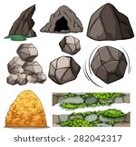  - Read the text about Caves and answer the questions. Choose the level of text (2 or 3 stars). Go to www.twinkl.co.uk/offer and enter the code Parentstwinklhelps. Download the Caves text and questions for free. Answers provided.
Weekly Spelling, Punctuation & Grammar Tasks – aim to do one per day | Weekly Writing tasks – aim to do one per day
- Work through the tasks to learn how to spell words with “shul” sound.  - http://www.scootle.edu.au/ec/viewing/L935/index.html Lots of tasks here to keep you busy while learning how to write a newspaper report.  - Practise your punctuation: https://www.topmarks.co.uk/Flash.aspx?e=spelling-grammar05  - Play games and practise words from the year 5 and 6 statutory spelling list:  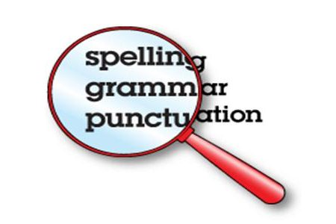 | Focus: Newspaper report  - Watch the video about a cavern. Write down descriptive words and phrases to describe what you can see. Imagine what you might hear? What would the stalagmites feel like? How would you be feeling in the cavern? E.g.: Freezing cold, the pale rocks felt as shiny as a marble.  - Complete the activities here to learn how to write an effective newspaper report. http://www.scootle.edu.au/ec/viewing/L864/index.html  - Read about different things that have been found in caves here. What could you find in a cave? Perhaps a new species, or treasure, or ancient paintings? Imagine you found a secret cave and discovered something amazing inside. Draw what you find and write descriptive sentences about it, e.g. Deep underground, hidden for thousands of years, lay an immense bronze statue. As tall as a giant, the statue depicted a fierce dragon, wings splayed, teeth bared and its eyes still shone with animosity.  - Plan and write a newspaper report about an amazing cave that has been discovered under your house! Describe the cave and anything unique that has been found in it (you could use your ideas from yesterday). You will need to include: headline, introductory sentence (5 w’s), quotes from witnesses, a picture with caption, a re-orientation. You will probably need to do this task over a couple of days.
Learning Project to be done throughout the week
- Science:
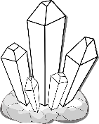
- In the book “Rock On Minerals”, https://readon.myon.co.uk/reader/index.html?a=ro_miner_s16 it tells you how to grow your own crystals using salt and water. Follow the instructions and make observations every day. You could take photographs and compare the progress each day.
- Watch this video for a reminder of what a solution is: https://www.bbc.co.uk/bitesize/topics/zcvv4wx/articles/zpbdpbk Make another saltwater solution. Growing crystals is one way of extracting the salt, can you think of other ways? Could you sieve it? Filter? Boil? Watch this video for more information: https://www.bbc.co.uk/bitesize/topics/zcvv4wx/articles/zw7tv9q Then complete the activities underneath the video. If you want to try any of these methods of separation, please ask an adult to supervise.

- Music: Watch the video of the piece of music called “Hall of the Mountain King”. As you listen, draw what you visualise on a large sheet of paper. Use different colours to show the mood/ atmosphere of the piece. Now listen carefully to the first part of the piece. The pizzicato (plucking of strings) creates the effect of footsteps. Try to recreate this sound using things you have at home. You could use: an elastic band or string. Listen to how the music speeds up. This is called accelerando. Try to play your pizzicato along with the music – keep in time as it gets faster! Think about how you feel as the music gets faster. Does the music effectively express the idea of running away? How does it do that? Think about: pitch, volume, pace, range of instruments.

- Geography: Read about settlements here: https://www.3dgeography.co.uk/settlement-geography . Some parts of moorland Derbyshire would not be suitable for settlement but people moved to live there. Can you work out why? Explore Castleton on Google maps. Click here. What reasons can you find for people to have moved here to live? What resources were available? (Refer to the information you read on 3d geography).

- Design and Technology: Make a fruit pie. Adult supervision required. https://www.bbcgoodfood.com/recipes/gales-blackberry-apple-pie Practise rubbing in, rolling out skills to make the pastry and knife skills to prepare the fruit. Discuss the seasonality of the fruit you have chosen: where in the world does it come from? What type of climate is it grown in?

- Computing: if you have no experience of coding: complete the “Sequencing” express course: https://studio.code.org/s/pre-express-2019 If you already have some experience, start at the “Loops” activity.

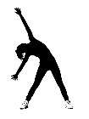
- RE: Many people find comfort from their religion in difficult times. This might be through prayer or through gathering in their religious community, reading sacred texts, singing, talking to a religious leader, etc. Think about things that you do to feel better when you may be feeling upset. How do these things help you?

- PE: Every day, Joe Wicks has a 30 minute workout at 9 am. Join in via YouTube.
Family learning
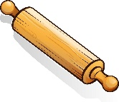
- Learn to use a new kitchen tool together e.g. whisk, rolling pin. Use to bake a cake or biscuits together and eat them!

- PSHCE: Your child may have concerns about the current situation. Childline has lots of advice about how to discuss it with your child. https://www.childline.org.uk/info-advice/your-feelings/anxiety-stress-panic/worries-about-the-world/coronavirus/

