Learning Project Week 4 ‘Water’
Age Range Year 6
Weekly Maths Tasks – aim to do one per day | Weekly Reading Tasks – aim to do one per day
Try to do 10 minutes of arithmetic/ mental maths each day:  - https://www.topmarks.co.uk/maths-games/daily10  (Choose level 6 partitioning)  - https://www.timestables.com/rally.html (a range of times tables games to test and challenge you!)  - Year 6 skills check: (answers published next week) Reproduced with kind permission from mathsbox.org.uk  Answers from last week: 1. 1.13, 2. 3$\frac{1}{3}$, 3.11.5, 4. £8 £52, 5. 3.1, 6. 5.4, 7. 5% $\frac{1}{5}$ 0.5, 8. 240, 9. 64.2, 10. 4$\frac{3}{4}$  - White Rose Maths has daily maths lessons for you to work through:  https://whiterosemaths.com/homelearning/year-6/  Watch the video, pausing to do the activities when you are told. The BBC are providing free worksheets to support the White Rose Maths lessons. Access these here.  From May 4th, White Rose Maths are charging for their worksheets – your school may provide you with a code to access these – the BBC sheets are completely compatible with White Rose. | Try to read every day. There are some ideas here:  - This book is all about how water can be used to make electricity:  https://readon.myon.co.uk/reader/index.html?a=ej_wtecr_f15  It is quite a long book, with lots of information so aim to read about 10 pages each day. Each day, make notes about 3 important facts you have learned.  - Audible have made all their children’s books free while schools are closed. Choose one and listen:  https://stories.audible.com/discovery  - Read a book of your choice to an adult. Talk about the story and the characters. Predict what you think might happen next. Explain why you like/ do not like the book.  - Read the text about Water Woman and answer the questions. Choose the level of text (2 or 3 stars). Go to www.twinkl.co.uk/offer and enter the code Parentstwinklhelps. Download the text and questions for free. Answers provided.
Weekly Spelling, Punctuation & Grammar Tasks – aim to do one per day | Weekly Writing tasks – aim to do one per day
- Work through these tasks to learn more about how to add suffixes -ent, -ant, -ence, -ance.  - Watch this video to remind you how to use speech marks. Pause the video at 3:03 and try to write the sentence with correct punctuation. Press play to check your answer. Pause again at 3:36 and punctuate that sentence correctly. Repeat again at 4:10. Then try the quiz – choose the correct answer within the time limit.  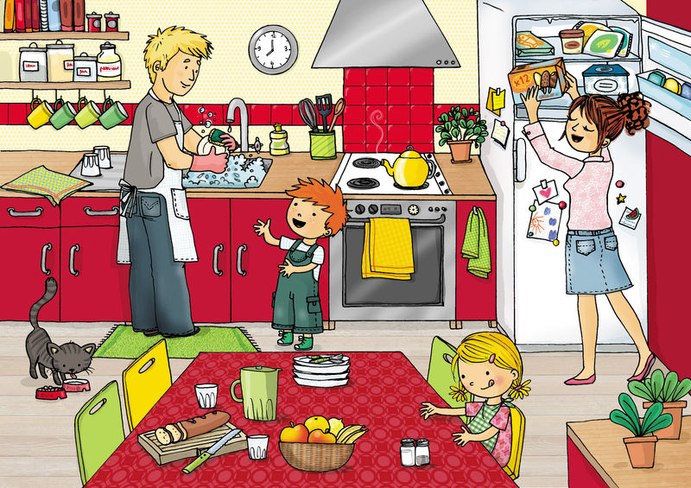  - Write 8 sentences using speech marks about this picture. CHALLENGE: use pauses in speech or quote someone else’s speech.  - Practise words from the year 5 and 6 statutory spelling list: https://spellingframe.co.uk/spelling-rule/56/56-Word-list-years-5-and-6---eq-to-f  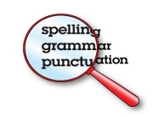 | Focus: Fiction  - This week’s tasks are all about the power of water. Use a dictionary and thesaurus to find as many verbs, adjectives and adverbs you could use when writing about water, e.g.  flowing, splashing, pouring; pure, transparent, cool; gently, ferociously, silently, etc.  - Read the Water Woman text again. Invent your own water-based superhero (remember water has several forms: ice, steam, liquid). Draw a picture of him/ her and label with descriptive words and phrases. Think about his/ her character as well as appearance. Consider how he/she became a superhero. What happened to him/ her? You could use this idea as a ‘flashback’ when you write your story later in the week.  - Your superhero needs a nemesis (enemy). Invent an enemy for your superhero to battle against. Think carefully about why they are enemies (you could use this in your story as a ‘flashback’ later in the week). Write a detailed description of the enemy: appearance, personality, any superpowers they have, etc.  - Plan and write a story about your water superhero Your plan needs an introduction, build-up, dilemma, resolution and ending.  In your introduction, introduce your superhero. Describe him/ her and explain how he/ she got his/ her powers. In the build-up, describe the events leading up to the threat/ catastrophe including your enemy’s description. The dilemma is the part where you describe an impending disaster! What has the enemy done? In the resolution, explain how the superhero defeated the enemy or solved the catastrophe. In the ending explain what happened after the event. This task will take you more than one day to complete.  Use lots of description to add detail. Try to use some relative clauses and speech marks too.
Learning Project to be done throughout the week
- Science: Water is a powerful force and is often used to produce energy that we can use. In this experiment, you will be recording how far a small object can be moved using just the power of water.
You will need: a small object (e.g. a small stone, an eraser, a plastic toy - the object should not absorb water and should be heavy enough that it will not float easily); a large plastic tub or use the bath; masking tape; permanent marker; a measuring jug or bucket; water; a ruler.
Instructions:
- Use the masking tape to make a vertical line at one end of the plastic tub or bath. This will be the starting point for your light object each time. Put water in the tub or bath to a depth of around 5 cm.
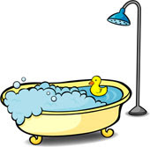
- Using the permanent marker, write START on the masking tape.
- Place your object at the masking tape line.
- Put 100ml of water in your jug or bucket.
- Pour the water into the tub or bath. This should be done quickly and from behind the object.
- Watch how far the water moves the object.
- Put a piece of masking tape where the object stops.
- On this piece of tape write 100ml. Do you think more water will make the object move further? Make a prediction.
- Repeat steps 3 to 8 for 500ml, 1 litre, 1.5 litres, 2 litres.
- Once you have done each one, use the ruler to measure the distance from the starting line to each piece of masking tape and record the distance in a table.
- What conclusions can you draw about the power of water? Do you think this is a fair test? How could you make sure it is fairer?
- Make sure you are water smart and reuse as much water as you can (use it to water plants)
CHALLENGE: How could you change this experiment to test how the mass of the object affects the distance travelled? Think about what needs to stay the same now.

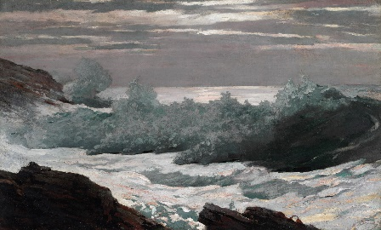
- Music: Watch the video of the full performance of the piece of music “Storm” by Benjamin Britten. The piece “tells” the story of a storm at sea. Imagine the storm as you listen for the first time. Watch the video introduced by Leanne & Sarah. It explains the music to you. As you listen, can you hear the same melody being repeated several times? This is called the Chorus. How many times in the piece can you hear it? Find something at home you could use as a percussion instrument (a drum could be made from a bowl or pan). Listen to the piece again and every time you hear the chorus, join in with the rhythm of it. Experiment with different sizes of pan or bowl, which kind produce a sound that fits in with the atmosphere of a storm? Can you find something else at home that makes a noise that would fit with the piece? Try making up words to the chorus part. Experiment with your voice to add atmosphere: whisper, shout, use low pitch, high pitch, etc. Halfway through the piece, the pace slows down. What do you think is happening on the sea at this time? At the end (the Coda), the piece speeds up again. What do you think happened? What makes you think that?
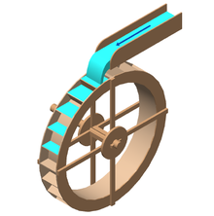
- Design & Technology: you are going to create a waterwheel to further investigate the power of water. Waterwheels have been used for centuries to drive machinery. Today, they are often used to create electricity. The instructions for how to do this are given in the book From Falling Water to Electric Car that you read as the ‘Reading’ task. Go to the ‘Other pages’ section and choose activity 1. If you do not have a cotton reel at home, you could use a ball of play-doh or blu-tack, or even try an empty toilet roll. Experiment with different sizes of paddle and different numbers of paddles. Do bigger paddles make the wheel spin quicker or slower? Do more paddles make it spin quicker or slower? Make sure that you make the test fair. Think about what needs to stay the same to make sure it is fair.

- Geography: Complete the tasks here. First, label the water cycle features (if you can’t print at home, you could draw and label your own version). Then think about how humans are disrupting the water cycle through their actions of farming, factories, dams, waste and litter. Write down your ideas. Answers are given so you can check. CHALLENGE: how might these actions change the planet’s water supply in the future?

- Computing: Continue with the coding activities you started: https://studio.code.org/s/pre-express-2019

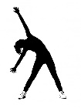
- RE: water is used in religious ceremonies for many faiths: baptism for Christians, cleansing for Jews and Wudu for Muslims. Find out 5 facts about each of these activities. In each ceremony, what does the water symbolise?

- PE: Every day, Joe Wicks has a 30- minute workout at 9 am. Join in via YouTube.
Family learning
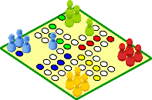
- Design, make and play a board game for the whole family. You could base it on a water adventure if you like or something completely different!

- PSHCE: Your child may have concerns about the current situation. Childline has lots of advice about how to discuss it with your child. https://www.childline.org.uk/info-advice/your-feelings/anxiety-stress-panic/worries-about-the-world/coronavirus/ .
- You could also try using stories to help address any worries. There are some options here: https://www.youtube.com/watch?v=TQ0wyzjr5mg https://www.youtube.com/watch?v=VCyiiHI2SJU

