Learning Project Week 5 ‘Air’
Age Range Year 6
Weekly Maths Tasks – aim to do one per day | Weekly Reading Tasks – aim to do one per day
Try to do 10 minutes of arithmetic/ mental maths each day:  - https://www.topmarks.co.uk/maths-games/daily10  (Choose level 6 digit values)  - https://www.timestables.com/rally.html (a range of times tables games to test and challenge you!)  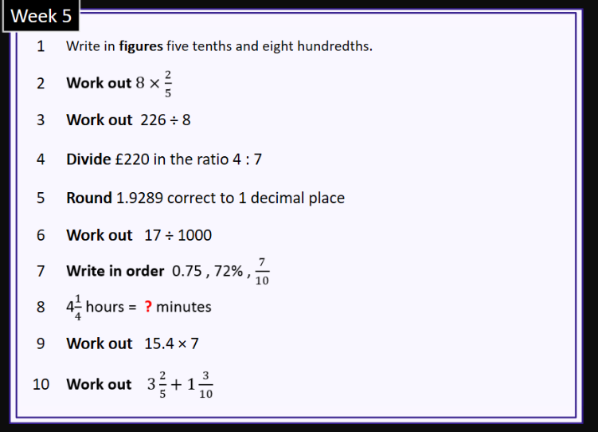  - Year 6 skills check: (answers published next week) Reproduced by kind permission of mathsbox.org.uk  Answers from last week: 1. 1.52, 2. 4, 3. 17.5, 4. £54 £126, 5. 11, 6. 0.06, 7. 15% $\frac{1}{5}$ 0.21, 8. 105, 9. 100, 10. 3$\frac{1}{2}$  - White Rose Maths has daily maths lessons for you to work through:  https://whiterosemaths.com/homelearning/year-6/  Watch the video, pausing to do the activities when you are told. The BBC are providing free worksheets to support the White Rose Maths lessons. Access these here.  From May 4th, White Rose Maths are charging for their worksheets – your school may provide you with a code to access these – the BBC sheets are completely compatible with White Rose. | Try to read every day. There are some ideas here:  - This book is all about different extreme weather:  https://readon.myon.co.uk/reader/index.html?a=dh_tskie_f13  - Read a few sections each day. At the end of each day, write quiz questions you could ask someone about the facts in the book. Try quizzing someone at home and see what they know about severe weather.  - When you finish the book, explain why accurate weather forecasting is so important. Use examples of events from the book to justify your answer.  - Throughout the book, there are many words to suggest how dangerous weather can be, e.g. threatening, deadly, etc. Find as many as you can and think of antonyms for each one.  - Audible have made all their children’s books free while schools are closed. Choose one and listen:  https://stories.audible.com/discovery  - Read a book of your choice to an adult. Talk about the story and the characters. Predict what you think might happen next. Explain why you like/ do not like the book.  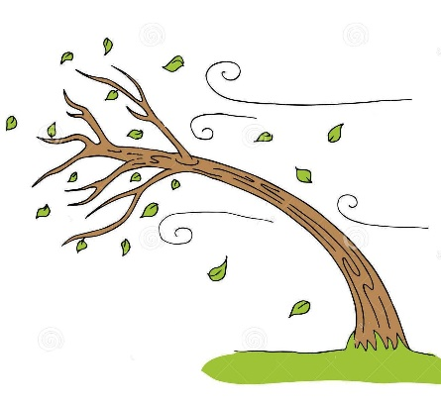  - Read the text about Air Pollution and answer the questions. Choose the level of text (2 or 3 stars). Go to www.twinkl.co.uk/offer and enter the code Parentstwinklhelps. Download the text and questions for free. Answers provided.
Weekly Spelling, Punctuation & Grammar Tasks – aim to do one per day | Weekly Writing tasks – aim to do one per day
- Work through these tasks to learn about how to add suffixes -able and -ible.  - Look at these 3 sentences that show parenthesis:  - I miss seeing Adam, my best friend from school, every day.  - I miss seeing Adam – my best friend from school – every day.  - I miss seeing Adam (my best friend from school) every day.  The most common way to show parenthesis is to use brackets within a sentence to add information for detail or clarification. What is key to remember is that the sentence to which the parenthesis is being added should make grammatical sense whether the information in the brackets is there or not.  E.g. I miss seeing Adam every day makes sense on its own.  Watch this video to see how they work. In the Quiz, can you answer the question correctly before the time runs out?  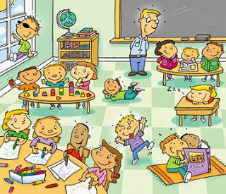  - Write 8 sentences using parenthesis about this picture. Try to use all 3 types: brackets, dashes and commas.  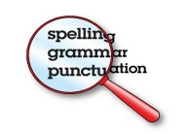  - Practise words from the year 5 and 6 statutory spelling list: https://spellingframe.co.uk/spelling-rule/57/57-Word-list-years-5-and-6---g-to-le- | Focus: Non-Fiction  - Go outside if you can (otherwise go into a room alone). Sit quietly and listen to everything around you. Make a quick list of all the sounds you hear. Focus on even the quietest rustle. Then write a sentence about each sound to describe what made it. Try to use similes, metaphors, fronted adverbials, expanded noun phrases and adverbs. E.g.: In the silence, the ancient trees by the lake are softly whispering secrets to each other. You could even try to write a sentence about the sound of your own breathing.  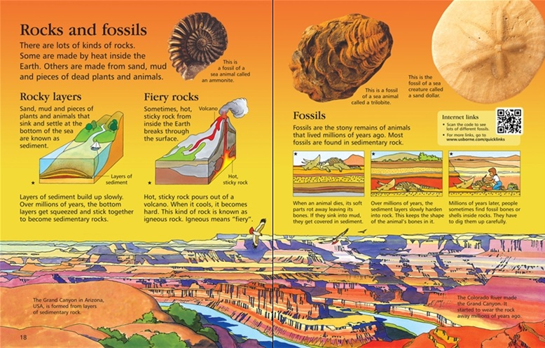  - Look at this image. It is a page from a non-fiction book. What features can you see? What is the job of each feature? E.g.: sub-headings tell you what each section of text is about.  - Watch the video about breathing again. As you watch, write down sub- headings you could use in your report about oxygen and breathing. Make notes under each heading. This website will also help you to get enough facts: https://www.ducksters.com/science/breathing.php  - Watch the video about breathing again. Write sentences about what how each of these things are involved: nose, trachea (wind-pipe), diaphragm, bronchi tubes, alveoli, blood. Try to use parenthesis in each of your sentences, e.g.: The nose, which has two openings called nostrils, takes in the air from the environment.  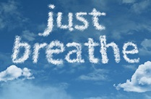  - Write a report (like the Rocks and Fossils text above) that explains how oxygen travels around your body. You can use any information sources you have used this week. Make sure you have a title, introduction, sub-headings, diagrams with labels and give lots of facts. Make your work attractive so that people want to read it.
Learning Project to be done throughout the week
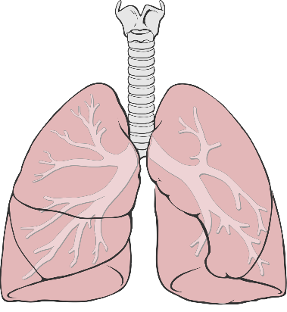
Science: Take a deep breath in and out. When we breathe in, a muscle under our lungs (diaphragm) pulls down, which pulls air into our lungs (takes in oxygen in the air) - What else happens? Our chest rises pushing our ribs up and out! When the muscle relaxes, our chest falls - forcing air out of our lungs through our mouth (gets rid of carbon dioxide)! The amount of air that we breathe in when we take a deep breath is called our lung capacity. Amazing fact: we breathe over 23 000 times a day (more if we exercise!). Watch this video that explains how we breathe and why it is so important.
Today you are going to measure your lung capacity like the children in the video. You will need: a large plastic bottle, a large bowl, a straw or tube, a measuring jug, a felt-tipped pen or masking tape. This can cause spills so do it outside or over a sink/ bath!
- First you will need to mark the bottle showing the capacity. Pour 100ml of water into the bottle and label the side with tape or felt-tip. Add another 100ml and mark it, then another and another until it is full.
- Put the straw or tube into the bottle and carefully turn it upside down holding your fingers over the end so no water comes out. Putting it into a bowl of water helps to keep the water inside.
- Ask someone to hold the bottle for you. Take a deep breath in and then blow out in one breath until your lungs are as empty as possible.
- Look at the scale to see your lung capacity. Repeat the experiment twice more so you have 3 results.
- Ask someone in your house to try it too. Predict it you think they will have a larger lung capacity than you or not. Compare your lung capacities. Remember to think about keeping your test fair. What can you do to ensure it is a fair test? What do you need to keep the same?
Write an explanation of the test you carried out and what you discovered. Was your prediction correct? Why do you think lung capacities might be different? Do you think age, gender, weight, height, health conditions will have an effect? Explain your thinking.
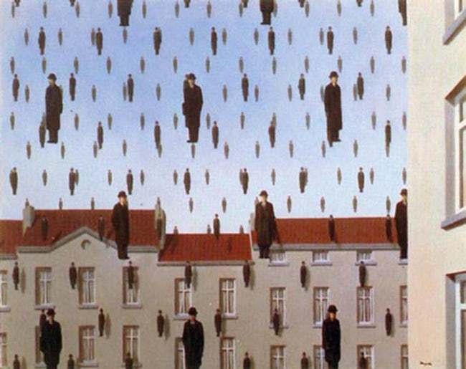
- Art: Look at this painting called Golconda by Rene Magritte. Magritte was a Surrealist artist. Surrealism began in the 1920s and the style was very different at the time. It was influenced by dreams and famous artists include Salvador Dali and Dorothea Tanning. The paintings were very precise and almost photographic in their detail. Watch this video that explains the style more.
Magritte lived in the street shown here and he often wore a bowler hat and black coat like the figure in his work.
Use this painting as inspiration for your own surrealist painting.
Use the view from your window as a backdrop and draw figures floating in the air. Perhaps each figure could be you or someone in your family!

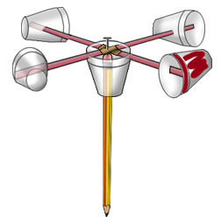
- Design & Technology: You are going to create an anemometer so you can record the wind speed for your Geography work this week. You will need: 5 paper cups, 2 straws, 1 pencil with a rubber on the end, 1 drawing pin.
- Using a pair of scissors, poke 4 evenly spaced holes around the edge of 1 cup. These holes should all be the same distance away from the edge of the cup. Adult supervision required.
- Insert the straws through the holes you just made so that the straws overlap in the centre of the cup.
- Make a hole in the bottom of the cup at the very centre. Make sure that the hole is the size of your pencil.
- Insert the pencil through the hole in the bottom so that the eraser is touching the intersection of the straws.
- Poke your drawing pin through the two straws and into the rubber in the pencil.
- Using the scissors, make two holes in the remaining 4 cups. Make sure that these holes are opposite each other and are the same distance from the lip of the cups.
- Place them onto the straws by threading the straws through the holes you just made in the cups. Position the cups so that the opening of one cup faces the bottom of the one before it.
- Measure the windspeed! Ten turns in one minute is equal to 1 mph of wind speed. Marking the bottom of one cup will help you to count the turns.
Day | Wind speed | Rainfall (mm) | Cloud coverage | Type of cloud | Temperature (optional)

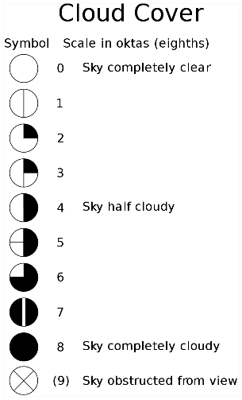
- Geography: The weather affects many aspects of life. It controls what crops we can grow, the shape of the land, water supply, leisure activities. Can you think of any more? Keep a weather diary for the week. Record wind speed, rainfall (by collecting it in a cup each day), cloud coverage (see scale), types of cloud (identification sheet given) and temperature if you can.

CHALLENGE: Using your results, try to predict what you think the weather will be like for the next 2 days. What are you basing your predictions on? Were you correct? Why (not)?

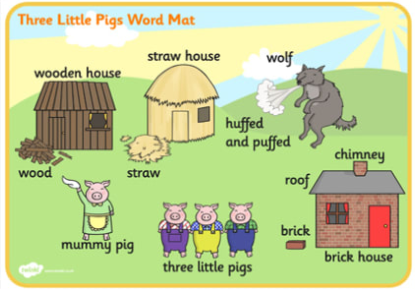
- French: Watch the video of the 3 little pigs in French. There are English sub-titles to help you understand. Watch again and match these French words to the English ones in this picture.
- Trois petits cochons 7. Maman cochon
- paille 8. Une maison en paille
- soufflé et soufflé 9. Une maison en bois
- loup 10. Une maison en briques
- bois 11. brique
- La grande cheminée 12. toit
Draw a cartoon strip of the story and label it in French.

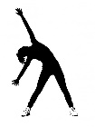
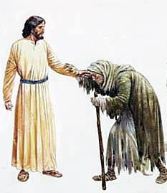
- RE: Watch the video story of Jesus Calms the Storm . What does this story tell Christians about Jesus in times of trouble? Can Christians use this message to help them to cope with the difficulties during the coronavirus pandemic? What do you think Jesus would do if he were here now? In the bible, Jesus visited the sick and healed lepers (people suffering from leprosy – a very contagious disease), but we are not allowed to leave our homes. Does this cause a dilemma for Christians today who want to follow Jesus’ teaching? Discuss this with the people in your home. How can Christians follow Jesus’ example without leaving their homes?

- PE: Every day, Joe Wicks has a 30- minute workout at 9 am. Join in via YouTube.
Family learning
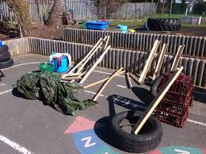
- Use different materials that you can find at home to create a structure that will keep a teddy bear safe in the wind. What are the best shapes? How tall is it going to be? What is the best material? Test your structure with a hairdryer! Can your structure stay up for longer than 2 minutes in the wind?

- PSHCE: Your child may have concerns about the current situation. Childline has lots of advice about how to discuss it with your child. https://www.childline.org.uk/info-advice/your-feelings/anxiety-stress-panic/worries-about-the-world/coronavirus/ .
- You could also try using stories to help address any worries. There are some options here: https://www.youtube.com/watch?v=TQ0wyzjr5mg https://www.youtube.com/watch?v=VCyiiHI2SJU

