Learning Project Week 6 ‘Air’
Age Range Year 6
Weekly Maths Tasks – aim to do one per day | Weekly Reading Tasks – aim to do one per day
Try to do 10 minutes of arithmetic/ mental maths each day:  - https://www.topmarks.co.uk/maths-games/daily10  (Choose level 6 multiplication)  - https://www.timestables.com/rally.html (a range of times tables games to test and challenge you!)  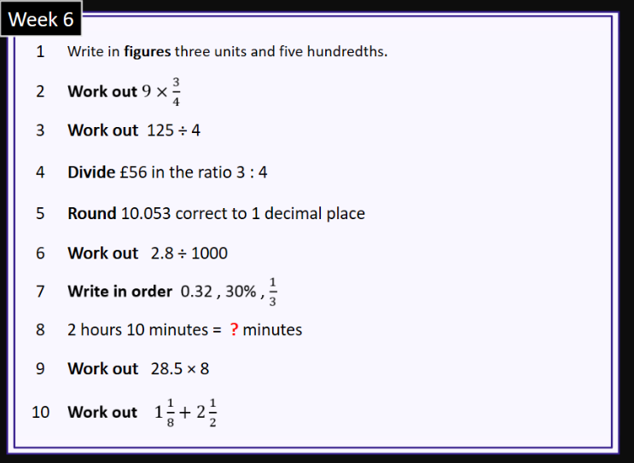  - Year 6 skills check: (answers published next week) Reproduced by kind permission of mathsbox.org.uk  Answers from last week: 1. 0.58, 2. 3$\frac{1}{5}$, 3. 28.25, 4. £80 £146, 5. 1.9, 6. 0.017, 7. $\frac{7}{10}$ 72% 0.75 8. 255, 9. 107.8, 10. 4$\frac{7}{10}$  - White Rose Maths has daily maths lessons for you to work through:  https://whiterosemaths.com/homelearning/year-6/  Watch the video, pausing to do the activities when you are told. The BBC are providing free worksheets to support the White Rose Maths lessons. Access these here.  From May 4th, White Rose Maths are charging for their worksheets – your school may provide you with a code to access these – the BBC sheets are completely compatible with White Rose. | Try to read every day. There are some ideas here:  - This book is all about energy sources:  https://readon.myon.co.uk/reader/index.html?a=ow_pplay_f16  - Read a section each day. After each section, make a list of advantages and disadvantages of each energy source mentioned.  - When you finish the book, write a summary of each section.  - Audible have made all their children’s books free while schools are closed. Choose one and listen:  https://stories.audible.com/discovery  - Read a book of your choice to an adult. Talk about the story and the characters. Predict what you think might happen next. Explain why you like/ do not like the book.  - Read the text about the cyclone in the Wizard of Oz. Answer the questions that follow it. Write down all the words in the passage that describe the way the wind moves or sounds, e.g. shrieked, whistled, etc.
Weekly Spelling, Punctuation & Grammar Tasks – aim to do one per day | Weekly Writing tasks – aim to do one per day
- Work through these tasks to learn more about how to add suffixes -able and -ible.  - The way we talk and write involves formal and informal English.  Formal language is used for more official and serious purposes. The correct grammar should always be used.  In informal situations and informal writing, a more relaxed casual and chatty style can be used. Slang words and abbreviations are more acceptable.  Think of formal words to replace these informal words: job, enough, now, chat, get better, get bigger.  - Now re-write these sentences to make them formal:  - Are you coming?  - What do you want?  - I need more!  - Let’s go now!  - Do you want some dinner?  - Go and get your coat.  - The garden’s a right mess.  - It’s hot today, innit?  - I can’t stand pineapple.  - Try not to fall.  - Practise words from the year 5 and 6 statutory spelling list: https://spellingframe.co.uk/spelling-rule/58/58-Word-list-years-5-and-6---li--to-pe-  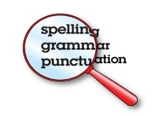 | 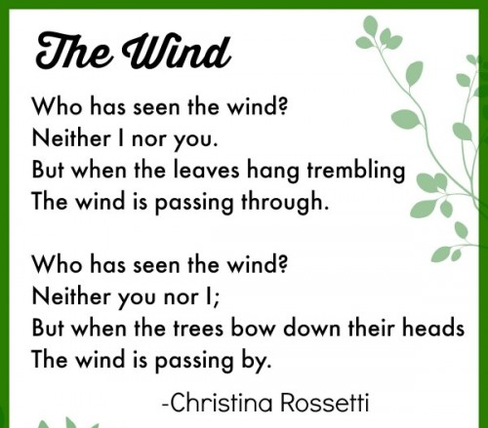  Focus: Balanced Argument  - Read this famous poem about the wind. The first 3 lines of each stanza are very similar. Write a third stanza for the poem where the wind is stronger. Use interesting language to create a strong image of the tree for your reader.  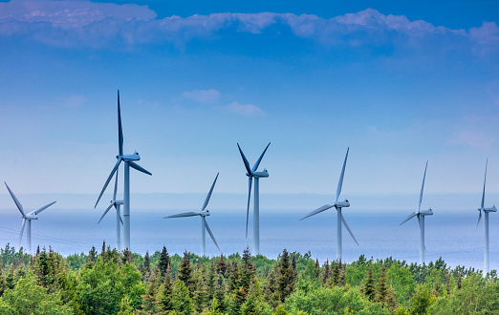  - Look at this picture of wind turbines. How does it make you feel? Do you feel that they spoil the view? Discuss your opinion of them with other people in your house. Do they feel the same? Write 5 formal sentences that explain your opinion about how wind turbines look.  Words to help you start:  In my opinion, Personally, From my perspective, My impression is that, etc.  - Watch this video about writing a balanced argument. Pause it at 2:30 and put the factors into the table under headings ‘for’ and ‘against’. Pause it again at 3:43 and write sentences using the sentence openers given and the reasons, E.g. Some people say tourists should not be allowed to climb Snowdon as they are eroding the pathways.  - Plan a balanced argument about wind power. You will need to gather a list of reasons ‘for’ and ‘against’ using wind power. Here are some ideas: it’s free, it doesn’t cause pollution, it can provide energy to remote places, wind is not constant, turbines are expensive and unattractive. Add some more of your own and write sentences using the sentence starters from the video to help you.  - Write your final balanced argument about wind power. Remember to use the sentence starters from the video and use formal language throughout your writing. You could also use parenthesis that your learned about last week.
Learning Project to be done throughout the week
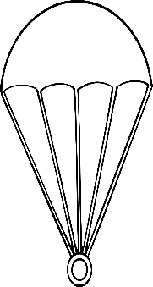
- Science: Although we can’t see the air around us, it causes friction on our bodies as we move through it. The force we feel from it (like when the wind blows) is called air resistance. Watch this video to see air resistance in action. Pay close attention to the section about parachutes. These are used to slow down the effect of falling by increasing air resistance.
Investigate how different sizes of parachute affect the rate of falling. Design and make a parachute from an air resistant material (a piece cut from a plastic bag is ideal). Attach an object to it (anything you have at home is fine, as long as it is unbreakable!). Release the object with the attached parachute from an upstairs window if possible and time how long it takes to fall to the ground. How could you increase the time it takes to fall? What would you change? To keep the test fair, what do you need to keep the same? Repeat the investigation changing only one thing. Did you manage to slow down the descent?
Write an explanation of your investigation and draw a diagram to explain what you did. CHALLENGE: write a sentence explaining how air resistance slowed down your parachute.

- Music: Join in with this online Body Percussion lesson. You will learn how to make different pitch sounds using just your body. All the different sounds you make are made by the air around you. You will also learn about rhythm, pulse, beat and volume. It is also great fun! If you clap for the NHS on Thursdays, maybe you could do a rhythm you have learned on here this week!

- History: Explore how changes in energy production through history have changed life on Earth. You could use the reading book as a good starting point. This video shows you more detail of each energy source. Consider how each of the following inventions (or discoveries) impacted people’s lives: fire (burning biomass), kiln (burning biomass to hotter temperatures), water, wind, coal, natural gas, internal combustion engine, oil, nuclear. Create a timeline to show the invention of each energy source and explain how this changed life for people at the time. Think about changes to health, jobs, leisure. Draw a picture for each energy source.
Example:
1.5 Million Years Ago, early humans discovered fire. They burned biomass (wood) and began to cook food. By cooking food, more nutrients were released so people’s brains grew larger and humans began to spend more time doing new things and discovering more.

- PSHCE: Looking after your lungs is essential to keep you healthy. Watch this video about the harmful effects of smoking and design a poster to warn people of the dangers of smoking.

- Computing: Continue with the coding activities you started: https://studio.code.org/s/pre-express-2019.
If you have already completed the 3 sections, try making your own ‘Flappy Birds’ game by following the tutorial here.

- RE: Watch this video that explains why the Qu’ran is so important for Muslims. Identify three reasons why the Holy Qur’an is important to Muslims, and how it makes a difference to how they live. Watch the video story of The Night Journey . In this story from the Hadith (a book of sayings and actions of the prophet Muhammad), Muhammad is transported to Jerusalem and then to Heaven in one night. How does the story help Muslims to understand the nature of God? Does this story help Muslims to visualise God? Compare this story with others you know about people or prophets who communicated with God, e.g. Moses receiving the 10 commandments. What are the similarities/ differences between these stories?
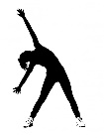

- PE: Every day, Joe Wicks has a 30- minute workout at 9 am. Join in via YouTube.
Family learning
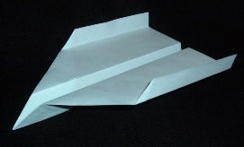
- Design and make a paper aeroplane. Decorate it and test it. Which member of the family has made the best paper aeroplane that travels the furthest?

- PSHCE: Your child may have concerns about the current situation. Childline has lots of advice about how to discuss it with your child. https://www.childline.org.uk/info-advice/your-feelings/anxiety-stress-panic/worries-about-the-world/coronavirus/ .

