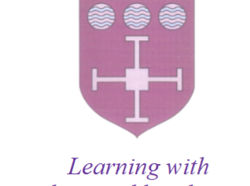
St Laurence C of E Primary School
(Part of The Derby Diocesan Academy Trust)
Collingwood Road
Long Eaton
Derbyshire
NG10 1DR
Tel. 0115 9728469
Head of School: Mrs R Barker BA (Honours)

SUMMARY OF MAIN DUTIES / RESPONSIBILITIES

Job Title: Midday Supervisor

Job Purpose:

To supervise and ensure the safety of children throughout the mid-day break by encouraging children to treat each other with respect and to follow the school Behaviour Policy at all times.

Main Duties / Responsibilities

ORGANISATION

- Take instructions from the Senior Midday Supervisor and/or Senior Management Team (SMT) regarding the supervision of children throughout the breakfast and lunchtime break, giving instructions and guidance to Breakfast / Lunchtime Supervisors as appropriate
- Supervise designated areas by following the rules set out in the Behaviour Policy and reporting unruly behaviour to a member of SMT
- Deal with minor problems and report any persistent unruly behaviour, incidents of fighting, bullying or racial / personal abuse to the Senior Midday Supervisor or a member of the SMT as appropriate
- Ensure children leave the dining hall in a tidy condition by giving the necessary guidance to children in respect of cleaning plates, placing cutlery and crockery in trays provided and seating arrangement.
- Be aware of and comply with school polices relating to child protection, health and safety, confidentiality and data protection

RESOURCES

- Work as support to SMT, duty teachers during breaks as appropriate
- Provide advice and guidance to staff, pupils, parents/carers and others

Person Specification
- Will possess basic literacy and numeracy skills (grammar, spelling and basic mathematical knowledge) (Essential)
- Equivalent experience (Desirable)
Knowledge and skills:
- Will be aware of, and comply with, policies and procedures relating to child protection, health, safety and security and confidentiality, reporting all concerns to an appropriate person (Essential)
- Will be prepared to use relevant equipment (Essential)
- Will possess the ability to relate well to children and adults (Essential)
- Will be prepared to gain knowledge of health, hygiene and safety procedures, first aid, and precautions and regulations (Desirable)
- Will possess the ability to work alone or as part of a team (Essential)

