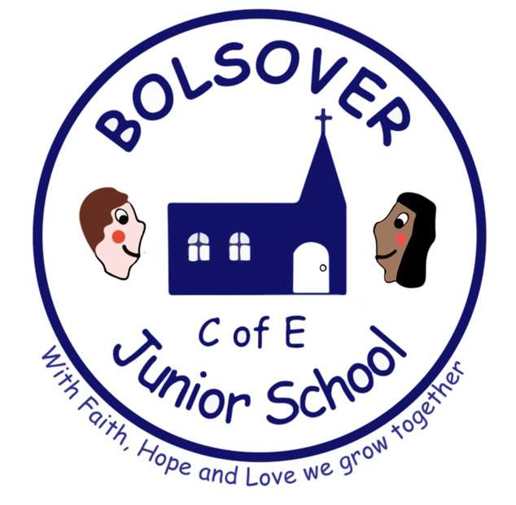

Job Description

Cleaner/Relief Cleaner

Main duties and responsibilities

To work flexibly as part of a small school site team, providing a high-quality cleaning service across the school.

Relief hours

Reporting to Premises Manager

Duties

- Moving and lifting of chairs on and off tables to aid cleaning
- Emptying waste bins or similar receptacles, transporting waste material to designated collection points
- Sweeping hard floors with brushes or dust control mops
- Mopping floors with wet or damp mops
- Vacuum cleaning carpeted areas and ‘spot’ cleaning carpets
- To dust, damp wipe, wash or polish furniture, ledges, windowsills, external surfaces of cupboards, radiators, shelves and fitments
- To clean/sterilise desktops daily
- To clean toilets, urinals, hand basins and sinks
- To use such chemical agents as directed by the supervising officer (after receiving proper instruction and training)
- To undertake wall washing or inside window pane cleaning to a height no greater than body height plus an arm’s extension from the floor level, during periodic cleaning and maintenance programmes
- On occasion, to be available for deep clean programmes during school holidays, for which prior notice will be given. To carry out any other reasonable duties within the overall function of the job.
- Any other duties required within the role of Cleaner

Signed: Dated:

Person Specification

Cleaner/Relief Cleaner

 | Essential | Desirable
Experience | - Performing cleaning tasks using a variety of methods and equipment | - Commercial cleaning
Skills | - Ability to work and communicate with other people.  - Ability to clean to a high standard  - Safe use of cleaning equipment including vacuum cleaners, floor cleaners, steam cleaners and carpet cleaners  - Safe use of cleaning chemicals  - Ability to follow written and verbal instructions  - Effective time management  - Ability to work as part of a team or as a lone worker
Knowledge | - Simple First Aid, hygiene, cleanliness and safe working practices  - Control of substances hazardous to health (COSHH)
Qualifications | - Not essential | - COSSH training  - NVQ Level 1 / 2
Equal Opportunities | - Awareness of equality of opportunities and diversity
Other requirements | - Committed to safeguarding and promoting the welfare of children and to have an Enhanced DBS check.  - Willing to undertake relevant instruction and training.

